“Personalized News Aggregator”

***A Dissertation submitted in partial fulfillment of the requirements for the award of degree of***

# MASTERS OF COMPUTER APPLICATIONS

**Of**

***BENGALURU CITY UNIVERSITY***

For the Academic year - May 2024

**Submitted By**

**Rahul Dayashankar Yadav**

**P18FY22S126036**

**Under the Guidance of**

**Ms. Sunitha K**



**SAMBHRAM ACADEMY OF MANAGMENT STUDIES**

**M S PALYA, VIDYARANYAPURA POST**

**BENGALURU – 560097**

**SAMBHRAM ACADEMY OF MANAGMENT STUDIES**

M S PALYA, VIDYARANYAPURA POST, BENGALURU – 560097



Department of Computer Applications

CERTIFICATE

This is to certify that **Rahul Dayashankar Yadav** (P18FY22S126036) has satisfactorily completed the Third Semester MCA mini project titled “**Personalized News Aggregator**” towards partial fulfillment of the requirements for the completion of 3rd semester of the Degree in “Master of Computer Applications”, awarded by BENGALURU CITY UNIVERSITY, during the Academic Year 2023-2024.

1. Rahul Dayashankar Yadav - P18FY22S126036

Sunitha K Mrs. Sunitha K

Assoc. Professor,HOD DCA Assoc. Professor, HOD, DCA

SAMS, Bengaluru SAMS, Bengaluru

EXAMINERS: -

**ACKNOWLEDGEMENT**

I have taken efforts in this project it would have not been possible without the help and support of many individuals and organizations. I would like to extend my sincere thanks to all of them.

I take this opportunity to thank our honorable principal **Wg. Cdr Dr. K.Srinivas Rao** for permitting us to undertake this project as the part of our curriculum.

I express sincere thanks to **Prof. SUNITHA K, HOD of MCA** department for their immense support and guidance throughout the project.

I am highly indebted to our project internal guide, **Prof , Sunitha K** Department of MCA, Sambhram Academy of Management Studies, Bengaluru, who helped me in channeling my effort in the right direction. She/He has guided me to correctly carry out phases of the project. I would like to express my gratitude to all the lectures of MCA department for their valuable guidance, suggestions, and encouragement throughout this work.

Last but not the least, I thank almighty, my beloved parents and friends for their constant encouragement without which this assignment would have not been possible.

Thank you,

Rahul Dayashankar Yadav

P18FY22S126036

**Abstract**

In an era characterized by information overload and the rapid evolution of digital media, the demand for personalized news consumption solutions has never been more pronounced. The Personalized News Aggregator stands at the forefront of this revolution, offering users a groundbreaking platform that transforms the way they engage with news content.

At its core, the Personalized News Aggregator harnesses the power of advanced algorithms and machine learning techniques to curate a tailored selection of articles from a vast and diverse array of sources. By analyzing user preferences, behavior, and feedback, the platform ensures that each user receives a personalized news feed that aligns with their unique interests and preferences. This dynamic curation process not only saves users time and effort but also enhances their overall news consumption experience by delivering content that is relevant, engaging, and informative.

Unlike traditional news platforms that adopt a one-size-fits-all approach, the Personalized News Aggregator prioritizes customization and flexibility. Through customizable filters and preferences, users have the freedom to fine-tune their news feed according to a multitude of factors, including topic relevance, publication source, and geographic location. This level of customization empowers users to tailor their news consumption experience to suit their individual preferences, ensuring a more enriching and personalized reading experience.

Furthermore, the integration of social media functionalities within the Personalized News Aggregator adds a new dimension to the news consumption experience. By enabling users to share articles, initiate discussions, and connect with like-minded individuals within the platform, the aggregator fosters a sense of community and collaboration among its users. This social engagement aspect not only enhances user interaction but also enriches the overall news ecosystem by facilitating the exchange of ideas, insights, and perspectives.

This level of customization empowers users to tailor their news consumption experience to suit their individual preferences, ensuring a more enriching and personalized reading experience. Whether users prefer to focus on breaking news from reputable international sources or niche topics from specialized publications, the Personalized News Aggregator provides the tools and flexibility to cater to their specific interests.

In addition to its advanced curation and social integration features, the Personalized News Aggregator leverages natural language processing technology to further enhance the user experience. By analyzing and summarizing news articles, the platform provides users with concise and informative summaries that capture the essence of each story, enabling them to quickly grasp key insights and implications without having to sift through lengthy articles. This streamlined approach to information consumption not only saves users time but also empowers them to stay informed and engaged with current events. As society grapples with the challenges of navigating an increasingly complex media landscape, the Personalized News Aggregator emerges as a trusted ally, offering users a curated selection of articles that reflect their individual interests and perspectives

In conclusion, the Personalized News Aggregator represents a paradigm shift in news consumption, where personalization, engagement, and efficiency converge to create a more enriching and fulfilling user experience. As it continues to evolve and adapt to the ever-changing needs and preferences of its users, the platform remains committed to redefining the way we consume news in the digital age.

**Index**

|  |  |  |
| --- | --- | --- |
| Sl. No. | Topic | Page No. |
|  | **Introduction**   * + Background Overview     - The organization Profile     - Study on Existing System   + Statement of the Problem | **1** |
|  | **Problem Analysis/System Analysis**   * + Preliminary Investigation | **4** |
|  | **Feasibility Study**   * Technical Feasibility * Economical Feasibility * Operational Feasibility | **8** |
|  | **Software Engineering Paradigm Applied/ Methodology applied** | **10** |
|  | **Software and Hardware Requirement and Specifications** | **12** |
|  | **System Design/ Design Strategy**   * + - Design Notations     - Flow Chart/ DFD     - Behavioral diagram/E-R diagram     - Structure Chart     - Module descriptions | **13** |
|  | **Coding**   * Form/Module wise coding with comments. | **23** |
|  | **Code Efficiency Analysis**   * Optimization Of Code | **51** |
|  | **Verification Checks** | **53** |
|  | **Validation Checks** | **56** |
|  | **Testing and Implementation**   * + Testing     - Strategy/ Methodology of testing     - Test results     - Analysis   + Implementation     - Implementation Procedures     - User Training     - Operational Documentation | **60** |
|  | **Cost Estimation of Project** | **66** |
|  | **Time Scheduling of Project** | **70** |
|  | **Future Scope and Future Enhancement Of The Project** | **72** |
|  | **List of Forms** | **77** |
|  | **List of Screens** | **80** |
|  | **List of Figures** | **84** |
|  | **List of Tables** | **85** |
|  | **Conclusion** | **86** |
|  | **Bibliography** | **87** |
|  | **glossary of Technical terms**  **Appendices** | **88** |

1. **Introduction**

Greetings! My name is Rahul Dayashankar Yadav, and I am currently pursuing my Master of Computer Applications (MCA) degree. The project titled "Personalized News Aggregator" has been developed under the guidance and supervision of my project advisor, Sunitha K. This endeavor seeks to introduce a transformative approach to news consumption in the digital era.

In today's fast-paced world, where information overload has become a common challenge, there is a growing need for personalized solutions in news consumption. The "Personalized News Aggregator" project endeavors to address this need by offering a platform that tailors news content to individual user preferences and interests.

At its core, this project leverages advanced algorithms and machine learning techniques to curate a bespoke selection of news articles from a diverse range of sources. Through thorough analysis of user behavior, engagement patterns, and feedback, the platform ensures that each user receives a curated news feed aligned with their unique interests and preferences.

Beyond personalization, the "Personalized News Aggregator" integrates social media functionalities, enabling users to engage with content and connect with like-minded individuals within the platform. This fosters a sense of community and collaboration, enriching the overall user experience.

Furthermore, the project harnesses the power of natural language processing technology to analyze and summarize news articles, facilitating quick comprehension of key insights and implications. This streamlined approach to information consumption not only saves users time but also keeps them informed and engaged with current events.

This project forms an integral part of my MCA curriculum and represents a culmination of theoretical knowledge and practical application under the guidance of my project advisor, Sunitha K. Its objective is to present a novel approach to news consumption that is personalized, enriching, and efficient. Moving forward, the project aims to further develop and refine its features to meet the evolving needs of users in the dynamic landscape of digital media.

**1.1. Background Overview**

In today's digital age, the landscape of news consumption has undergone significant transformation. With the advent of the internet and social media, access to information has become more accessible than ever before. However, this abundance of information has also led to challenges such as information overload and the spread of misinformation.

Recognizing these challenges, the need for personalized news consumption solutions has become increasingly apparent. Traditional news platforms often adopt a one-size-fits-all approach, offering generic content that may not resonate with individual users' interests and preferences. This gap between available content and user preferences has created an opportunity for the development of innovative solutions tailored to meet the needs of modern consumers.

The "Personalized News Aggregator" project aims to address this gap by leveraging advanced technologies such as machine learning, natural language processing, and social media integration to curate a personalized news experience for users. By analyzing user behavior, engagement patterns, and feedback, the platform aims to deliver a curated selection of news articles that align with each user's unique interests and preferences.

Furthermore, the project seeks to enhance the user experience by integrating social media functionalities, allowing users to engage with content and connect with like-minded individuals within the platform. This social engagement aspect not only enriches the user experience but also fosters a sense of community and collaboration among users.

Additionally, the project incorporates natural language processing technology to analyze and summarize news articles, enabling users to quickly grasp key insights and implications without having to sift through lengthy articles. This streamlined approach to information consumption not only saves users time but also empowers them to stay informed and engaged with current events.

Overall, the "Personalized News Aggregator" project represents a concerted effort to revolutionize the way news is consumed in the digital age. By harnessing the power of technology to personalize the news consumption experience, the project aims to empower users to make informed decisions, engage in meaningful discussions, and stay connected with the world around them.

Importance of Personalized News Aggregator:-

Meeting In today's rapidly evolving media landscape, the traditional one-size-fits-all approach to news consumption is no longer sufficient. As individuals, we each have unique interests, preferences, and priorities, and our information needs vary accordingly. This is where the importance of a Personalized News Aggregator comes into play.

Tailored Content Delivery: One of the primary benefits of a Personalized News Aggregator is its ability to deliver content tailored to the individual user's interests and preferences. By leveraging advanced algorithms and machine learning techniques, the aggregator can analyze user behavior, engagement patterns, and feedback to curate a personalized news feed. This ensures that users receive content that is relevant, timely, and engaging, leading to a more satisfying and fulfilling news consumption experience.

Efficient Information Consumption: In today's fast-paced world, time is of the essence. With an abundance of news articles and information available online, it can be overwhelming for users to sift through the noise and find content that is truly relevant to them. A Personalized News Aggregator streamlines this process by presenting users with a curated selection of articles that align with their interests and preferences. This not only saves users time but also enables them to stay informed without feeling overwhelmed by information overload.

Enhanced Engagement: By tailoring content to individual user preferences, a Personalized News Aggregator fosters deeper engagement and interaction with news content. Users are more likely to read, share, and engage with articles that are personally relevant to them, leading to increased user satisfaction and loyalty. Additionally, the integration of social media functionalities allows users to connect with like-minded individuals, share articles, and participate in discussions, further enhancing engagement within the platform.

Mitigation of Information Bias: In an era marked by the proliferation of misinformation and fake news, the importance of reliable and trustworthy news sources cannot be overstated. A Personalized News Aggregator can help mitigate the effects of information bias by curating content from reputable sources and providing users with diverse perspectives on current events. This not only promotes media literacy but also helps users develop a more comprehensive understanding of complex issues.

Empowerment and Agency: Perhaps most importantly, a Personalized News Aggregator empowers users to take control of their news consumption experience. By allowing users to customize their news feed based on their individual interests and preferences, the aggregator puts the power back in the hands of the user, enabling them to make informed decisions and stay connected with the world around them on their own terms.

In conclusion, the importance of a Personalized News Aggregator lies in its ability to revolutionize the way we consume news in the digital age. By delivering tailored content, streamlining information consumption, enhancing engagement, mitigating information bias, and empowering users, a Personalized News Aggregator offers a transformative solution to the challenges of modern news consumption.

**1.2. Statement of the Problem**

The In today's rapidly evolving media landscape, the traditional one-size-fits-all approach to news consumption is no longer sufficient. The abundance of information available online, coupled with the rise of social media, has created a fragmented and often overwhelming news ecosystem. Users are inundated with a deluge of articles, opinions, and updates, making it increasingly challenging to filter through the noise and find content that is relevant, reliable, and engaging.

Existing news aggregation platforms, while offering a wealth of content, often fall short in delivering a personalized experience tailored to individual user preferences. Users are left to navigate through a sea of generic articles, lacking the time or inclination to sift through the myriad options to find content that aligns with their specific interests and values.

Moreover, the prevalence of misinformation and biased narratives further complicates the news consumption landscape, eroding trust in traditional news sources and undermining the public's ability to form informed opinions on critical issues. Therefore, the primary problem to be addressed is twofold: first, the need for a personalized news aggregation solution that effectively curates content based on individual user interests, preferences, and behaviors; and second, the imperative to mitigate the effects of misinformation and bias by sourcing content from reputable sources and providing users with diverse perspectives on current events.

This necessitates the development of a "Personalized News Aggregator" that leverages advanced algorithms and machine learning techniques to analyze user behavior, engagement patterns, and feedback. By understanding each user's unique preferences, the aggregator can deliver a curated selection of news articles that are relevant, timely, and engaging, thereby enhancing the overall news consumption experience.

Additionally, the aggregator must integrate social media functionalities to foster community engagement and facilitate meaningful discussions among users. By connecting like-minded individuals and providing a platform for interaction and collaboration, the aggregator can enrich the user experience and deepen user engagement with news content.

Furthermore, the aggregator must prioritize the sourcing of content from reputable sources and employ natural language processing technology to analyze and summarize articles, enabling users to quickly grasp key insights and implications without being overwhelmed by lengthy or complex narratives.

In summary, the problem at hand is to develop a "Personalized News Aggregator" that not only addresses the challenges of information overload and misinformation but also empowers users to make informed decisions, engage in meaningful discussions, and stay connected with the world around them in the digital age.

1. **Problem Analysis / System Analysis**

In today's digital age, news consumers face a myriad of challenges, including information overload, the spread of misinformation, and a lack of personalized content delivery. Traditional news aggregation platforms often fail to address these challenges, delivering generic content that may not resonate with individual user preferences. This disconnect between available content and user interests leads to decreased engagement and trust in online news sources. Additionally, the fragmented nature of the digital news ecosystem makes it difficult for users to access comprehensive coverage of topics that matter to them. Furthermore, the absence of robust social features limits opportunities for community interaction and meaningful discussions around news topics. Integrating advanced technologies such as machine learning and natural language processing presents an opportunity to revolutionize news aggregation, but effective implementation requires careful consideration of user needs and technological capabilities. Thus, there is a pressing need for a "Personalized News Aggregator" that addresses these challenges by delivering tailore­d content, fostering community engagement, and promoting trust and credibility in online news consumption.

* 1. **Existing System**

Before The current landscape of news aggregation platforms is characterized by several shortcomings that hinder the effectiveness and user experience of such systems. Firstly, traditional platforms lack robust personalization features, often employing a one-size-fits-all approach that fails to deliver content tailored to individual user preferences. Consequently, users are inundated with a plethora of generic articles, leading to information overload and reduced engagement. Moreover, the prevalence of misinformation on these platforms erodes trust in online news sources, as users struggle to discern reliable information from biased or inaccurate content. Additionally, the fragmented nature of the digital news ecosystem exacerbates the challenge of accessing comprehensive coverage of topics, as users must navigate through multiple sources and platforms to gather relevant information. Furthermore, the absence of social features limits opportunities for community interaction and meaningful discussions around news topics, detracting from the overall user experience. While some platforms may integrate basic technology solutions, such as keyword-based filtering, they often lack the sophistication required to effectively address these challenges. Overall, the existing system falls short in providing users with a personalized, reliable, and engaging news consumption experience tailored to their individual needs and preferences.

* **Lack of Personalization:** Traditional news aggregation platforms often employ a one-size-fits-all approach, delivering generic content to all users irrespective of their individual interests and preferences. This approach leads to a disconnect between available content and user preferences, resulting in decreased user engagement and satisfaction.
* **Information Overload:** The abundance of content available on traditional news aggregation platforms contributes to information overload for users. Without effective filtering mechanisms, users may find it challenging to navigate through the vast array of articles to find those that are relevant and interesting to them.
* **Trust and Credibility Issues**: The proliferation of misinformation and biased narratives on online platforms undermines trust in the credibility of news sources. Users may struggle to discern reliable sources from unreliable ones, leading to skepticism and uncertainty about the accuracy of the news they consume.
* **Fragmented News Ecosystem**: The digital news ecosystem is fragmented, with news articles scattered across various sources and platforms. This fragmentation makes it difficult for users to access comprehensive coverage of topics, as they must navigate through multiple sources to gather relevant information.
* **Limited Community Interaction:** Many existing news aggregation platforms lack robust social features that foster community interaction and meaningful discussions around news topics. This limits opportunities for users to engage with both content and fellow users, detracting from the overall user experience.
* **Basic Technological Solutions:** While some platforms may integrate basic technology solutions, such as keyword-based filtering, they often lack the sophistication required to effectively address the aforementioned challenges. Advanced technologies such as machine learning and natural language processing are underutilized, limiting the platform's ability to deliver personalized and relevant content to users.
* **User Interface Complexity:** The user interface of existing news aggregation platforms may be complex and cluttered, making it challenging for users to navigate and find relevant content efficiently. A cluttered interface can contribute to user frustration and detract from the overall user experience.
* **Limited Content Summarization:** While some platforms may offer content summarization features, they often lack the ability to provide concise and informative summaries of news articles. This can be particularly problematic for users with limited time who seek quick access to key insights and information.
* So, the existing system of news aggregation platforms is characterized by a lack of personalization, issues of information overload and trust, fragmentation of the news ecosystem, limited community interaction, reliance on basic technological solutions, complexity of user interfaces, and shortcomings in content summarization capabilities. Addressing these challenges requires the development of a more sophisticated and user-centric "Personalized News Aggregator" that leverages advanced technologies to deliver personalized, reliable, and engaging news experiences to users.
  1. **Proposed System**

The The proposed "Personalized News Aggregator" system aims to address the shortcomings identified in existing news aggregation platforms by leveraging advanced technologies to provide a more personalized, engaging, and reliable news consumption experience. The key features and components of the proposed system are outlined below:

**2.2.1 Advanced Personalization Engine**

Machine Learning Algorithms:

The proposed system will utilize sophisticated machine learning algorithms to analyze user behavior, engagement patterns, and feedback. By learning from user interactions, the system will curate a personalized news feed that aligns with individual preferences and interests.

* **Behavioral Analysis:**

The system will track and analyze various metrics such as reading time, click-through rates, and user ratings to refine content recommendations continuously.

* **Preference Settings:**

Users will have the option to manually adjust their preferences, specifying topics of interest, preferred sources, and content formats (e.g., articles, videos, podcasts).

**2.2.2 Efficient Information Consumption**

* **Content Summarization:**

Natural language processing (NLP) technology will be employed to generate concise summaries of news articles. This feature will enable users to quickly grasp key insights and decide whether to read the full article.

* **Relevance Filtering:**

The system will filter out irrelevant and low-quality content, presenting users with only the most pertinent and engaging articles. This will reduce information overload and help users stay focused on important news.

**2.2.3 Enhanced User Engagement**

**Interactive Features:**

The platform will integrate social media functionalities, allowing users to comment on articles, share content with their network, and participate in discussions.

**Community Building:**

Users will be able to follow other users with similar interests, join topic-based groups, and receive notifications about trending discussions within their community.

**Personalized Notifications:**

The system will send personalized notifications to users about breaking news, updates on favorite topics, and responses to their comments, keeping them engaged with the platform.

**2.2.4 Trust and Credibility**

**Source Credibility Analysis:**

The system will evaluate the credibility of news sources using a combination of automated and manual methods. Trusted sources will be prioritized in the news feed, and sources known for spreading misinformation will be de-emphasized.

**Diverse Perspectives:**

To combat information bias, the platform will provide diverse perspectives on major news stories, ensuring users are exposed to a balanced view of current events.

**2.2.5 User Empowerment**

Customization Options:

Users will have extensive customization options, allowing them to tailor their news feed to their specific interests and needs. This empowers users to control their news consumption experience.

**Feedback Mechanism:**

The platform will incorporate a feedback mechanism where users can rate articles, suggest improvements, and report issues. This feedback will be used to enhance the personalization engine and overall user experience.

**2.2.6 User-Friendly Interface**

**Intuitive Design:**

The user interface will be designed to be intuitive and user-friendly, ensuring easy navigation and accessibility. A clean, clutter-free layout will help users quickly find and engage with relevant content.

**Adaptive Layout:**

The platform will feature an adaptive layout that adjusts to different devices and screen sizes, providing a seamless experience across desktops, tablets, and smartphones.

**2.2.7 Technological Infrastructure**

**Scalable Architecture:**

The backend system will be built on a scalable architecture to handle a growing number of users and large volumes of data. This will ensure consistent performance and reliability.

**Real-Time Processing:**

Real-time data processing capabilities will be implemented to provide up-to-the-minute news updates and dynamic content adjustments based on user interactions.

**2.2.8 Social Media Integration**

**Seamless Sharing:**

Users will be able to seamlessly share articles and news stories directly from the platform to their social media accounts. This will enhance the reach and engagement of the content.

**Social Feeds:**

The platform will include social feeds that display trending news shared by users’ connections, fostering a community-driven news discovery experience.

**Discussion Forums:**

Integrated discussion forums will allow users to engage in deeper conversations about news topics, share opinions, and connect with others who have similar interests.

**2.2.9 Content Diversity and Inclusion**

Wide Range of Sources:

The aggregator will pull news from a diverse array of sources, including international outlets, local newspapers, niche blogs, and expert journals. This ensures users receive a broad spectrum of viewpoints.

**Inclusive Content:**

Efforts will be made to include content that reflects diverse cultures, communities, and perspectives, promoting inclusivity and broadening users’ understanding of global issues.

**2.2.10 Advanced Search and Filtering**

**Enhanced Search Capabilities:**

The platform will offer advanced search functionalities, allowing users to find articles based on keywords, topics, dates, and sources.

**Custom Filters:**

Users can apply custom filters to their news feed, such as filtering by article length, publication date, author, and more, to match their specific preferences and needs.

1. **Feasibility Study**

The feasibility study assesses the practicality and viability of the "Personalized News Aggregator" project. This study includes several aspects such as technical, operational, economic, legal, and scheduling feasibility. Each aspect is evaluated to ensure the project's success and sustainability.

**3.1 Technical Feasibility**

**Technological Requirements:**

The project requires a robust technological infrastructure, including advanced machine learning algorithms, natural language processing (NLP) capabilities, and scalable cloud computing services. Current technology supports these requirements, with tools and frameworks such as TensorFlow, PyTorch, and AWS/Azure providing the necessary resources for development and deployment.

**Skill Set Availability:**

The development team must possess expertise in machine learning, NLP, software development, and data science. Given the rising popularity of these fields, skilled professionals are readily available, and necessary training can be provided if needed.

**Integration with Existing Systems:**

The platform will integrate with existing news APIs, social media platforms, and databases. APIs from major news sources like NewsAPI, and social media platforms like Twitter and Facebook, are well-documented and supported, facilitating smooth integration.

**Scalability:**

The system's architecture will be designed to handle a growing user base and increasing amounts of data. Cloud services like AWS and Azure offer scalable solutions that can be adjusted according to demand, ensuring the platform remains responsive and efficient.

**3.2 Operational Feasibility**

**User Adoption:**

The platform's user-friendly interface, personalized content delivery, and social engagement features are designed to attract and retain users. Market research indicates a growing demand for personalized news solutions, suggesting high potential for user adoption.

**Maintenance and Support:**

A dedicated team will be required to maintain the platform, address technical issues, and provide customer support. This includes regular updates, bug fixes, and feature enhancements. A comprehensive support plan will ensure the platform operates smoothly.

**Training Requirements:**

Minimal training will be required for end-users due to the intuitive design of the platform. Tutorials and help guides will be available to assist users in navigating and customizing their news feeds.

**3.3 Economic Feasibility**

**Development Costs:**

The initial investment includes costs for development, testing, and deployment. This covers salaries for the development team, licensing fees for software tools, and cloud service subscriptions. A detailed budget will be created to manage these expenses effectively.

**Operational Costs:**

Ongoing costs include server maintenance, customer support, and marketing. These costs are expected to be manageable and will be offset by revenue generated through various monetization strategies.

**Revenue Generation:**

The platform can generate revenue through advertisements, premium subscriptions, and partnerships with news providers. Advertisements will be strategically placed to avoid disrupting the user experience, and premium subscriptions will offer enhanced features such as ad-free browsing and advanced customization options.

**Return on Investment (ROI):**

Given the high demand for personalized news solutions and the diverse revenue streams, the project is expected to achieve a positive ROI within a reasonable timeframe. Detailed financial projections will be developed to monitor and ensure profitability.

**3.4 Legal Feasibility**

**Compliance with Regulations:**

The platform will comply with data protection regulations such as GDPR and CCPA, ensuring user data privacy and security. Legal counsel will be consulted to ensure all regulatory requirements are met.

**Intellectual Property:**

The project will respect intellectual property rights by sourcing content from reputable and licensed sources. Agreements will be established with news providers to legally aggregate and display their content.

**Terms of Service and Privacy Policy:**

Comprehensive terms of service and privacy policy documents will be drafted to clearly outline user rights and platform responsibilities. These documents will be made available to users upon registration.

**3.5 Scheduling Feasibility**

**Project Timeline:**

A detailed project timeline will be created, outlining key milestones and deliverables. The timeline will include phases for planning, development, testing, deployment, and post-launch support.

**Resource Allocation:**

Resources will be allocated efficiently to ensure timely completion of each phase. This includes assigning tasks to team members based on their expertise and ensuring that all necessary tools and infrastructure are in place.

**Risk Management:**

Potential risks, such as delays in development or unforeseen technical challenges, will be identified and mitigated through proactive planning and contingency measures. Regular progress reviews will ensure the project stays on track.

The feasibility study indicates that the "Personalized News Aggregator" project is viable across technical, operational, economic, legal, and scheduling dimensions. With careful planning and execution, the project has the potential to succeed and deliver significant value to users in the digital news landscape..

1. **Software Engineering Paradigm Applied/ Methodology applied**

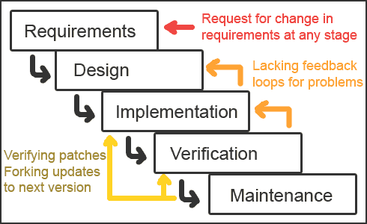

* **Waterfall Model**

The waterfall model derivers its name due to the cascading effect from one phase to the other as is illustrated in above figure. In this model each phase well define starting and ending point, with identifiable deliveries to the next phase.

The water fall diagram is basically divided into following 5 models.

•Requirement

•Design

•Implementation

•Verification

•Maintenance

* **Requirement:**-

The project kicks off with the Requirement Phase, focusing on understanding the needs and objectives of the software to be developed. This involves extensive communication with stakeholders to gather requirements, which are then analyzed, documented, and validated. Requirements can be functional (features the system must provide) or non-functional (qualities like performance or usability). Techniques such as interviews, surveys, and workshops aid in requirements elicitation. The output of this phase includes a Requirements Specification Document, outlining system functionalities, constraints, and user expectations. Use Cases and User Stories may also be created to provide detailed scenarios of system usage.

* **Design: -**

With designs in hand, developers embark on the Implementation Phase, where they write code according to the specifications outlined in the design documents. This phase involves translating design concepts into executable software, adhering to coding standards and best practices. Developers may work in teams, each responsible for different modules or components. Coding is followed by unit testing, where individual units of code are tested in isolation to ensure they function correctly. Integration testing then verifies that modules work together as intended. Debugging plays a crucial role in identifying and resolving issues. The outcome is executable code, accompanied by source code and test artifacts.

* **Implementation: -**

Implementation is the process of having a system personnel phase check out and put new equipment into use, train users, install new application and construct any file of data need to use it.

* **Verification: -**

After the whole application is being the developed the main phase is the verification phase where the whole application tested and verified to check the whole application.

* **Maintenance: -**

After After successful verification, the software enters the Maintenance Phase, where it is deployed for use in the real world. This phase involves ongoing support and maintenance activities to ensure the software remains operational and effective. Maintenance tasks include bug fixes, performance enhancements, security updates, and feature additions based on user feedback or changing requirements. Maintenance can be categorized into corrective maintenance (fixing defects), adaptive maintenance (adapting to new environments), perfective maintenance (improving performance or usability), and preventive maintenance (proactively addressing potential issues). Regular monitoring and feedback mechanisms help identify areas for improvement.

The Waterfall Model provides a structured approach to software development, offering clear milestones and deliverables at each phase. However, its linear nature can pose challenges in accommodating changing requirements or adapting to feedback during development. Despite its limitations, the Waterfall Model remains a valuable framework for projects with well-defined requirements and stable environments, where predictability and control are paramount.

1. **Software and Hardware Requirement and Specifications**

The selection of hardware is very important in the existence and proper working of any software. When selecting hardware, the size and requirements are also important.

* **Hardware Components**
* **Processor**: Intel Core i3 or equivalent
* **RAM**: 4 GB or higher
* **Memory**
  + **HDD/SSD**: 250 MB or higher
* **Software Components**
* **Browsers**: Chrome, Firefox, Safari, Edge, etc. (Any modern browser)
* **Operating System**: Windows 7/8/10/11, macOS, Linux, etc.
* **Text Editor**: Visual Studio Code (recommended), Sublime Text, Atom, etc.

**Additional Software Components: (**May Or May Not Be OPTIONAL)

**Web Scraping Tools:** If you're collecting news from various sources across the web, you'll need web scraping tools or libraries like BeautifulSoup (for Python) to extract relevant information efficiently.

**Machine Learning Libraries:** If you intend to personalize news feeds based on user preferences and behavior, incorporating machine learning libraries like TensorFlow or scikit-learn might be necessary.

**APIs:** Integration with APIs of various news sources for fetching real-time news updates. Ensure compatibility with RESTful APIs or other formats provided by news websites.

**Caching Mechanism:** Implement a caching mechanism to store frequently accessed articles locally, reducing the need for repeated requests to external sources and improving overall performance.

**User Authentication and Authorization:** Implement secure user authentication mechanisms to ensure that only authorized users can access personalized news feeds.

**Data Analytics Tools:** Incorporate tools or libraries for analyzing user interaction with news articles, enabling you to refine the personalization algorithms over time

**Content Management System (CMS):** Develop or integrate a CMS to manage and organize news articles efficiently, allowing for easy retrieval and presentation to users.

**Cross-Platform Compatibility:** Ensure compatibility with various devices and screen sizes, including desktops, tablets, and smartphones, by utilizing responsive design principles

1. **System Design/ Design Strategy**
2. **Design Notations**

Design notations are used when planning and should be able to communicate the purpose of a program without the need for formal code.

Commonly used design notations are:

* + - Flow chart / DFD
    - E-R Diagram
    - Structure Diagram
    - Module Description
    1. **Flow Chart/ Data Flow Diagram (DFD)**

A Data Flow Diagram (DFD) is a diagram that describes the flow of data and the processes that change data throughout a system. It’s a structured analysis and design tool that can be used for flowcharting in place of or in association with information. Oriented and process oriented system flowcharts.

DATA FLOW DIAGRAM SYMBOLS:-

- Source or Destination of Data

- Data Flow

- Process

- Data Store

Steps to Construct Data Flow Diagrams:-

* Process should be named and numbered for easy reference. Each name should be representative of the process.
* The destination of flow is from top to bottom and from left to right.
* When a process is exploded in to lower level details they are numbered.
* The names of data stores, sources and destinations are written in capital letters.

Rules for constructing a Data Flow Diagram: -

* Arrows should not cross each other.
* Squares, circles and files must bear names.
* Decomposed data flow squares and circles can have same names.
* Draw all data flow around the outside of the diagram.
* **Flow Chart**

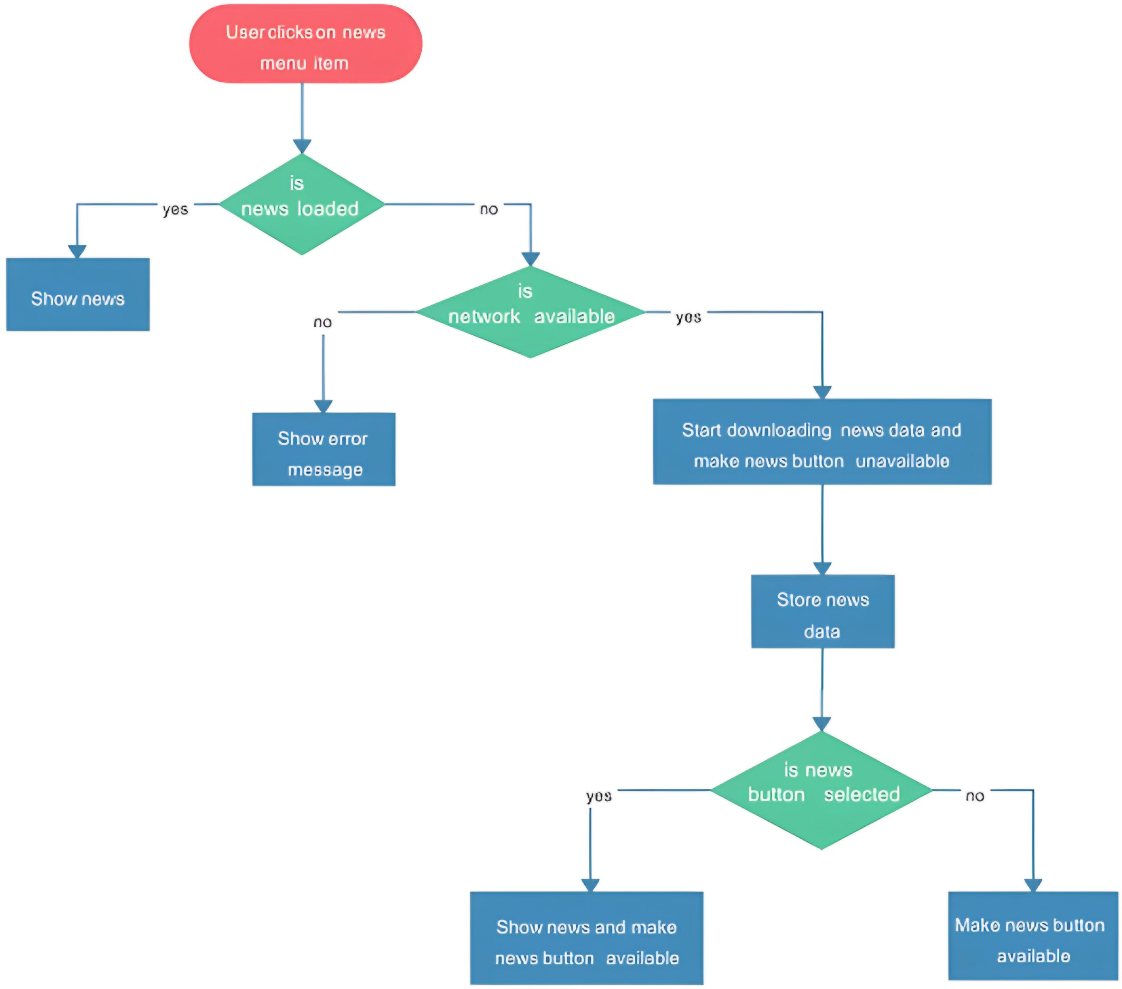

* **Zero Level Data flow Diagram (Level 0 DFD) of Personalized News Aggregator**

The The Zero Level DFD is the highest abstraction level and represents the entire system as a single process with its interactions with external entities. For the Personalized News Aggregator, the primary external entities are Users and Administrators. The main process is the Personalized News Aggregator itself.

Users: These are the end-users who interact with the system to consume news, provide preferences, and manage their accounts.

Administrators: These are the system admins who manage the content (CRUD operations on articles) and user accounts.

Personalized News Aggregator: This is the main process that handles all interactions between users and the system, providing personalized news content based on user preferences and enabling administrators to manage content

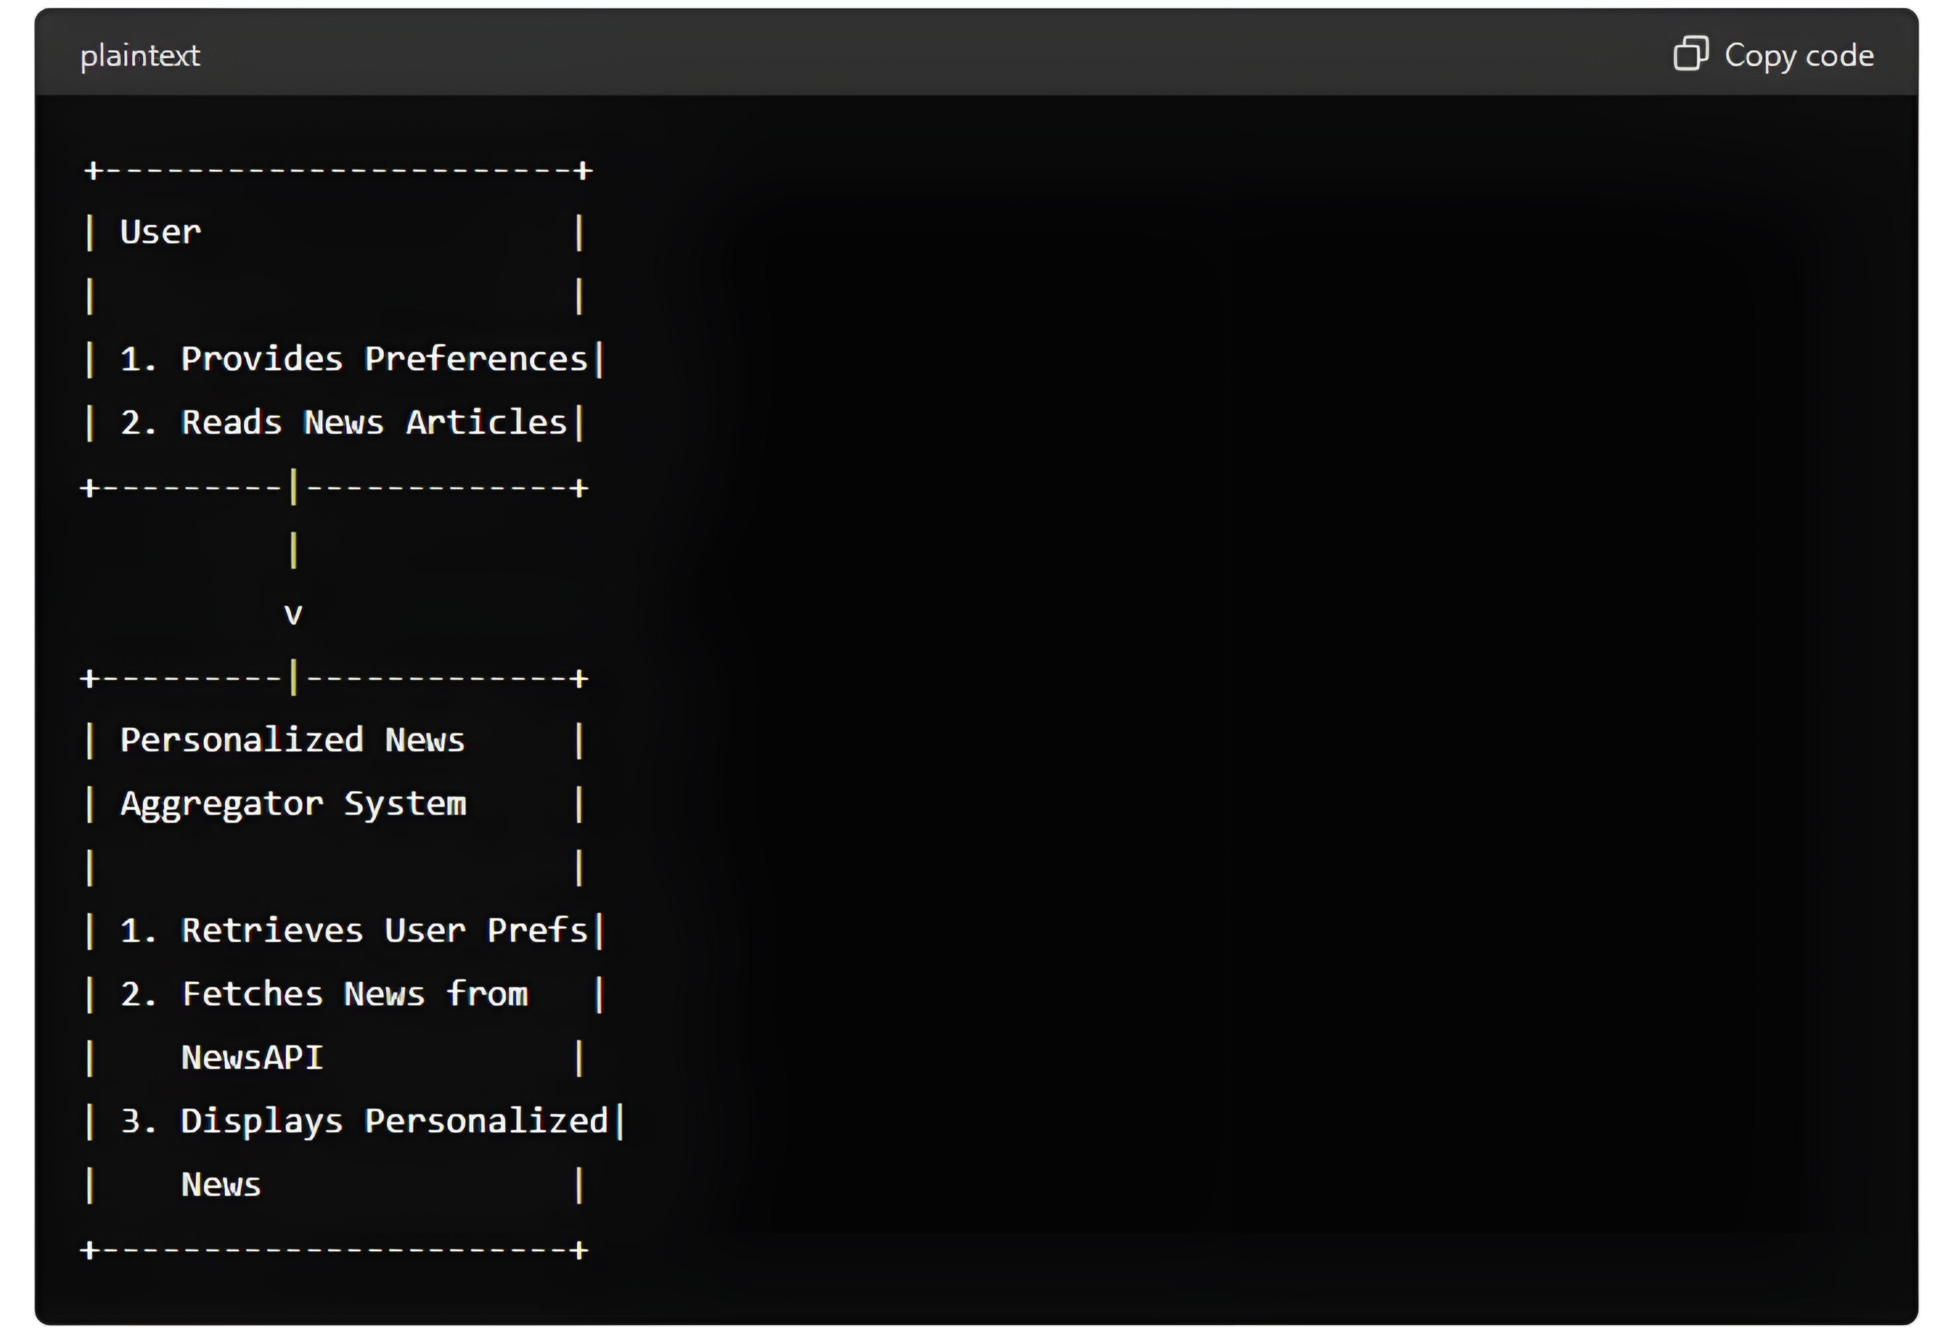

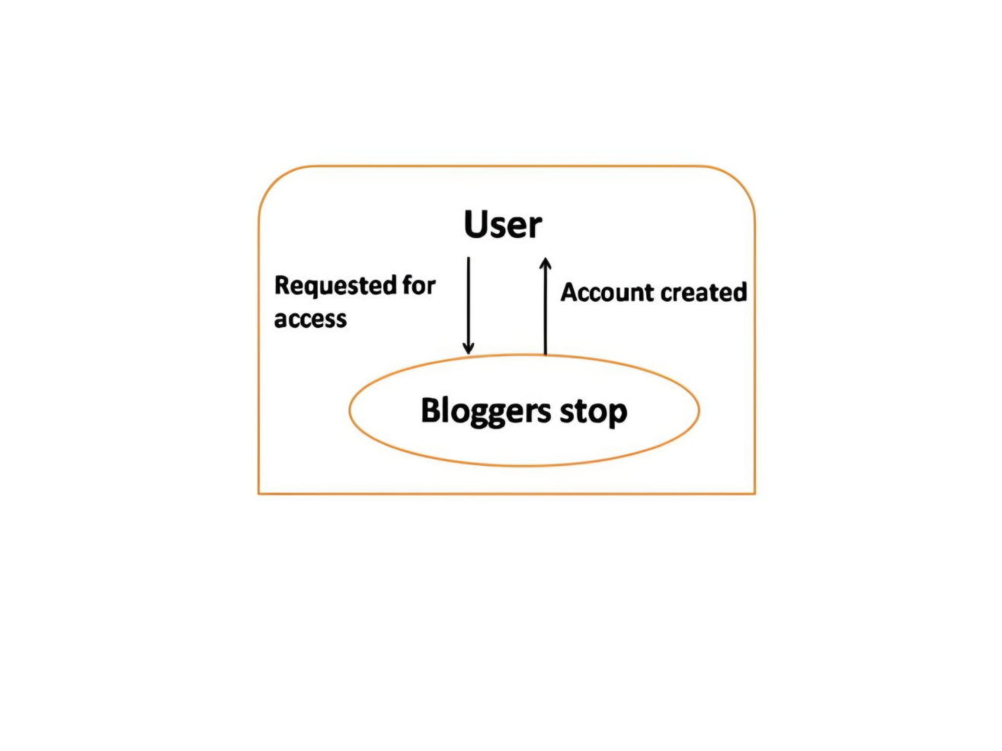

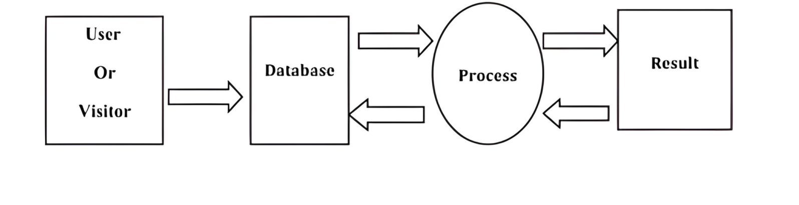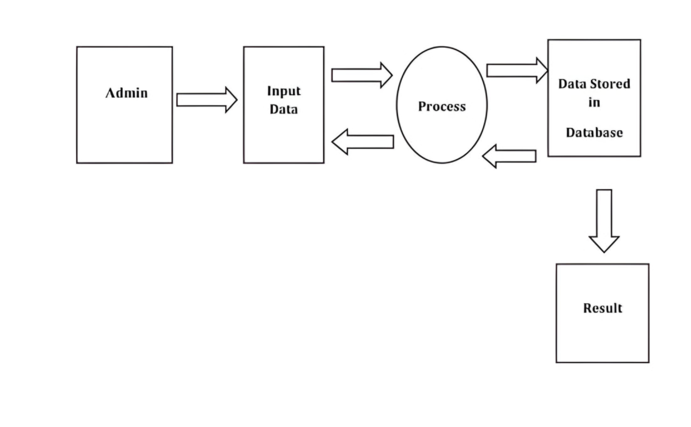

* **First Level Data flow Diagram(1st Level DFD) of Personalized News Aggregator**

The Level 1 DFD provides more detail by breaking down the main process (Personalized News Aggregator) into sub-processes. It shows how the system handles various operations like user authentication, content creation, content management, and data storage.

1. User Authentication: This sub-process handles user login and registration.
2. Content Creation: This sub-process handles the creation and editing of articles by administrators.
3. Content Management: This sub-process manages articles, user preferences, and user interactions with the content.
4. 4. Data Storage: This sub-process stores user information, preferences, and articles.

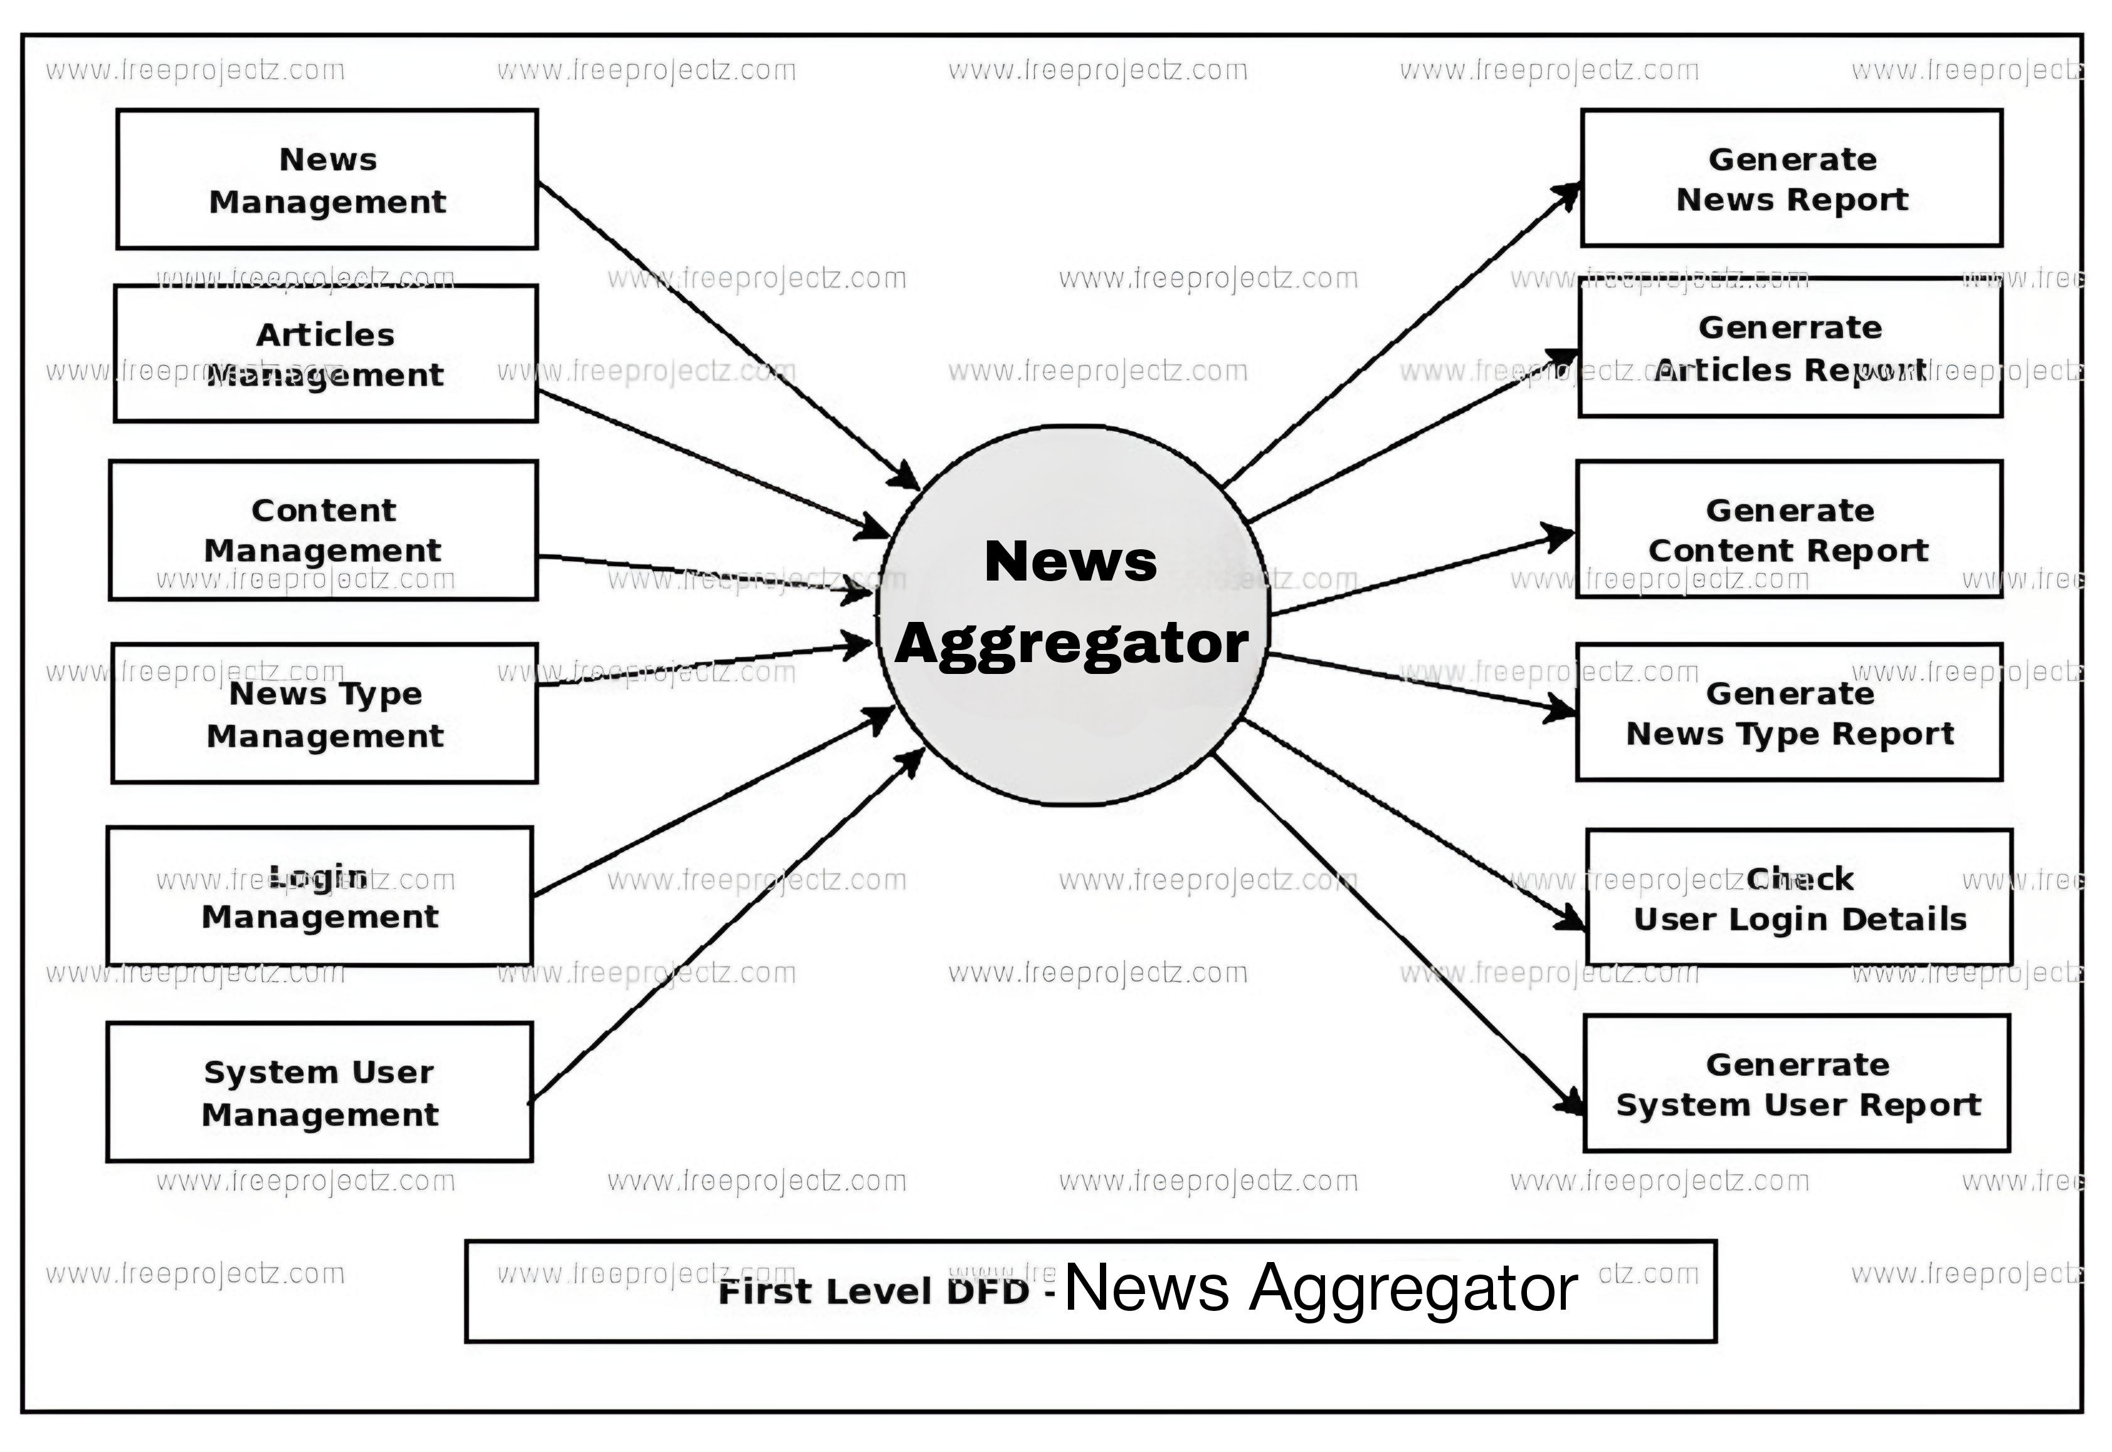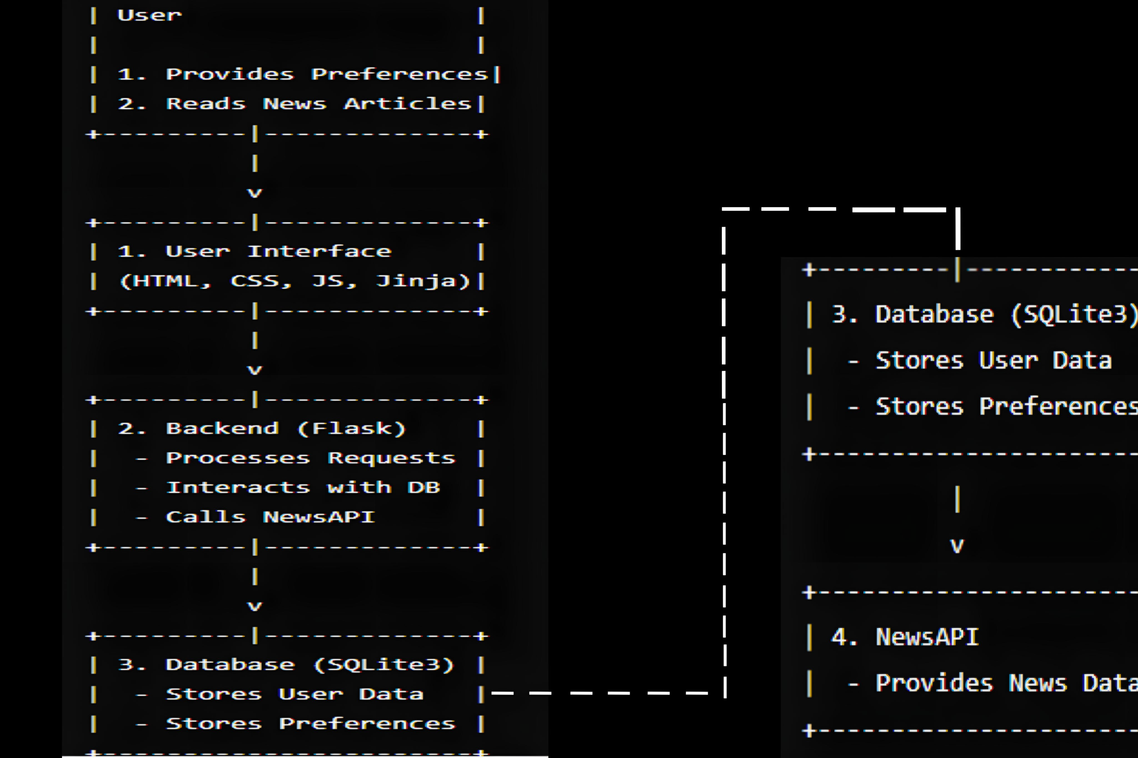

* **Second Level Data flow Diagram(2nd Level DFD) of Personalized News Aggregator**

The Level 2 DFD further decomposes each sub-process to provide more detailed information. Each sub-process is broken down into its constituent parts to show more specific actions and data interactions.

* Login: Handles user login, validating credentials against stored data.
* Registration: Handles new user registration, storing user details in the database.
* Create Article: Handles the creation of new articles by administrators.
* Edit Article: Allows administrators to edit existing articles.
* Manage Articles: Allows administrators to view and manage articles.
* Manage Preferences: Allows users to set and update their preferences. Store User
* Data: Stores user information and preferences.
* Store Articles: Stores article data.

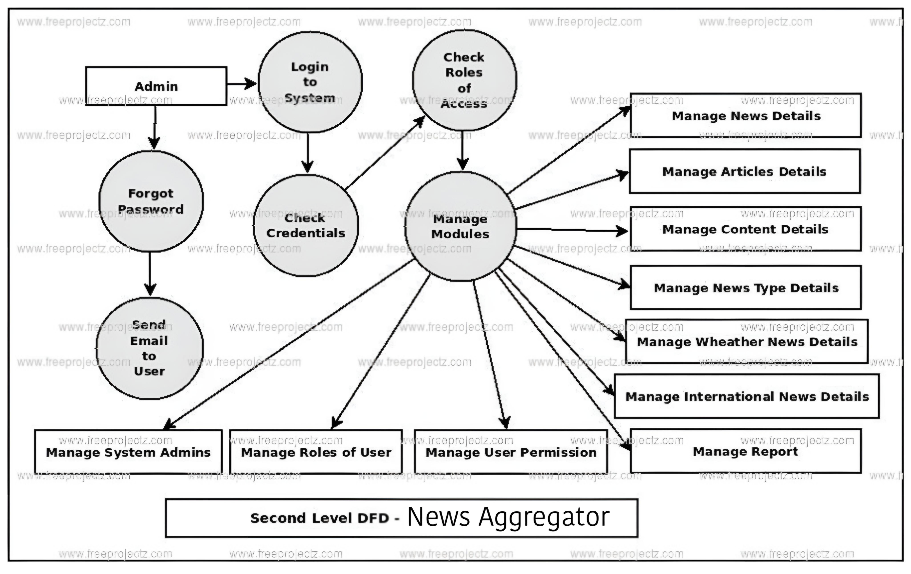

**E- R Diagram**

The ERD provides a clear visualization of the database structure for the Personalized News Aggregator, showing how users, admins, and articles are interconnected. This ensures efficient data management and retrieval, supporting the application's personalized news delivery and content management functionalities.

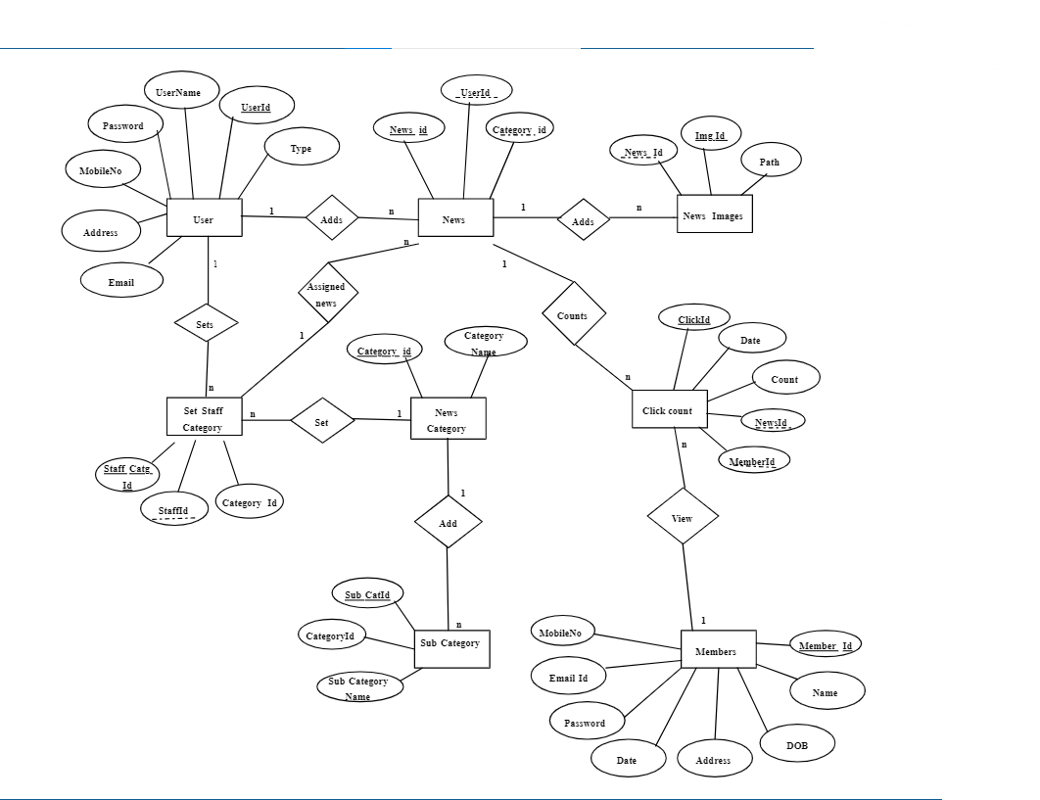

**Aggregator Structure Chart**

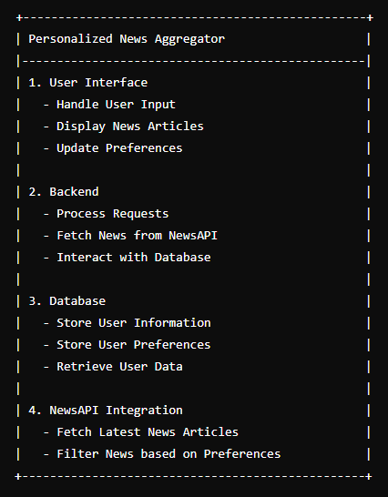

**Personalized News Module Descriptions**

Personalized News Aggregator" project leverages modern web technologies and APIs to create a dynamic, user-friendly news platform. By addressing the need for personalization and efficient content management, it offers a compelling solution for today's digital news consumers, with potential for future enhancements to further improve user engagement and satisfaction.

### Built-in Python Modules

1. **os**:
   * **os.path.dirname(__file__)**: Retrieves the directory path of the current script.
   * **os.path.join(...)**: Joins one or more path components intelligently.
2. **sqlite3**:

**sqlite3.connect(...)**: Connects to the SQLite database.

**sqlite3.Row**: Allows accessing columns of a row by name.

1. **json**:
   * **json.load(f)**: Deserializes a JSON document to a Python object.
   * **json.dump(obj, f, indent=2)**: Serializes a Python object to a JSON formatted stream.

### Third-Party Modules

1. **Flask**:
   * **Flask**: The main class for creating a Flask application.
   * **render_template**: Renders an HTML template.
   * **request**: Handles incoming request data.
   * **redirect**: Redirects to a different route.
   * **url_for**: Constructs a URL to a specific function.
   * **g**: A namespace object for handling request-scoped global variables.
   * **session**: A dictionary-like object for storing session variables.
   * **flash**: Flashes messages to the next request.
2. **requests**:
   * **requests.get(url, params=params)**: Sends a GET request to the specified URL with optional parameters.
3. **bcrypt**:
   * **bcrypt.hashpw(password.encode('utf-8'), bcrypt.gensalt())**: Hashes a password with a salt.
   * **bcrypt.checkpw(password.encode('utf-8'), hashed_password)**: Checks if a password matches a given hash.
4. **werkzeug.security**:
   * **check_password_hash**: Compares a plaintext password with its hashed version.

### Application Structure and Custom Functions

1. **Application Setup**:
   * **app = Flask(__name__)**: Initializes the Flask application.
   * **app.secret_key = 'SecretKey'**: Sets a secret key for session management and CSRF protection.
2. **Custom Filter**:
   * **zip_lists(a, b)**: A custom filter to zip two lists together, added to Jinja2 environment filters.
3. **Database Connection**:
   * **get_db()**: Establishes and returns a connection to the SQLite database.
   * **close_db(error)**: Closes the database connection after the context ends.
4. **Database Initialization**:
   * **init_db()**: Initializes the database by creating necessary tables.
5. **User Authentication and Session Management**
   * **is_logged_in()**: Checks if a user is logged in by verifying session variables.
   * **save_user_to_database(username, hashed_password)**: Saves a new user to the database.
   * **is_admin(username)**: Checks if a given username belongs to an admin.
   * **is_author(article_id)**: Checks if the logged-in user is the author of a specific article.
6. **Article Management**:
   * **save_article_to_database(title, content, source, user_id)**: Saves a new article to the database.
   * **update_article_in_database(article_id, title, content, source, user_id, edit_count)**: Updates an existing article in the database.
   * **fetch_articles_from_database()**: Fetches all articles from the database.
   * **fetch_articles_from_json(filename)**: Fetches articles from a JSON file.
   * **save_data_to_files(data, filename)**: Saves data to SQLite database and JSON file.
7. **News API Integration**:
   * **get_top_headlines(api_key, selected_country)**: Fetches top headlines from the News API based on the selected country.

### Routes

1. **Home and Authentication Routes**:
   * **/**: Displays the homepage with top news headlines.
   * **/signup**: Handles user signup.
   * **/login**: Handles user login.
   * **/logout**: Logs the user out.
   * **/admin_login**: Logs in the admin.
2. **Article Management Routes**:
   * **/articles**: Displays and handles article submission and editing.
   * **/article/<int:article_id>**: Displays details of a specific article.
   * **/edit_article/<int:article_id>**: Edits a specific article.
   * **/delete_file/<int:article_id>/<path:file_name>**: Deletes a specific file from an article.
3. **Admin Dashboard Routes**:
   * **/admin_dashboard**: Displays the admin dashboard.
   * **/view_table/<table_name>**: Views records in a specified table.
   * **/admin_dashboard/add/<table_name>**: Adds a record to a specified table.
   * **/admin_dashboard/edit/<table_name>/<int:record_id>**: Edits a record in a specified table.
   * **/admin_dashboard/delete/<table_name>/<int:record_id>**: Deletes a record from a specified table.
   * **/admin/users**: Views all users.
   * **/admin/user/articles/<int:user_id>**: Views articles of a specific user.
   * **/admin/user/add_article/<int:user_id>**: Adds an article for a specific user.
   * **/admin/user/edit_article/<int:user_id>/<int:article_id>**: Edits an article of a specific user.
4. **Coding**

* **Frontend**
* **Index.html**

<!DOCTYPE html>

<html lang=**"en"**>

<head>

<meta charset=**"UTF-8"**>

<meta name=**"viewport"** content=**"width=device-width, initial-scale=1.0"**>

<title>**Personalized News Aggregator**</title>

<link rel=**"stylesheet"** href=**"{{ url_for('static', filename='style.css') }}"**>

<!-- Google Translate widget script -->

<script type=**"text/javascript"**>

***function*** googleTranslateElementInit**()** **{**

***new*** google.translate.TranslateElement**({**pageLanguage**:** 'en'**},** 'google_translate_element'**);**

**}**

</script>

<script type=**"text/javascript"** src=**"//translate.google.com/translate_a/element.js?cb=googleTranslateElementInit"**></script>

</head>

<body>

<header>

<div class=**"header"**>

<div class=**"translate-widget"**>

<div id=**"google_translate_element"**></div>

</div>

<h1>**Welcome {{ username }}**</h1>

<button class=**"menu-toggle"** onclick=**"showOptions()"**>

<span class=**"bar"**></span>

<span class=**"bar"**></span>

<span class=**"bar"**></span>

</button>

<div class=**"options"**>

<ul>

<li><a href=**"/user_articles"**>**Read Articles**</a></li>

<li><a href=**"#"** onclick=**"toggleDarkMode()"**>**Dark/Light Mode**</a></li>

<li><a href=**"/SwehulYoutube"**>**Youtube**</a></li>

<li><a href=**"/PersonalisedGenresSelection"**>**Select Genre**</a></li>

<li><a href=**"/about"**>**About**</a></li>

<li><a href=**"{{ url_for('logout') }}"**>**Logout**</a></li>

</ul>

</div>

</div>

</header>

<div>

<main class=**"container"**>

<div id=**"MyClockDisplay"** class=**"clock"** onload=**"showTime()"**></div>

<form action=**"/"** method=**"GET"** class=**"country-form"**>

<label for=**"country"**>**Select Country:**</label>

<select name=**"country"** id=**"country"**>

<option value=**"0"**>**-- Select Country --**</option>

<option value=**"IN"**>**India**</option>

<option value=**"US"**>**United States**</option>

<option value=**"CN"**>**China**</option>

<option value=**"RU"**>**Russia**</option>

<option value=**"BR"**>**Brazil**</option>

<option value=**"GB"**>**United Kingdom**</option>

<option value=**"FR"**>**France**</option>

<option value=**"DE"**>**Germany**</option>

<option value=**"JP"**>**Japan**</option>

<option value=**"CA"**>**Canada**</option>

<option value=**"AU"**>**Australia**</option>

<option value=**"KR"**>**South Korea**</option>

<option value=**"IT"**>**Italy**</option>

<option value=**"ES"**>**Spain**</option>

<option value=**"MX"**>**Mexico**</option>

<option value=**"ID"**>**Indonesia**</option>

<option value=**"TR"**>**Turkey**</option>

<option value=**"SA"**>**Saudi Arabia**</option>

<option value=**"ZA"**>**South Africa**</option>

<option value=**"AR"**>**Argentina**</option>

<option value=**"NG"**>**Nigeria**</option>

<option value=**"EG"**>**Egypt**</option>

<option value=**"PK"**>**Pakistan**</option>

<option value=**"IR"**>**Iran**</option>

<option value=**"VN"**>**Vietnam**</option>

<!-- Add more options for other countries as needed -->

</select>

<button type=**"submit"**>**Get News**</button>

</form>

<h2><span id=**"country-name"**>**India**</span> **News Feed**</h2>

<div class=**"news-feed"**>

**{% if headlines %}**

**{% for article in headlines %}**

<a href=**"{{ article.url }}"** class=**"article"** style=**"background-color: {{ article.color }}"**>

<img src=**"{{ article.urlToImage }}"** alt=**"{{ article.title }}"**>

<h3>**{{ article.title }}**</h3>

<p>**Source: {{ article.source.name }}**</p>

</a>

**{% endfor %}**

**{% else %}**

<p>**No headlines available**</p>

**{% endif %}**

</div>

<!-- Pagination Links -->

<div class=**"pagination"**>

**{% if page_number > 1 %}**

<a href=**"?page={{ page_number - 1 }}&country={{ country }}"** class=**"prev"**>**Previous**</a>

**{% endif %}**

**{% if headlines %}**

<a href=**"?page={{ page_number + 1 }}&country={{ country }}"** class=**"next"**>**Next**</a>

**{% endif %}**

</div>

<div class=**"spacer"**></div>

</main>

<br><br>

<footer>

<p>**© 2024 Personalized News Aggregator**</p>

<div class=**"spacer"**></div>

</footer>

<br><br><br>

</div>

<script src=**"https://translate.google.com/translate_a/element.js?cb=googleTranslateElementInit"**></script>

<script>

document.querySelector**(**'.country-form'**).**addEventListener**(**'submit'**,** ***function*(**event**)** **{**

// Prevent default form submission

event.preventDefault**();**

// Get the selected country value

***var*** selectedCountry **=** document.getElementById**(**'country'**).**value**;**

// Check if a country is selected

***if*** **(**selectedCountry **===** '0'**)** **{**

// If no country is selected, show an alert

alert**(**'Please select a country.'**);**

**}** ***else*** **{**

// Redirect to the URL with the selected country

window.location.href **=** "/?country=" **+** selectedCountry**;**

**}**

**});**

// Toggle options menu

***function*** showOptions**()** **{**

***const*** options **=** document.querySelector**(**'.options'**);**

***const*** menuToggle **=** document.querySelector**(**'.menu-toggle'**);**

options.style.display **=** options.style.display **===** 'none' **?** 'block' **:** 'none'**;**

menuToggle.classList.toggle**(**'menu-open'**);**

**}**

// Function to update the selected country name

***function*** updateCountryName**()** **{**

***var*** selectedCountry **=** document.getElementById**(**'country'**);**

***var*** countryName **=** selectedCountry.options**[**selectedCountry.selectedIndex**].**text**;**

document.getElementById**(**'country-name'**).**textContent **=** countryName**;**

localStorage.setItem**(**'selectedCountry'**,** countryName**);**

**}**

// Add event listener to handle country selection

document.getElementById**(**'country'**).**addEventListener**(**'change'**,** updateCountryName**);**

// Check if a country name is stored in localStorage

***var*** storedCountry **=** localStorage.getItem**(**'selectedCountry'**);**

***if*** **(**storedCountry**)** **{**

document.getElementById**(**'country-name'**).**textContent **=** storedCountry**;**

**}** ***else*** **{**

document.getElementById**(**'country'**).**value **=** 'IN'**;** // Default to India

updateCountryName**();** // Update country name display

**}**

// Add event listeners to handle pagination logic

document.getElementById**(**"first-page"**).**addEventListener**(**"click"**,** navigateToPage**);**

document.getElementById**(**"last-page"**).**addEventListener**(**"click"**,** navigateToPage**);**

document.getElementById**(**"prev-page"**).**addEventListener**(**"click"**,** navigateToPage**);**

document.getElementById**(**"next-page"**).**addEventListener**(**"click"**,** navigateToPage**);**

// Function to handle pagination

***function*** navigateToPage**(**e**)** **{**

e.preventDefault**();**

***var*** currentPage **=** getCurrentPage**();**

***var*** targetPage**;**

***switch*** **(**e.target.id**)** **{**

***case*** "first-page"**:**

targetPage **=** 1**;**

***break*;**

***case*** "last-page"**:**

targetPage **=** getLastPageNumber**();**

***break*;**

***case*** "prev-page"**:**

targetPage **=** currentPage **>** 1**?** currentPage **-** 1 **:** 1**;**

***break*;**

***case*** "next-page"**:**

targetPage **=** currentPage **+** 1**;**

***break*;**

***default*:**

targetPage **=** currentPage**;**

**}**

window.location.href **=** "/" **+** targetPage**;**

**}**

// Function to extract the current page number from the URL

***function*** getCurrentPage**()** **{**

***var*** url **=** window.location.href**;**

***var*** matches **=** url.match**(**/\/(\d+)/**);**

***return*** matches **&&** matches.length **>** 1**?** parseInt**(**matches**[**1**])** **:** 1**;**

**}**

// Function to get the last page number

***function*** getLastPageNumber**()** **{**

// Replace this with your logic to get the last page number

***return*** 10**;** // Example: Assuming there are 10 pages

**}**

// Dark mode toggle functionality

***function*** toggleDarkMode**()** **{**

document.body.classList.toggle**(**"dark-mode"**);**

**}**

</script>

</body>

</html>

* **login_signup.html**

<!DOCTYPE html>

<html lang=**"en"**>

<head>

<meta charset=**"UTF-8"**>

<meta name=**"viewport"** content=**"width=device-width, initial-scale=1.0"**>

<title>**News Aggregator**</title>

<link href=**"https://cdn.jsdelivr.net/npm/bootstrap@5.0.0-beta1/dist/css/bootstrap.min.css"** rel=**"stylesheet"** integrity=**"sha384-giJF6kkoqNQ00vy+HMDP7azOuL0xtbfIcaT9wjKHr8RbDVddVHyTfAAsrekwKmP1"** crossorigin=**"anonymous"**>

<script src=**"https://cdn.jsdelivr.net/npm/bootstrap@5.0.0-beta1/dist/js/bootstrap.bundle.min.js"** integrity=**"sha384-ygbV9kiqUc6oa4msXn9868pTtWMgiQaeYH7/t7LECLbyPA2x65Kgf80OJFdroafW"** crossorigin=**"anonymous"**></script>

<link rel=**"stylesheet"** type=**"text/css"** href=**"{{ url_for('static', filename='style.css') }}"**>

<link rel=**"shortcut icon"** href=**"{{ url_for('static', filename='images/login.jpeg') }}"**>

<script src=**"https://kit.fontawesome.com/c8e4d183c2.js"** crossorigin=**"anonymous"**></script>

</head>

<body>

**{% for mess in get_flashed_messages() %}**

<div class=**"alert alert-warning alert-dismissible fade show"** role=**"alert"**>

<button type=**"button"** class=**"btn-close"** data-bs-dismiss=**"alert"** aria-label=**"Close"**>

<span aria-hidden=**"true"**>*&times;*</span>

</button>

**{{ mess }}**

</div>

**{% endfor %}**

<div class=**"container"**>

<div class=**"tab"**>

<button class=**"tablinks"** onclick=**"openForm(event, 'login')"**>**Login**</button>

<button class=**"tablinks"** onclick=**"openForm(event, 'signup')"**>**Signup**</button>

<button class=**"tablinks"** onclick=**"openForm(event, 'admin_login')"**>**Admin Login**</button>

</div>

<!-- Login Form -->

<div id=**"login"** class=**"tabcontent"**>

<div class=**"user signinbox"**>

<div class=**"imgbox"**><img src=**"{{ url_for('static', filename='images/login.jpeg') }}"** alt=**"Login Image"**></div>

<div class=**"formbox"**>

<form method=**"POST"** action=**"{{ url_for('login') }}"**>

<div class=**"form-group"**>

<label for=**"username_or_email"**>**Username or Email**</label>

<input type=**"text"** name=**"username_or_email"** class=**"form-control"** id=**"username_or_email"** placeholder=**"Enter username or email"**>

</div>

<div class=**"form-group"**>

<label for=**"password"**>**Password**</label>

<input type=**"password"** name=**"password"** class=**"form-control"** id=**"password"** placeholder=**"Password"**>

</div>

<button type=**"submit"** class=**"btn btn-primary"**>**Login**</button>

</form>

</div>

</div>

</div>

<!-- Signup Form -->

<div id=**"signup"** class=**"tabcontent"**>

<div class=**"user signupbox"**>

<div class=**"formbox"**>

<form method=**"post"** action=**"{{ url_for('signup') }}"** enctype=**"multipart/form-data"**>

<h2>**Create an account**</h2>

<div class=**"form-group"**>

<div class=**"form-group"**>

<input type=**"text"** name=**"username"** placeholder=**"Unique Username"** required aria-label=**"Username"**>

</div>

<input type=**"text"** name=**"usrname"** placeholder=**"Full Name"** required aria-label=**"Name"**>

</div>

<div class=**"form-group"**>

<input type=**"email"** name=**"email"** placeholder=**"Email"** required aria-label=**"Email"**>

</div>

<div class=**"form-group"**>

<input type=**"tel"** name=**"mobile_number"** placeholder=**"Mobile Number"** required aria-label=**"Mobile Number"**>

</div>

<!-- Add this div for the password strength popup -->

<div id=**"passwordStrengthPopup"** class=**"password-strength-popup"**>

**Password Should Contain Min 8 Chars Including ABCabc123**

</div>

<!-- Modify the password input field to trigger the popup -->

<div class=**"form-group"**>

<input type=**"password"** id=**"pd1"** name=**"password"** placeholder=**"Create Password"** pattern=**"(?=.*\d)(?=.*[a-z])(?=.*[A-Z]).{8,}"** required aria-label=**"Create Password"** onfocus=**"showPasswordStrengthPopup()"** onblur=**"hidePasswordStrengthPopup()"**>

</div>

<div class=**"form-group"**>

<input type=**"password"** id=**"pd2"** name=**"confirm_password"** placeholder=**"Confirm Password"** pattern=**"(?=.*\d)(?=.*[a-z])(?=.*[A-Z]).{8,}"** required aria-label=**"Confirm Password"**>

</div>

<input type=**"submit"** value=**"Sign Up"**>

<p class=**"signup"**>**Already have an account?** <a href=**"#"** onclick=**"openForm(event, 'login');"**>**Sign In**</a></p>

</form>

</div>

<div class=**"imgbox"**><img src=**"{{ url_for('static', filename='images/signup.jpg') }}"** alt=**"Signup Image"**></div>

</div>

</div>

<!-- Admin Login Form -->

<div id=**"admin_login"** class=**"tabcontent"**>

<div class=**"user signinbox"**>

<div class=**"imgbox"**><img src=**"{{ url_for('static', filename='images/login.jpeg') }}"** alt=**"Admin Login Image"**></div>

<div class=**"formbox"**>

<form action=**"{{ url_for('admin_login') }}"** method=**"post"** enctype=**"multipart/form-data"**>

<h2>**Admin Login**</h2>

<div class=**"form-group"**>

<input type=**"text"** name=**"username"** placeholder=**"Username"** required aria-label=**"Username"**>

</div>

<div class=**"form-group"**>

<input type=**"password"** name=**"admin_password"** placeholder=**"Admin Password"** required aria-label=**"Admin Password"**>

</div>

<input type=**"submit"** value=**"Login"**>

</form>

</div>

</div>

</div>

<!-- Forgot Password Form -->

<div id=**"forgot_password"** class=**"tabcontent"**>

<div class=**"user signinbox"**>

<div class=**"imgbox"**><img src=**"{{ url_for('static', filename='images/login.jpeg') }}"** alt=**"Forgot Password Image"**></div>

<div class=**"formbox"**>

<form action=**"{{ url_for('changepass') }}"** method=**"post"** enctype=**"multipart/form-data"**>

<h2>**Forgot Password**</h2>

<div class=**"form-group"**>

<input type =**"email"** name=**"femail"** placeholder=**"Enter email here"** required aria-label=**"Email"**>

</div>

<input type=**"submit"** value=**"Next"**>

</form>

</div>

</div>

</div>

<!-- Admin Dashboard Content -->

**{% if session.logged_in and session.username == 'SWEHUL' %}**

<div id=**"admin_dashboard"** class=**"tabcontent"**>

<h1>**Welcome to the Admin Dashboard**</h1>

<!-- Add your admin dashboard content here -->

</div>

**{% endif %}**

</div>

<script type=**"text/javascript"**>

***function*** openForm**(**evt**,** formName**)** **{**

***var*** i**,** tabcontent**,** tablinks**;**

tabcontent **=** document.getElementsByClassName**(**"tabcontent"**);**

***for*** **(**i **=** 0**;** i **<** tabcontent.length**;** i**++)** **{**

tabcontent**[**i**].**style.display **=** "none"**;**

**}**

tablinks **=** document.getElementsByClassName**(**"tablinks"**);**

***for*** **(**i **=** 0**;** i **<** tablinks.length**;** i**++)** **{**

tablinks**[**i**].**classList.remove**(**"active"**);**

**}**

document.getElementById**(**formName**).**style.display **=** "block"**;**

evt.currentTarget.classList.add**(**"active"**);**

**}**

***function*** toggleForm**()** **{**

***var*** container **=** document.querySelector**(**'.container'**);**

container.classList.toggle**(**'active'**);**

**}**

window.history.forward**();**

***function*** noBack**()** **{**

window.history.forward**();**

**}**

***function*** showPasswordStrengthPopup**()** **{**

***var*** passwordStrengthPopup **=** document.getElementById**(**"passwordStrengthPopup"**);**

passwordStrengthPopup.style.display **=** "block"**;**

**}**

***function*** hidePasswordStrengthPopup**()** **{**

***var*** passwordStrengthPopup **=** document.getElementById**(**"passwordStrengthPopup"**);**

passwordStrengthPopup.style.display **=** "none"**;**

**}**

</script>

</body>

</html>

* **articles.html**

<!DOCTYPE html>

<html lang=**"en"**>

<head>

<meta charset=**"UTF-8"**>

<meta name=**"viewport"** content=**"width=device-width, initial-scale=1.0"**>

<title>**Personalized News Aggregator**</title>

<link rel=**"stylesheet"** href=**"{{ url_for('static', filename='style.css') }}"**>

</head>

<body>

<header>

<div class=**"container"**>

<h1>**Welcome, {{ username }}**</h1>

<a href=**"{{ url_for('logout') }}"**>**Logout**</a>

<h1><center>**Content Management**</center></h1>

</div>

</header>

<main class=**"container"**>

<section>

<h2><center>**Create Article**</center></h2>

<form id=**"create-article-form"** method=**"POST"** enctype=**"multipart/form-data"**>

<label for=**"title"**><h3>**Title:**</h3></label>

<input type=**"text"** id=**"title"** name=**"title"** maxlength=**"150"** required value=**"{{ old_title }}"**>

<label for=**"content"**><h3>**Content:**</h3></label>

<textarea id=**"content"** name=**"content"** rows=**"25"** cols=**"71.5"** maxlength=**"10000000"** required>**{{ old_content }}**</textarea>

**{% if old_files %}**

<div>

<h3>**Uploaded Files:**</h3>

<ul>

**{% for file_name in old_files.split(',') %}**

<li>**{{ file_name }}** <a href=**"{{ url_for('delete_file', article_id=old_article_id, file_name=file_name) }}"**>**Delete**</a></li>

**{% endfor %}**

</ul>

</div>

**{% endif %}**

<!-- Source input -->

<label for=**"source"**><h3>**Source:**</h3></label>

<input type=**"text"** id=**"source"** name=**"source"** maxlength=**"10000"** required value=**"{{ old_source }}"**>

<!-- File upload box -->

<div class=**"file-upload-box"** id=**"fileUploadBox"** ondragover=**"handleDragOver(event)"** ondrop=**"handleDrop(event)"**>

<label for=**"file-upload"** class=**"add-files-btn"**>**+ Add Files**</label>

<input type=**"file"** id=**"file-upload"** name=**"file_upload"** style=**"display: none;"**>

<p>**Drag and drop files here or click the button**</p>

<ul id=**"uploadedFilesList"**></ul><!-- Display uploaded files -->

</div>

<!-- Form buttons -->

<button type=**"submit"**>**Submit**</button>

<button type=**"reset"**>**Reset**</button>

<!-- Lists container -->

<div class=**"lists-container"**>

<!-- Your lists go here -->

</div>

<!-- Spacer for layout -->

**{% for _ in range(15) %}**

<div class=**"spacer"**></div>

**{% endfor %}**

</form>

</section>

<div class=**"spacer"**></div>

</main>

<script>

document.addEventListener**(**'DOMContentLoaded'**,** **()** **=>** **{**

// Hide dropdown and lists on page load

***const*** dropdownContent **=** document.querySelector**(**'.dropdown-content'**);**

***const*** listsContainer **=** document.querySelector**(**'.lists-container'**);**

***if*** **(**dropdownContent **&&** listsContainer**)** **{**

dropdownContent.style.display **=** 'none'**;**

listsContainer.style.display **=** 'none'**;**

**}**

**});**

***const*** toggleMode **=** **()** **=>** **{**

***const*** body **=** document.body**;**

body.classList.toggle**(**"dark-mode"**);**

**};**

***function*** handleDragOver**(**event**)** **{**

event.preventDefault**();**

event.stopPropagation**();**

fileUploadBox.classList.add**(**'drag-over'**);**

**}**

***function*** handleDrop**(**event**)** **{**

event.preventDefault**();**

fileUploadBox.classList.remove**(**'drag-over'**);**

***const*** files **=** event.dataTransfer.files**;**

***if*** **(**files.length **>** 0**)** **{**

***const*** fileInput **=** document.getElementById**(**'file-upload'**);**

fileInput.files **=** files**;**

displayUploadedFiles**(**Array.from**(**files**));** // Convert to array

**}**

**}**

// Handle file upload and display uploaded files

***function*** handleFileUpload**(**event**)** **{**

***const*** fileList **=** event.target.files**;**

displayUploadedFiles**(**Array.from**(**fileList**));** // Convert to array

**}**

// Display uploaded files in the list

***function*** displayUploadedFiles**(**fileList**)** **{**

***const*** uploadedFilesList **=** document.getElementById**(**'uploadedFilesList'**);**

uploadedFilesList.innerHTML **=** ''**;** // Clear existing list

fileList.forEach**((**file**,** index**)** **=>** **{**

***const*** listItem **=** document.createElement**(**'li'**);**

listItem.textContent **=** "${file.name} uploaded"**;**

uploadedFilesList.appendChild**(**listItem**);**

**});**

// Adjust file-upload-box height based on the number of uploaded files

***const*** fileUploadBox **=** document.getElementById**(**'fileUploadBox'**);**

***const*** minHeight **=** 150**;** // Minimum height

***const*** additionalHeight **=** fileList.length **\*** 20**;** // Assuming 20px per file

fileUploadBox.style.height **=** `$**{**minHeight **+** additionalHeight**}**px`**;**

**}**

// Event listener for file upload input

document.getElementById**(**'file-upload'**).**addEventListener**(**'change'**,** handleFileUpload**);**

</script>

<!-- Footer -->

<footer>

<div class=**"container"**>

<p>*&copy;* **2024 Personalized News Aggregator**</p>

</div>

</footer>

</body>

</html>

* **user_articles.html**

<!DOCTYPE html>

<html lang=**"en"**>

<head>

<meta charset=**"UTF-8"**>

<meta name=**"viewport"** content=**"width=device-width, initial-scale=1.0"**>

<title>**Read Blog Articles**</title>

<link rel=**"stylesheet"** href=**"{{ url_for('static', filename='style.css') }}"**>

**</head>**

**<body>**

**<header>**

**<button id="create-article-btn" class="header-button" onclick="openCreateArticlePage()">Create Article</button></br>**

**<button id="edit-db-btn" class="header-button" onclick="openAdminDBManagePage()">Edit Database</button>**

**<h1>Read Blog Articles</h1>**

**<a href="{{ url_for('logout') }}">Logout</a>**

**<button id="dark-mode-toggle" class="header-button" onclick="toggleDarkMode()">**

**🌙 <!-- Moon icon -->**

**</button>**

**</header>**

**<div class="articles" id="articles-container">**

**<!-- Articles will be dynamically added here -->**

**{% for article in user_articles %}**

**<div class="article">**

**<h2>{{ article[1] }}</h2>**

**<p>{{ article[2] }}</p>**

**<p class="author">Author: {{ article[3] }}</p>**

**<div class="options">**

**<!-- Button to redirect to the edit_article page -->**

**<a href="{{ url_for('edit_article', article_id=article[0]) }}">Edit</a>**

**<!-- Button to delete the article -->**

**<button onclick="deleteArticle('{{ article[0] }}')">Delete</button>**

**</div>**

**</div>**

**{% endfor %}**

**</div>**

**<!-- Existing code... -->**

**{% if is_admin %}**

**<div>**

**<a href="{{ url_for('admin_dashboard') }}">Manage Database</a>**

**</div>**

**{% endif %}**

**<input type="hidden" id="csrf_token" value="{{ csrf_token }}">**

**<footer>**

**<p>&copy; 2024 Swehul's News Aggregator. All rights reserved.</p>**

**</footer>**

**<br><br>**

**<script>**

**document.addEventListener('DOMContentLoaded', () => {**

**// Connect the button click event to the function**

**const createArticleBtn = document.getElementById('create-article-btn');**

**createArticleBtn.addEventListener('click', () => {**

**openCreateArticlePage();**

**});**

**});**

**function openCreateArticlePage() {**

**window.location.href = '/articles';**

**}**

**function openAdminDBManagePage() {**

**window.location.href = '/AdminDBManage'; // Ensure this endpoint exists in your Flask app**

**}**

**function openArticle(articleId) {**

**fetch(`/article/${articleId}`)**

**.then(response => response.json())**

**.then(article => {**

**// Redirect to a temporary page to show the full article content**

**window.location.href = `/article/${article.id}`;**

**})**

**.catch(error => {**

**console.error('Error fetching article:', error);**

**});**

**}**

**function editArticle(articleId) {**

**window.location.href = `/edit/${articleId}`;**

**}**

**function deleteArticle(articleId) {**

**// Confirm with the user before deleting the article**

**const csrfToken = document.getElementById('csrf_token').value;**

**if (confirm("Are you sure you want to delete this article?")) {**

**// Send a POST request to the server to delete the article**

**fetch(`/delete_article/${articleId}`, {**

**method: 'POST',**

**headers: {**

**'Content-Type': 'application/json',**

**'X-CSRFToken': '{{ csrf_token }}' // Use the CSRF token passed from the server**

**},**

**body: JSON.stringify({ article_id: articleId })**

**})**

**.then(response => {**

**if (response.ok) {**

**// If the deletion was successful, reload the page to reflect the changes**

**window.location.reload();**

**} else {**

**// If there was an error, display an error message**

**throw new Error('Failed to delete article');**

**}**

**})**

**.catch(error => {**

**console.error('Error deleting article:', error);**

**alert('Failed to delete article. Please try again later.');**

**});**

**}**

**}**

**function toggleDarkMode() {**

**document.body.classList.toggle("dark-mode");**

**}**

**function showOptions(element) {**

**const options = element.querySelector('.options');**

**options.style.display = 'block';**

**}**

**function hideOptions(element) {**

**const options = element.querySelector('.options');**

**options.style.display = 'none';**

**}**

**document.addEventListener('DOMContentLoaded', () => {**

**fetchArticles();**

**});**

**function fetchArticles() {**

**const apiKey = 'your_api_key'; // Replace 'your_api_key' with your actual API key**

**const apiUrl = `https://example.com/api/articles?apiKey=${apiKey}`;**

**fetch(apiUrl)**

**.then(response => response.json())**

**.then(data => {**

**// Assuming the API response contains an array of articles**

**displayArticles(data.articles);**

**})**

**.catch(error => {**

**console.error('Error fetching articles:', error);**

**});**

**}**

**function displayArticles(articles) {**

**const articlesContainer = document.getElementById('articles-container');**

**articlesContainer.innerHTML = ''; // Clear existing articles**

**articles.forEach(article => {**

**const articleDiv = document.createElement('div');**

**articleDiv.classList.add('article');**

**articleDiv.onclick = () => openArticle(article.url);**

**articleDiv.innerHTML = `**

**<h2>${article.title}</h2>**

**<p>${article.description}</p>**

**<p class="author">Author: ${article.author}</p>**

**`;**

**articlesContainer.appendChild(articleDiv);**

**});**

**}**

**function openArticle(articleUrl) {**

**// Redirect to the article URL**

**window.location.href = articleUrl;**

**}**

**</script>**

**</body>**

**</html>**

* **AdminDBManage.html**

<!DOCTYPE html>

<html lang=**"en"**>

<head>

<meta charset=**"UTF-8"**>

<title>**Admin Database Management**</title>

</head>

<body>

<h1>**Admin Database Management**</h1>

<!-- Section to display list of tables -->

<div id=**"table-list"**>

<h2>**Tables in Database**</h2>

<ul>

**{% for table in tables %}**

<li><a href=**"{{ url_for('view_table', table_name=table[0]) }}"**>**{{ table[0] }}**</a></li>

**{% endfor %}**

</ul>

</div>

<!-- Section to display records of a specific table -->

<div id=**"table-view"** style=**"display: none;"**>

<h2>**Table: {{ table_name }}**</h2>

<a href=**"{{ url_for('add_record', table_name=table_name) }}"**>**Add Record**</a>

<table>

<tr>

**{% for field in fields %}**

<th>**{{ field }}**</th>

**{% endfor %}**

<th>**Actions**</th>

</tr>

**{% for record in records %}**

<tr>

**{% for value in record %}**

<td>**{{ value }}**</td>

**{% endfor %}**

<td>

<a href=**"{{ url_for('edit_record', table_name=table_name, record_id=record.record_id) }}"**>**Edit**</a>

<form action=**"{{ url_for('delete_record', table_name=table_name, record_id=record['id']) }}"** method=**"post"**>

<button type=**"submit"**>**Delete**</button>

</form>

</td>

</tr>

**{% endfor %}**

</table>

</div>

<!-- Section to add a new record -->

<div id=**"add-record"** style=**"display: none;"**>

<h2>**Add Record to {{ table_name }}**</h2>

<form action=**"{{ url_for('add_record', table_name=table_name) }}"** method=**"post"**>

**{% for column, name in columns %}**

**{% if column != 'id' %}**

<label for=**"{{ column }}"**>**{{ name }}**</label>

<input type=**"text"** name=**"{{ column }}"** id=**"{{ column }}"**>

**{% endif %}**

**{% endfor %}**

<input type=**"submit"** value=**"Add Record"**>

</form>

</div>

<!-- Section to edit an existing record -->

<div id=**"edit-record"** style=**"display: none;"**>

<h2>**Edit Record in {{ table_name }}**</h2>

<form action=**"{{ url_for('edit_record', table_name=table_name, record_id=record_id) }}"** method=**"post"**>

**{% for column, value in columns|zip_lists(record) %}**

**{% if column != 'id' %}**

<label for=**"{{ column }}"**>**{{ column }}**</label>

<input type=**"text"** name=**"{{ column }}"** id=**"{{ column }}"** value=**"{{ value }}"**>

**{% endif %}**

**{% endfor %}**

<input type=**"submit"** value=**"Update Record"**>

</form>

</div>

<script>

// JavaScript to handle showing/hiding different sections

***const*** urlParams **=** ***new*** URLSearchParams**(**window.location.search**);**

***const*** section **=** urlParams.get**(**'section'**);**

***if*** **(**section **===** 'view'**)** **{**

document.getElementById**(**'table-view'**).**style.display **=** 'block'**;**

document.getElementById**(**'table-list'**).**style.display **=** 'none'**;**

**}** ***else*** ***if*** **(**section **===** 'add'**)** **{**

document.getElementById**(**'add-record'**).**style.display **=** 'block'**;**

document.getElementById**(**'table-list'**).**style.display **=** 'none'**;**

**}** ***else*** ***if*** **(**section **===** 'edit'**)** **{**

document.getElementById**(**'edit-record'**).**style.display **=** 'block'**;**

document.getElementById**(**'table-list'**).**style.display **=** 'none'**;**

**}** ***else*** ***if*** **(**section **===** 'view_articles'**)** **{**

document.getElementById**(**'view-articles'**).**style.display **=** 'block'**;**

document.getElementById**(**'table-list'**).**style.display **=** 'none'**;**

**}** ***else*** ***if*** **(**section **===** 'add_article'**)** **{**

document.getElementById**(**'add-article'**).**style.display **=** 'block'**;**

document.getElementById**(**'table-list'**).**style.display **=** 'none'**;**

**}** ***else*** ***if*** **(**section **===** 'edit_article'**)** **{**

document.getElementById**(**'edit-article'**).**style.display **=** 'block'**;**

document.getElementById**(**'table-list'**).**style.display **=** 'none'**;**

**}** ***else*** **{**

document.getElementById**(**'table-list'**).**style.display **=** 'block'**;**

**}**

// Dynamic styling for table

***const*** table **=** document.querySelector**(**'table'**);**

***const*** updateTableFontSize **=** **()** **=>** **{**

***const*** windowWidth **=** window.innerWidth**;**

table.style.fontSize **=** windowWidth **>** 1024 **?** '1.2em' **:** windowWidth **>** 768 **?** '1em' **:** '0.8em'**;**

**};**

updateTableFontSize**();**

window.addEventListener**(**'resize'**,** updateTableFontSize**);**

</script>

</body>

</html>

* **Backend**
* **app.py**

# Import required libraries

**from** flask **import** Flask**,** render_template**,** request**,** redirect**,** url_for**,** g**,** session

**from** flask_wtf **import** csrf

**import** sqlite3

**import** bcrypt

**import** requests

**import** json

**import** os

**import** secrets

**from** werkzeug**.***security* **import** check_password_hash

**from** flask **import** flash**,** get_flashed_messages

app **=** Flask**(**__name__**)**

app**.***secret_key* **=** 'SectetKey'

# Custom filter to zip two lists together

**def** zip_lists**(**a**,** b**):**

**return** **zip(**a**,** b**)**

# Add the custom filter to Jinja2 environment

app**.***jinja_env***.***filters***[**'zip_lists'**]** **=** zip_lists

# Function to get a connection to the SQLite database

**def** get_db**():**

**if** 'db' **not** **in** g**:**

g**.***db* **=** sqlite3**.***connect***(**'news_aggregator.db'**)**

g**.***db***.***row_factory* **=** sqlite3**.***Row* # Set row factory to sqlite3.Row

**return** g**.***db*

# Function to close the database connection

*@app***.***teardown_appcontext*

**def** close_db**(**error**):**

db **=** g**.***pop***(**'db'**,** **None)**

**if** db **is** **not** **None:**

db**.***close***()**

# Function to initialize database

def init_db():

with app.app_context():

conn = get_db()

c = conn.cursor()

# Drop the existing 'users' table if it exists

c.execute('''DROP TABLE IF EXISTS users''')

# Create a new 'users' table with the required columns

c.execute('''

CREATE TABLE IF NOT EXISTS users (

id INTEGER PRIMARY KEY AUTOINCREMENT,

name TEXT,

email TEXT UNIQUE,

mobile_number TEXT,

username TEXT UNIQUE,

password TEXT,

confirm_password TEXT

)

''')

# Create the 'articles' table if it doesn't exist

c.execute('''

CREATE TABLE IF NOT EXISTS articles (

id INTEGER PRIMARY KEY AUTOINCREMENT,

title TEXT,

content TEXT,

source TEXT,

user_id INTEGER,

edit_count INTEGER DEFAULT 0,

files BLOB

)

''')

# Commit the changes to the database

conn.commit()

# Call the init_db() function to create tables if they don't exist

init_db()

# Function to check if user is logged in

def is_logged_in():

return 'username' in session

# Function to fetch top headlines from News API

def get_top_headlines(api_key, selected_country, page_size=10, page_number=1):

url = 'https://newsapi.org/v2/top-headlines'

params = {

'apiKey': api_key,

'country': selected_country, # Use the selected country parameter here

'pageSize': page_size,

'page': page_number

}

response = requests.get(url, params=params)

data = response.json()

if data['status'] == 'ok':

return data['articles']

else:

return None

def generate_csrf():

if 'csrf_token' not in session:

session['csrf_token'] = secrets.token_hex(16)

return session['csrf_token']

# Function to save user data to the database

def save_user_to_database(name, email, mobile_number, username, hashed_password):

conn = sqlite3.connect('news_aggregator.db')

c = conn.cursor()

c.execute("INSERT INTO users (name, email, mobile_number, username, password) VALUES (?, ?, ?, ?, ?)",

(name, email, mobile_number, username, hashed_password))

conn.commit()

conn.close()

# Function to save article data to the database

def save_article_to_database(title, content, source, user_id):

conn = get_db()

c = conn.cursor()

c.execute("INSERT INTO articles (title, content, source, user_id) VALUES (?, ?, ?, ?)", (title, content, source, user_id))

conn.commit()

# Function to update article data in the database

def update_article_in_database(article_id, title, content, source, user_id, edit_count, files=None):

conn = get_db()

c = conn.cursor()

c.execute("UPDATE articles SET title = ?, content = ?, source = ?, edit_count = edit_count + 1, files = ? WHERE id = ?", (title, content, source, files, article_id))

conn.commit()

# Homepage route

@app.route('/')

def index():

api_key = 'fbe4e4dc0f944629b23db0c5f03a210b'

selected_country = request.args.get('country', 'IN')

page_number = request.args.get('page', 1, type=int)

headlines = get_top_headlines(api_key, selected_country, page_number=page_number)

if headlines:

return render_template('index.html', headlines=headlines, page_number=page_number, country=selected_country)

else:

return "Failed to fetch top headlines."

# Admin Login route

@app.route('/admin_login', methods=['POST'])

def admin_login():

if request.method == 'POST':

username = request.form.get('username')

password = request.form.get('admin_password')

if username == 'SWEHUL' and password == 'ADMIN':

session['username'] = username # Set the username in the session

flash('You have successfully logged in as admin!', 'success')

return redirect(url_for('user_articles')) # Redirect to admin_dashboard

else:

flash('Invalid admin credentials. Please try again.', 'danger')

# If login fails or method is not POST, redirect back to the login page

return redirect(url_for('login'))

# Route user_articles READ ARTICLES

@app.route('/user_articles')

def user_articles():

if is_logged_in():

conn = get_db()

cursor = conn.cursor()

cursor.execute("SELECT * FROM articles")

all_articles = cursor.fetchall()

conn.close()

if all_articles:

csrf_token = generate_csrf() # Generate CSRF token

return render_template('user_articles.html', user_articles=all_articles, csrf_token=csrf_token)

else:

flash('No articles found.', 'info')

csrf_token = generate_csrf() # Generate CSRF token

return render_template('user_articles.html', user_articles=[], csrf_token=csrf_token)

else:

flash('You need to login first to view your articles.', 'danger')

return redirect(url_for('login'))

@app.route('/signup', methods=['GET', 'POST'])

def signup():

if request.method == 'POST':

# Get form data

name = request.form['usrname']

email = request.form['email']

mobile_number = request.form['mobile_number']

username = request.form['usrname']

password = request.form['password']

confirm_password = request.form['confirm_password']

# Check if passwords match

if password != confirm_password:

flash('Passwords do not match.', 'danger')

return render_template('login_signup.html')

# Check if username or email already exists

conn = sqlite3.connect('news_aggregator.db')

c = conn.cursor()

c.execute("SELECT * FROM users WHERE username = ? OR email = ?", (username, email))

existing_user = c.fetchone()

conn.close()

if existing_user:

if existing_user[3] == username:

flash('Username already exists. Please choose another.', 'danger')

elif existing_user[2] == email:

flash('Email already registered. Please use another email or log in.', 'danger')

return render_template('login_signup.html')

# Hash the password

hashed_password = bcrypt.hashpw(password.encode('utf-8'), bcrypt.gensalt())

# Save user to database

try:

save_user_to_database(name, email, mobile_number, username, hashed_password)

flash('You have successfully signed up! Please log in.', 'success')

return redirect(url_for('login'))

except sqlite3.IntegrityError as e:

if 'UNIQUE constraint failed: users.email' in str(e):

flash('Email already registered. Please use another email or log in.', 'danger')

elif 'UNIQUE constraint failed: users.username' in str(e):

flash('Username already exists. Please choose another.', 'danger')

else:

flash('An error occurred. Please try again.', 'danger')

return render_template('login_signup.html')

else:

# Render signup form

return render_template('signup_form.html')

# Login route

@app.route('/login', methods=['GET', 'POST'])

def login():

if request.method == 'POST':

# Get form data

username_or_email = request.form['username_or_email']

password = request.form['password']

# Check if user exists

conn = sqlite3.connect('news_aggregator.db')

c = conn.cursor()

# Check if the username_or_email matches either username or email

c.execute("SELECT * FROM users WHERE username = ? OR email = ?", (username_or_email, username_or_email))

user = c.fetchone()

conn.close()

if user and bcrypt.checkpw(password.encode('utf-8'), user[5]):

# Set session variables

session['logged_in'] = True

session['username'] = user[3] # Username

session['user_id'] = user[0]

flash('You have successfully logged in!', 'success')

# Redirect to Read Articles Page after successful login

return redirect(url_for('user_articles'))

else:

flash('Invalid username or password. Please try again.', 'danger')

# If GET request or login fails, render the login form

return render_template('login_signup.html')

@app.route('/changepass', methods=['POST'])

def changepass():

# Your view logic here

pass

#Forgot Password

@app.route('/forgotpass', methods=['POST'])

def forgot_password():

if request.method == 'POST':

email = request.form['femail']

# Check if user exists

user = User.query.filter_by(email=email).first()

if user:

# Send email with password reset instructions

flash('Password reset instructions sent to your email.')

else:

flash('User with this email does not exist.')

return redirect('/')

# Logout route

@app.route('/logout')

def logout():

session.clear()

return redirect(url_for('login'))

# SwehulYoutube route

@app.route('/SwehulYoutube')

def swehul_youtube():

# Render the SwehulYoutube.html template

return render_template('SwehulYoutube.html')

# Article Detail Page route

@app.route('/article/<int:article_id>')

def article_detail(article_id):

conn = sqlite3.connect('news_aggregator.db')

c = conn.cursor()

c.execute("SELECT * FROM articles WHERE id = ?", (article_id,))

article = c.fetchone()

conn.close()

if article:

return render_template('article_detail.html', article=article)

else:

return "Article not found."

# Articles route

@app.route('/articles', methods=['GET', 'POST'])

def articles():

if is_logged_in():

if request.method == 'POST':

# Form data received, save or update the article in the database

title = request.form['title']

content = request.form['content']

source = request.form['source']

user_id = session.get('user_id')

article_id = request.form.get('article_id')

old_files = request.form.get('old_files') # Retrieve old files from form

if article_id:

# Update existing article

edit_count = int(request.form.get('edit_count', 0))

update_article_in_database(int(article_id), title, content, source, user_id, edit_count)

flash('Article updated successfully!','success')

else:

# Save new article

save_article_to_database(title, content, source, user_id)

flash('Article submitted successfully!','success')

# Redirect to user_articles page after submitting or updating article

return redirect(url_for('user_articles'))

else:

# Check if old content is passed along with the redirect

old_title = request.args.get('title')

old_source = request.args.get('source')

old_article_id = request.args.get('article_id') # Retrieve old_article_id from query parameters

old_edit_count = int(request.args.get('edit_count', 0))

old_files = request.args.get('old_files') # Retrieve old files from query parameters

# Render the articles page with the form to submit or edit articles

return render_template('articles.html', username=session['username'], old_title=old_title, old_source=old_source, old_article_id=old_article_id, old_edit_count=old_edit_count, old_files=old_files if old_files else '', article_id=old_article_id)

else:

flash('You need to login first to view articles.', 'danger')

return redirect(url_for('login'))

# Route for handling article submission

@app.route('/submit_article', methods=['POST'])

def submit_article():

if request.method == 'POST':

# Form data retrieve karein

title = request.form['title']

content = request.form['content']

source = request.form['source']

user_id = session.get('user_id')

files = request.files.getlist('files') # Retrieve files from form

if user_id:

#Save Article In Database

save_article_to_database(title, content, source, user_id, files=files)

flash('Article submitted successfully!', 'success')

# redirect to user_articles route after submit Article

return redirect(url_for('user_articles'))

else:

flash('User ID not found in session. Please log in again.', 'danger')

return redirect(url_for('login'))

# PersonalisedGenresSelection route

@app.route('/PersonalisedGenresSelection')

def personalised_genres_selection():

# Render the PersonalisedGenresSelection.html template

return render_template('PersonalisedGenresSelection.html')

# PersonalisedGenresSelection route

@app.route('/about')

def render_about_page():

return render_template('about.html')

# Function to fetch articles from database

def fetch_articles_from_database():

conn = sqlite3.connect('news_aggregator.db')

c = conn.cursor()

c.execute("SELECT * FROM articles")

articles = c.fetchall()

conn.close()

return articles

# Updated is_admin function signature

def is_admin():

return 'username' in session and session['username'] == 'SWEHUL'

# Function to check if a user is the author of a specific article

def is_author(article_id):

conn = get_db()

c = conn.cursor()

c.execute("SELECT user_id FROM articles WHERE id = ?", (article_id,))

result = c.fetchone()

article_user_id = result[0] if result else None

conn.close()

return 'username' in session and session.get('user_id') == article_user_id

# Route for Deleting an article

@app.route('/delete_file/<int:article_id>/<path:file_name>', methods=['GET', 'POST'])

def delete_file(article_id, file_name):

if is_logged_in():

if is_admin() or is_author(article_id):

conn = get_db()

c = conn.cursor()

c.execute("SELECT * FROM articles WHERE id =?", (article_id,))

article = c.fetchone()

if article:

# Check if the file exists for the given article_id and file_name

files = article['files'] if 'files' in article else ''

file_list = files.split(',') if files else []

if file_name in file_list:

# Remove the file name from the list of files

file_list.remove(file_name)

updated_files = ','.join(file_list)

# Update the article record with the new list of files

c.execute("UPDATE articles SET files =? WHERE id =?", (updated_files, article_id))

conn.commit()

conn.close()

flash(f'File {file_name} for article {article_id} deleted successfully','success')

return redirect(url_for('user_articles'))

else:

flash(f'File {file_name} not found for article {article_id}', 'danger')

else:

flash(f'Article {article_id} not found', 'danger')

else:

flash('You are not authorized to delete this file.', 'danger')

else:

flash('You need to login first to delete files.', 'danger')

return redirect(url_for('user_articles'))

#Route For Editing An Article

@app.route('/edit_article/<int:article_id>', methods=['GET', 'POST'])

def edit_article(article_id):

if is_logged_in():

if is_admin() or is_author(article_id):

if request.method == 'POST':

# Handle form data

title = request.form['title']

content = request.form['content']

source = request.form['source']

user_id = session.get('user_id')

if user_id:

# Update the article

edit_count = int(request.form.get('edit_count', 0))

update_article_in_database(article_id, title, content, source, user_id, edit_count)

flash('Article updated successfully!', 'success')

# Redirect user to articles page after updating article

return redirect(url_for('user_articles'))

else:

flash('User ID not found in session. Please log in again.', 'danger')

return redirect(url_for('login'))

else:

# Fetch the old content of the article from the database

conn = sqlite3.connect('news_aggregator.db')

c = conn.cursor()

c.execute("SELECT * FROM articles WHERE id = ?", (article_id,))

article = c.fetchone()

conn.close()

if article:

# Convert old_files to string explicitly

old_files = str(article[4]) if article[4] is not None else ''

# Render the edit article page with old content pre-filled in the form

return render_template('articles.html', username=session['username'], old_title=article[1], old_content=article[2], old_source=article[3], old_files=old_files, old_article_id=article[0], edit_count=article[5])

else:

flash('Article not found.', 'danger')

return redirect(url_for('user_articles'))

else:

flash('You are not authorized to edit this article.', 'danger')

return redirect(url_for('user_articles'))

else:

flash('You need to login first to edit articles.', 'danger')

return redirect(url_for('login'))

# Function to save data to SQLite database and JSON file

def save_data_to_files(data, filename):

# Save data to SQLite database

conn = sqlite3.connect('news_aggregator.db')

c = conn.cursor()

for article in data:

if isinstance(article, dict):

c.execute("INSERT OR REPLACE INTO articles (id, title, content, source, user_id, edit_count) VALUES (?, ?, ?, ?, ?, ?)",

(article['id'], article['title'], article['content'], article['source'], article['user_id'], article.get('edit_count', 0)))

conn.commit()

conn.close()

# Transform database rows into a list of dictionaries

json_data = []

for article in data:

if isinstance(article, dict):

json_data.append({

'id': article['id'],

'title': article['title'],

'content': article['content'],

'source': article['source'],

'user_id': article['user_id'],

'edit_count': article.get('edit_count', None)

})

# Save data to JSON file

with open(filename, 'w') as f:

json.dump(json_data, f, indent=2)

# Function to initialize database and JSON file

def init_db_and_files():

init_db()

articles = fetch_articles_from_database()

save_data_to_files(articles, 'articles.json')

# Get the directory path of the current script (app.py)

script_dir = os.path.dirname(__file__)

file_path = os.path.join(script_dir, "articles.json")

# Function to fetch articles from JSON file

def fetch_articles_from_json(filename):

try:

print(f"Trying to open JSON file: {filename}")

with open(filename, 'r') as f:

print("File opened successfully")

data = json.load(f)

print("Data loaded successfully")

return data

except FileNotFoundError:

print("File not found")

return []

# Route to view records in a table

@app.route('/view_table/<table_name>')

def view_table(table_name):

conn = sqlite3.connect('your_database.db')

cursor = conn.cursor()

cursor.execute(f"PRAGMA table_info({table_name})")

fields = [info[1] for info in cursor.fetchall()]

cursor.execute(f"SELECT rowid, * FROM {table_name}")

records = cursor.fetchall()

conn.close()

return render_template('AdminDBManage.html', table_name=table_name, fields=fields, records=records, section='view')

# Admin Dashboard route

@app.route('/admin_dashboard')

def admin_dashboard():

if 'username' in session and session['username'] == 'SWEHUL':

conn = get_db()

cursor = conn.cursor()

cursor.execute("SELECT * FROM articles")

articles = cursor.fetchall()

conn.close()

# Assuming you have the table_name and record_id available

table_name = "your_table_name" # Replace with actual table name

record_id = 123 # Replace with actual record ID

return render_template('AdminDBManage.html', articles=articles, table_name=table_name, record_id=record_id)

else:

flash('You need to log in as admin to access the dashboard.', 'danger')

return redirect(url_for('login'))

# add_record route

@app.route('/admin_dashboard/add/<table_name>', methods=['GET', 'POST'])

def add_record(table_name):

if 'username' in session and session['username'] == 'SWEHUL':

if request.method == 'POST':

# Retrieve form data and insert into the specified table

conn = get_db()

cursor = conn.cursor()

column_names = request.form.getlist('column_name')

column_values = request.form.getlist('column_value')

placeholders = ', '.join(['?'] * len(column_values))

cursor.execute(f"INSERT INTO {table_name} ({', '.join(column_names)}) VALUES ({placeholders})", column_values)

conn.commit()

conn.close()

flash('Record added successfully!', 'success')

return redirect(url_for('view_table_data', table_name=table_name))

else:

# Fetch table columns to render the form

conn = get_db()

cursor = conn.cursor()

cursor.execute(f"PRAGMA table_info({table_name})")

columns = cursor.fetchall()

conn.close()

return render_template('AddRecord.html', table_name=table_name, columns=columns)

else:

flash('You need to log in as admin to access the dashboard.', 'danger')

return redirect(url_for('login'))

# Route to edit an article

@app.route('/admin_dashboard/edit/<table_name>/<int:record_id>', methods=['GET', 'POST'])

def edit_record(table_name, record_id):

if 'username' in session and session['username'] == 'SWEHUL':

if request.method == 'POST':

# Retrieve form data and update the record in the specified table

conn = get_db()

cursor = conn.cursor()

column_names = request.form.getlist('column_name')

column_values = request.form.getlist('column_value')

update_query = ', '.join([f"{column_name} = ?" for column_name in column_names])

cursor.execute(f"UPDATE {table_name} SET {update_query} WHERE id = ?", column_values + [record_id])

conn.commit()

conn.close()

flash('Record updated successfully!', 'success')

return redirect(url_for('view_table_data', table_name=table_name))

else:

# Fetch the record from the specified table to pre-fill the form

conn = get_db()

cursor = conn.cursor()

cursor.execute(f"SELECT * FROM {table_name} WHERE id = ?", (record_id,))

record = cursor.fetchone()

column_names = [description[0] for description in cursor.description]

conn.close()

# Check if the current user is the author of the record or an admin

if session['username'] == 'SWEHUL' or record['user_id'] == session.get('user_id'):

return render_template('EditRecord.html', table_name=table_name, record=record, column_names=column_names, record_id=record_id)

else:

flash('You are not authorized to edit this record.', 'danger')

return redirect(url_for('view_table_data', table_name=table_name))

else:

flash('You need to log in as admin to access the dashboard.', 'danger')

return redirect(url_for('login'))

# Route to delete an article

@app.route('/delete_article/<int:article_id>', methods=['POST'])

def delete_article(article_id):

if 'username' in session:

conn = get_db()

cursor = conn.cursor()

# Retrieve user_id from session

user_id = session.get('user_id')

# Check if the current user is the author of the article or an admin

cursor.execute("SELECT user_id FROM articles WHERE id = ?", (article_id,))

result = cursor.fetchone()

article_user_id = result[0] if result else None

if session['username'] == 'SWEHUL' or (article_user_id is not None and user_id == article_user_id):

cursor.execute("DELETE FROM articles WHERE id = ?", (article_id,))

conn.commit()

conn.close()

flash('Article deleted successfully!', 'success')

else:

flash('You are not authorized to delete this article.', 'danger')

return redirect(url_for('admin_dashboard')) # Redirect to admin dashboard or any appropriate page

else:

flash('You need to log in to delete articles.', 'danger')

return redirect(url_for('login'))

# Route to display all users

@app.route('/admin/users')

def view_users():

conn = get_db_connection()

cursor = conn.cursor()

cursor.execute("SELECT * FROM users")

users = cursor.fetchall()

conn.close()

return render_template('AdminDBManage.html', tables=[], table_name='users', column_names=['id', 'username', 'email'], records=users, section='view')

# Route to display articles of a specific user

@app.route('/admin/user/articles/<int:user_id>')

def view_user_articles(user_id):

if not is_admin():

flash('You need to log in as admin first.', 'danger')

return redirect(url_for('login'))

conn = get_db()

cursor = conn.cursor()

cursor.execute("SELECT id, title, content FROM articles WHERE user_id = ?", (user_id,))

articles = cursor.fetchall() # Make sure to fetch the 'id' attribute

conn.close()

return render_template('AdminDBManage.html', table_name='articles', column_names=['ID', 'Title', 'Content'], records=articles)

# Route to add a new article for a user

@app.route('/admin/user/add_article/<int:user_id>', methods=['GET', 'POST'])

def add_user_article(user_id):

if not is_admin():

flash('You need to log in as admin first.', 'danger')

return redirect(url_for('login'))

if request.method == 'POST':

title = request.form['title']

content = request.form['content']

conn = get_db()

cursor = conn.cursor()

cursor.execute("INSERT INTO articles (user_id, title, content) VALUES (?, ?, ?)", (user_id, title, content))

conn.commit()

conn.close()

flash('Article added successfully!', 'success')

return redirect(url_for('view_user_articles', user_id=user_id))

return render_template('add_article.html', user_id=user_id)

# Route to edit an article of a user

@app.route('/admin/user/edit_article/<int:user_id>/<int:article_id>', methods=['GET', 'POST'])

def edit_user_article(user_id, article_id):

if not is_admin():

flash('You need to log in as admin first.', 'danger')

return redirect(url_for('login'))

conn = get_db()

cursor = conn.cursor()

cursor.execute("SELECT * FROM articles WHERE id = ?", (article_id,))

article = cursor.fetchone()

# Accessing the 'id' column of the article

article_id = article['id']

if request.method == 'POST':

title = request.form['title']

content = request.form['content']

conn = get_db()

cursor = conn.cursor()

cursor.execute("UPDATE articles SET title = ?, content = ? WHERE id = ?", (title, content, article_id))

conn.commit()

conn.close()

flash('Article updated successfully!', 'success')

return redirect(url_for('view_user_articles', user_id=user_id))

return render_template('edit_article.html', user_id=user_id, article=article)

# Route to delete an article of a user

@app.route('/admin/user/delete_article/<int:user_id>/<int:article_id>', methods=['POST'])

def delete_user_article(user_id, article_id):

if not is_admin():

flash('You need to log in as admin first.', 'danger')

return redirect(url_for('login'))

conn = get_db()

cursor = conn.cursor()

cursor.execute("DELETE FROM articles WHERE id = ?", (article_id,))

conn.commit()

conn.close()

flash('Article deleted successfully!', 'success')

return redirect(url_for('view_user_articles', user_id=user_id))

if __name__ == '__main__':

try:

init_db_and_files()

app.run(debug=True)

except Exception as e:

print(f"Error running the Flask app: {e}")

1. **Code Efficiency Analysis**

* **Algorithm Complexity:**

This involves analyzing the efficiency of algorithms in terms of their time and space complexity. For example, if you're using a sorting algorithm to display articles by popularity, you'd want to know its time complexity (like O(n log n) for quicksort) and space complexity (like O(n) for mergesort). This analysis helps understand how the algorithms perform as the size of data increases.

* **Backend Algorithm Analysis:**

This entails evaluating the efficiency of algorithms used in backend operations. For instance, when fetching articles from a database, you'd assess the efficiency of the query used. Similarly, for user authentication, you'd analyze the hashing algorithm used to store and verify passwords. Optimizing these algorithms can significantly improve overall system performance.

* **Pagination:**

Pagination refers to dividing a large set of data (like articles) into smaller, manageable chunks to improve user experience and system performance. Here, you'd analyze how efficiently pagination is implemented. For example, you'd assess the time it takes to fetch and display each page of articles and whether there's any unnecessary overhead in the pagination logic.

* **Caching:**

Caching involves storing frequently accessed data (like recently fetched articles) in memory or a faster storage layer to reduce the need for repeated computations or database queries. You'd evaluate the effectiveness of caching mechanisms in your system, such as how often cached data is invalidated or refreshed, and whether caching improves overall system responsiveness.

* **Frontend Algorithm Analysis:**

This involves analyzing the efficiency of algorithms used in frontend operations, such as sorting and filtering articles based on user preferences. For example, you'd assess the performance of algorithms used to render articles based on their relevance or popularity to the user.

* **Component Rendering:**

Component rendering refers to how efficiently frontend components are constructed and updated in response to user interactions or data changes. You'd examine factors like component hierarchy, state management, and the use of virtual DOM to identify any bottlenecks or performance issues in rendering.

* **Database Queries Optimization:**

Database queries are critical for fetching and manipulating data in the backend. You'd review the performance of database queries used in your system and optimize them for efficiency. This might involve adding appropriate indexes, restructuring queries, or caching query results to minimize response times.

* **Caching Mechanisms:**

This involves evaluating the effectiveness of caching mechanisms employed in your system, such as caching database query results or caching frequently accessed articles. You'd assess how well caching reduces the load on backend resources and improves overall system performance.

* **Frontend Performance Optimization:**

Frontend performance optimization focuses on improving the responsiveness and load times of frontend components and user interfaces. This might include techniques like code splitting, lazy loading, and optimizing image and resource loading to enhance the user experience.

* **Resource Utilization:**

Efficient resource utilization ensures that system resources like CPU, memory, and network bandwidth are used optimally to handle user requests and maintain system stability. You'd monitor resource usage patterns and optimize resource allocation to avoid bottlenecks and ensure smooth system operation.

* **Code Profiling:**

Code profiling involves using specialized tools to analyze the execution time, memory usage, and resource consumption of different parts of your codebase. This helps identify performance bottlenecks and areas for optimization, guiding targeted improvements to enhance overall system efficiency.

* **Code Review and Refactoring:**

Code review and refactoring involve systematically reviewing and improving the quality and efficiency of your codebase. This includes identifying redundant or inefficient code, improving code readability and maintainability, and optimizing algorithms and data structures to enhance overall performance.

* **Load Testing:**

Load testing involves subjecting your system to simulated levels of user traffic to evaluate its performance and scalability under different conditions. You'd analyze how the system responds to increasing loads, identify performance bottlenecks, and optimize system configuration and resources to improve scalability and reliability.

* **Minimization of I/O Operations:**

Minimizing I/O operations involves reducing the frequency and impact of input/output operations like file reads/writes and database queries, which can be resource-intensive and slow down system performance. You'd optimize data access patterns, implement caching mechanisms, and utilize efficient I/O libraries to minimize I/O overhead and improve overall system efficiency.

By thoroughly analyzing and optimizing each of these aspects, you can enhance the efficiency, performance, and scalability of your personalized news aggregator application.

1. **Verification Checks**
2. **User Authentication**:
   * Ensure that user authentication follows industry best practices, such as using strong cryptographic algorithms for password hashing (e.g., bcrypt), implementing multi-factor authentication (MFA) where appropriate, and enforcing password policies (e.g., minimum length, complexity requirements).
   * Verify that authentication mechanisms are resistant to common attacks like brute force attacks, credential stuffing, and password spraying by implementing account lockout mechanisms, rate limiting, and CAPTCHA challenges.
3. **Input Validation**:
   * Perform thorough input validation on both client and server sides to sanitize and validate user inputs before processing them. Use server-side input validation as the primary defense mechanism to prevent bypassing client-side validation.
   * Validate input data against a whitelist of allowed characters, lengths, and formats, and reject or sanitize inputs that don't conform to expected patterns. Implement input validation at the earliest possible stage of request processing to prevent injection attacks and other vulnerabilities.
4. **Authorization**:
   * Implement granular authorization controls to enforce the principle of least privilege, ensuring that users only have access to the resources and functionalities necessary for their roles and responsibilities.
   * Use role-based access control (RBAC), attribute-based access control (ABAC), or other access control models to define and enforce access policies based on user roles, groups, or attributes.
   * Regularly review and update access control policies to reflect changes in user roles, organizational structure, or security requirements, and conduct periodic audits to detect and remediate unauthorized access attempts or policy violations.
5. **Data Integrity**:
   * Employ cryptographic techniques such as digital signatures, message authentication codes (MACs), and hash functions to ensure the integrity of data at rest and in transit.
   * Use secure hashing algorithms (e.g., SHA-256) to generate checksums or hashes of data, and verify these hashes to detect any unauthorized modifications or tampering.
   * Implement data validation mechanisms to validate input data, prevent injection attacks, and enforce data consistency and integrity constraints at the application layer.
6. **Error Handling**:
   * Implement structured error handling mechanisms to capture and log relevant error details, including stack traces, error codes, and contextual information, without exposing sensitive information to users or attackers.
   * Use centralized logging and monitoring tools to track application errors and performance metrics, enabling proactive detection and resolution of issues before they impact users or compromise security.
   * Implement fallback mechanisms and graceful degradation strategies to maintain essential functionality and user experience in the event of errors or service disruptions.
7. **Security Headers**:
   * Configure HTTP security headers to control browser behavior and mitigate common security risks, such as XSS, clickjacking, and MIME sniffing attacks.
   * Use Content Security Policy (CSP) directives to restrict the sources from which content can be loaded, preventing injection of malicious scripts and resources.
   * Enable Strict-Transport-Security (HSTS) to enforce secure connections over HTTPS and prevent downgrade attacks, ensuring that communication between clients and the server is encrypted and tamper-proof.
8. **Secure Communication**:
   * Use industry-standard encryption protocols like TLS/SSL to encrypt data in transit and protect against eavesdropping, tampering, and interception by unauthorized parties.
   * Ensure that SSL/TLS certificates are issued by trusted certificate authorities (CAs), have not expired, and are properly configured to enable strong encryption algorithms and protocols.
   * Implement certificate pinning to validate server certificates and prevent man-in-the-middle (MITM) attacks by associating specific SSL/TLS certificates with trusted public keys.
9. **Session Management**:
   * Implement secure session management practices, such as generating unique session identifiers using strong random number generators and securely transmitting session cookies over HTTPS.
   * Enforce session expiration and idle timeout policies to limit the lifespan of sessions and reduce the risk of session fixation and session hijacking attacks.
   * Use secure session storage mechanisms, such as server-side sessions or encrypted client-side storage, to prevent session data leakage and unauthorized access.
10. **Cross-Site Request Forgery (CSRF)**:
    * Mitigate CSRF attacks by generating and validating unique anti-CSRF tokens for each user session and including them in HTML forms, AJAX requests, and other state-changing operations.
    * Use SameSite cookie attributes to restrict the scope of cookies and prevent cross-site request forgery attacks by ensuring that cookies are only sent in same-site requests.
    * Implement additional CSRF protections, such as checking the Origin or Referer headers, to validate the source of incoming requests and mitigate CSRF attacks across different domains.
11. **API Security**:
    * Secure APIs by implementing authentication mechanisms, such as API keys, OAuth tokens, or JWT tokens, to verify the identity of clients and control access to API resources.
    * Use rate limiting, throttling, and quota management to prevent abuse, denial-of-service (DoS) attacks, and resource exhaustion by limiting the number of requests per client or API key.
    * Validate and sanitize input parameters, headers, and payloads to prevent injection attacks, buffer overflows, and other security vulnerabilities in API requests and responses.
12. **Third-Party Libraries and Dependencies**:
    * Regularly scan third-party libraries and dependencies for known vulnerabilities using automated vulnerability scanners, dependency checkers, or security auditing tools.
    * Monitor security advisories, announcements, and CVE (Common Vulnerabilities and Exposures) databases for updates and patches related to third-party components used in the application.
    * Establish a vulnerability management process to assess, prioritize, and remediate security vulnerabilities in third-party libraries and dependencies, ensuring timely updates and patches to mitigate risks.
13. **Compliance with Security Standards**:
    * Align the application with relevant security standards, regulations, and compliance frameworks, such as ISO 27001, NIST SP 800-53, PCI DSS, or GDPR, to ensure the protection of sensitive data and regulatory compliance.
    * Conduct regular security assessments, audits, and penetration tests to evaluate the effectiveness of security controls, identify gaps and weaknesses, and demonstrate compliance with security standards and regulatory requirements.

Maintain documentation, policies, and procedures that outline security practices, controls, and responsibilities, and provide guidance on mitigating risks and addressing security incidents in accordance with applicable standards and regulations

1. **Input Sanitization:** In addition to input validation, implement input sanitization techniques to remove or neutralize potentially malicious content from user inputs, preventing XSS (Cross-Site Scripting) and SQL injection attacks.
2. **File Upload Security:** If your application allows users to upload files, implement strict validation and filtering of file types, enforce file size limits, and use server-side scanning and antivirus checks to detect and prevent malicious files from being uploaded.
3. **Sensitive Data Protection:** Encrypt sensitive data at rest and in transit using strong encryption algorithms and key management practices. Minimize the collection and storage of sensitive information, and ensure that it is securely handled and protected throughout its lifecycle.By incorporating these additional points into your security considerations, you can further strengthen the overall security posture of your application and better protect it against a wide range of security threats and vulnerabilities.

These expanded verification checks encompass a comprehensive approach to security, covering various aspects of authentication, authorization, data protection, communication security, error handling, and compliance with security standards and best practices. By implementing and validating these security measures, you can enhance the resilience of your application against a wide range of security threats and vulnerabilities.

1. **Validation Checks**

Validation checks are critical for ensuring that the personalized news aggregator system functions correctly, securely, and efficiently. Here’s a detailed explanation of each validation check category:

1. **Input Validation**:
   * **User Input Validation**: This involves sanitizing all user inputs to prevent common security vulnerabilities like SQL injection and cross-site scripting (XSS). For instance, using parameterized queries for database operations and encoding outputs can mitigate these risks.
   * **Data Format Validation**: Ensure that inputs conform to expected formats by using regular expressions or dedicated validation libraries. For example, email addresses should be validated to match standard email patterns, and dates should follow a specific format (e.g., YYYY-MM-DD).
2. **Authentication and Authorization**:
   * **User Authentication**: Implement secure methods to validate user credentials. This includes hashing passwords using algorithms like bcrypt, and optionally, implementing multi-factor authentication (MFA) to enhance security.
   * **Access Control Validation**: Use role-based access control (RBAC) or attribute-based access control (ABAC) to ensure that users have access only to the resources and functionalities they are authorized to use. This involves validating permissions during each access request.
3. **Data Integrity**:
   * **Database Consistency Checks**: Ensure that data within the database adheres to defined constraints. This includes primary keys, foreign keys, unique constraints, and not null constraints. Regularly run consistency checks and use transactions to maintain data integrity.
   * **Data Synchronization Validation**: Ensure that data remains consistent across different data stores or caches. Implement synchronization mechanisms like eventual consistency or strong consistency models, depending on the use case.
4. **Content Validation**:
   * **News Source Validation**: Verify the credibility and reliability of news sources by checking their reputation, reviewing editorial standards, and possibly incorporating user ratings. Automated checks can involve verifying source URLs against a whitelist of trusted domains.
   * **Duplicate Content Detection**: Implement algorithms to detect and handle duplicate news articles. Techniques like hashing the content or using text similarity measures (e.g., cosine similarity) can help identify duplicates.
5. **Performance Validation**:
   * **Load Testing**: Use tools like Apache JMeter or LoadRunner to simulate peak traffic conditions and assess the system’s performance. This helps identify bottlenecks and ensures the system can handle expected loads.
   * **Response Time Checks**: Continuously monitor API response times and page load times to ensure they meet predefined performance criteria. Set thresholds and alerts for when response times exceed acceptable limits.
6. **Security Validation**:
   * **Vulnerability Scanning**: Regularly scan the system for vulnerabilities using tools like OWASP ZAP or Nessus. Address any identified vulnerabilities promptly to maintain a secure environment.
   * **Encryption Validation**: Ensure that all sensitive data is encrypted both in transit (using protocols like TLS) and at rest (using encryption standards like AES-256). Regularly update encryption methods to adhere to current best practices.
7. **Algorithm Validation**:
   * **Recommendation Accuracy**: Test the accuracy and relevance of personalized news recommendations using metrics like precision, recall, and F1 score. Gather user feedback and incorporate it into iterative improvements of the recommendation algorithm.
   * **Algorithm Fairness**: Regularly review and test the recommendation algorithm for biases. Ensure diverse representation of news topics and sources to avoid skewing user perspectives.
8. **User Interface Validation**:
   * **Cross-browser Testing**: Validate that the user interface functions correctly across different browsers (e.g., Chrome, Firefox, Safari) and devices (e.g., desktops, tablets, smartphones). Use automated tools like Selenium to facilitate testing.
   * **Usability Testing**: Conduct usability tests with real users to ensure the interface is intuitive and user-friendly. Gather feedback on navigation, layout, and overall user experience, and make necessary improvements.
9. **Integration Validation**:
   * **API Validation**: Ensure that all external APIs (e.g., for news sources, user authentication) are correctly integrated. Implement robust error handling to gracefully manage failures or delays in API responses.
   * **Third-party Service Validation**: Regularly validate the functionality and reliability of third-party services integrated into the system. Monitor their performance and handle any disruptions or changes in service.
10. **Error Handling and Logging**:
    * **Exception Handling Checks**: Ensure the system correctly handles unexpected errors and exceptions without crashing. Implement comprehensive try-catch blocks and provide meaningful error messages to users.
    * **Logging Validation**: Validate that logging mechanisms accurately capture relevant information for debugging and monitoring purposes. Ensure that logs do not contain sensitive information and are stored securely.
11. **Compliance Validation**:
    * **Regulatory Compliance**: Ensure the system complies with relevant data protection regulations like GDPR or CCPA. This involves implementing measures like data anonymization, user consent management, and providing options for data deletion.
    * **Content Compliance**: Verify that aggregated news content complies with local laws and regulations regarding information dissemination. Implement filters to exclude prohibited content and regularly review compliance guidelines.
12. **User Feedback Validation**:
    * **Feedback Mechanism**: Implement mechanisms for users to provide feedback on the system’s functionality and content accuracy. This can include rating features, comment sections, and dedicated feedback forms.
    * **Feedback Processing**: Regularly review and act upon user feedback to improve the system. Implement an automated feedback analysis process to categorize and prioritize feedback for actionable insights.
13. **Scalability Validation**:
    * **Horizontal Scaling Tests**: Validate the system’s ability to scale horizontally by adding more servers or instances. Use tools to simulate increased load and monitor the system’s ability to distribute and manage the load effectively.
    * **Vertical Scaling Tests**: Ensure the system can efficiently utilize increased resources (CPU, memory) for vertical scaling. Monitor performance improvements and identify any limitations in resource utilization.

### ****Backup and Recovery Validation****:

* **Data Backup Verification**: Regularly test the data backup procedures to ensure that all critical data, including user preferences, news articles, and system configurations, are being correctly backed up. Perform routine checks to validate the integrity and completeness of the backups.
* **Disaster Recovery Testing**: Simulate disaster scenarios to validate the effectiveness of the recovery plan. This includes testing the restoration process from backups, verifying that data can be recovered within acceptable timeframes, and ensuring minimal data loss.

### 15. ****Accessibility Validation****:

* **Compliance with Accessibility Standards**: Validate that the user interface meets accessibility standards such as WCAG (Web Content Accessibility Guidelines). This involves ensuring that the system is usable by individuals with disabilities, including those who use screen readers or require keyboard navigation.
* **Assistive Technology Compatibility**: Test the system with various assistive technologies, such as screen readers, voice recognition software, and alternative input devices. Ensure that all features and functionalities are accessible and provide equivalent user experiences.
  + **Perceivable Information**: Ensure that text alternatives are provided for non-text content, such as images and videos. This includes alt text for images and transcripts for audio and video content.
  + **Operable Interface**: Make all functionality available from a keyboard, ensuring that users can navigate and interact with the website using keyboard shortcuts. This is crucial for users with mobility impairments who cannot use a mouse.
  + **Understandable Content**: The text content should be readable and understandable. This includes using clear and simple language, providing explanations for complex terms, and ensuring that the website's operation is predictable.
  + **Robust Content**: Ensure that content is compatible with current and future user tools, including assistive technologies. This involves using proper HTML semantics and following web standards

By including backup and recovery validation and accessibility validation, you can further ensure the resilience, inclusivity, and reliability of your personalized news aggregator system. These additional checks help mitigate risks associated with data loss and make the system accessible to a wider audience. By incorporating these detailed validation checks, the personalized news aggregator system can achieve high levels of robustness, security, and user satisfaction, ensuring it meets the desired performance and quality standards

1. **Testing and Implementation**

### Testing:

1. **Unit Testing**:
   1. **Purpose**: To verify that individual units of code (functions, methods, classes) work as intended.
   2. **Tools and Frameworks**: JUnit for Java, pytest for Python, Jest for JavaScript.
   3. **Approach**:
      1. **News Fetching Functionality**: Test the functions that fetch news articles from various sources. Ensure that the articles are correctly fetched, parsed, and formatted.
      2. **User Preferences Handling**: Test the functions that store and retrieve user preferences. Verify that user settings are correctly applied and updated.
      3. **Recommendation Engine**: Test the algorithm that recommends news articles based on user preferences and past interactions. Ensure that it returns relevant and accurate results.
      4. **Mocking External Dependencies**: Use mocking to simulate external API responses and database interactions to isolate the units being tested.
   4. **Best Practices**:
      1. Aim for high code coverage, especially for critical components like the recommendation engine and API integration.
      2. Write tests alongside development to catch issues early.
      3. Refactor tests when refactoring code to maintain relevance and accuracy.
2. **Integration Testing**:
   1. **Purpose**: To verify that different modules or services work together as expected.
   2. **Tools and Frameworks**: Spring Test for Java, pytest with fixtures for Python, Supertest for JavaScript.
   3. **Approach**:
      1. **API Integration**: Test the integration with external news APIs to ensure data is correctly fetched and processed.
      2. **Database Interaction**: Test interactions with the database to ensure that user preferences and news articles are correctly stored and retrieved.
      3. **User Interface Interaction**: Test the integration between the frontend and backend. Ensure that user actions on the frontend correctly trigger backend processes and that the results are correctly displayed.
   4. **Best Practices**:
      1. Test major workflows that span multiple components, such as fetching news, updating preferences, and displaying personalized articles.
      2. Mock external services when necessary to isolate system boundaries.
      3. Maintain a clean test environment to avoid conflicts and ensure repeatability.
3. **System Testing**:
   1. **Purpose**: To validate the entire system’s functionality and performance against the requirements.
   2. **Tools and Frameworks**: Selenium for UI testing, Postman for API testing, JMeter for load testing.
   3. **Approach**:
      1. **End-to-End Testing**: Test the entire user journey from signing up, setting preferences, fetching news, and receiving personalized recommendations.
      2. **Functional Testing**: Verify that all features work as expected, including user registration, preference setting, news fetching, and notifications.
      3. **Non-Functional Testing**: Perform performance testing to ensure the system can handle multiple users and large volumes of data. Conduct usability testing to ensure the application is user-friendly.
   4. **Best Practices**:
      1. Prioritize critical user paths and high-risk areas.
      2. Involve domain experts to validate complex business logic.
      3. Continuously update test cases as new features are added or requirements change.
4. **Acceptance Testing**:
   1. **Purpose**: To ensure the system meets the business requirements and is ready for deployment.
   2. **Participants**: End-users, stakeholders, product owners.
   3. **Approach**:
      1. **User Acceptance Testing (UAT)**: Conduct sessions where end-users validate the functionality. They should test setting preferences, receiving personalized news, and overall user experience.
      2. **Feedback Collection**: Gather feedback from users and stakeholders about the functionality, performance, and usability.
      3. **Scenario-Based Testing**: Create test scenarios based on real-world use cases, such as different user types, various news sources, and edge cases.
   4. **Best Practices**:
      1. Develop a detailed UAT plan with clear acceptance criteria.
      2. Involve actual users who understand the business context.
      3. Use automated acceptance tests where possible to streamline the process.
5. **Regression Testing**:
   1. **Purpose**: To ensure new changes do not adversely affect existing functionality.
   2. **Tools and Frameworks**: Selenium, Cypress for front-end regression testing, Jenkins for automated regression suites.
   3. **Approach**:
      1. **Re-run Existing Test Cases**: After every code change or release, run existing test cases to ensure nothing is broken.
      2. **Focus on Affected Areas**: Prioritize testing the areas most likely to be affected by recent changes, such as news fetching logic, user preferences, and the recommendation engine.
      3. **Automate Regression Tests**: Integrate regression tests into the CI/CD pipeline to automatically run them with every build.
   4. **Best Practices**:
      1. Maintain an up-to-date regression test suite.
      2. Prioritize tests based on impact and criticality.
      3. Regularly review and refine tests to remove redundancy and improve coverage.
6. **Performance Testing**:
   1. **Purpose**: To assess the system’s performance under various conditions and identify bottlenecks.
   2. **Tools and Frameworks**: Apache JMeter, Gatling for load testing, Locust for distributed load testing.
   3. **Approach**:
      1. **Load Testing**: Measure system behavior under expected and peak loads, focusing on response times and throughput for fetching and displaying news.
      2. **Stress Testing**: Determine the system’s breaking point by gradually increasing the load until it fails.
      3. **Profiling Tools**: Use profiling tools to identify performance bottlenecks in the backend (e.g., slow database queries) and frontend (e.g., rendering issues).
   4. **Best Practices**:
      1. Test with realistic data and usage patterns.
      2. Continuously monitor performance metrics and logs.
      3. Optimize system resources (database indexing, caching, etc.) based on test results.
7. **Security Testing**:
   1. **Purpose**: To identify and address vulnerabilities to protect the system from attacks.
   2. **Tools and Frameworks**: OWASP ZAP, Burp Suite for web application security testing, SonarQube for static code analysis.
   3. **Approach**:
      1. **Vulnerability Scanning**: Scan the application for common security issues such as SQL injection, XSS, and CSRF.
      2. **Penetration Testing**: Perform manual and automated penetration testing to uncover security flaws in the system.
      3. **Code Analysis**: Conduct static and dynamic code analysis to detect potential security issues in the codebase.
   4. **Best Practices**:
      1. Regularly update security tests to cover new threats.
      2. Follow secure coding practices to prevent common vulnerabilities.
      3. Involve security experts to review and test the system.

By implementing these detailed testing processes, you can ensure that your personalized news aggregator is reliable, secure, and performs well under various conditions, providing a high-quality experience for users

### Implementation:

1. **Requirements Gathering**:
   * **Purpose**: To understand and document what the system needs to accomplish.
   * **Approach**:
     + **Stakeholder Interviews**: Conduct interviews with key stakeholders to understand their needs and expectations.
     + **User Surveys**: Distribute surveys to potential users to gather input on desired features and functionality.
     + **Market Research**: Analyze similar applications to identify essential features and areas for improvement.
   * **Best Practices**:
     + Clearly define functional and non-functional requirements.
     + Prioritize requirements based on stakeholder input and feasibility.
     + Document requirements in a detailed and organized manner.
2. **System Design**:
   * **Purpose**: To create a blueprint for the system that meets the requirements.
   * **Approach**:
     + **Architecture Design**: Design the overall system architecture, including the frontend, backend, database, and external integrations.
     + **Component Design**: Break down the system into individual components and define their responsibilities and interactions.
     + **Data Modeling**: Design the database schema to efficiently store and retrieve user data, preferences, and news articles.
     + **Technology Stack Selection**: Choose appropriate technologies for each part of the system based on requirements and constraints.
   * **Best Practices**:
     + Use design patterns to solve common architectural problems.
     + Ensure scalability and flexibility in the design to accommodate future growth.
     + Document the design thoroughly to guide development and facilitate maintenance.
3. **Development**:
   * **Purpose**: To build the system according to the design specifications.
   * **Approach**:
     + **Agile Methodology**: Use Agile practices such as sprints, daily stand-ups, and iterative development to deliver incremental value.
     + **Version Control**: Use a version control system (e.g., Git) to manage code changes and collaborate with the development team.
     + **Code Reviews**: Conduct regular code reviews to ensure code quality and adherence to coding standards.
     + **Continuous Integration**: Set up a CI pipeline to automate testing and integration of code changes.
   * **Best Practices**:
     + Write clean, maintainable, and well-documented code.
     + Follow coding standards and best practices for the chosen technology stack.
     + Regularly integrate and test code to catch issues early.
4. **Testing**:
   * **Purpose**: To verify that the system works as intended and meets the requirements.
   * **Approach**:
     + **Unit Testing**: Write and run tests for individual units of code to ensure they function correctly.
     + **Integration Testing**: Test the interactions between different components and services.
     + **System Testing**: Perform end-to-end testing to validate the entire system’s functionality and performance.
     + **Acceptance Testing**: Conduct user acceptance testing to ensure the system meets business requirements.
   * **Best Practices**:
     + Maintain a comprehensive test suite to cover all aspects of the system.
     + Automate tests where possible to increase efficiency and consistency.
     + Continuously monitor and update tests to address new issues and changes.
5. **Deployment**:
   * **Purpose**: To release the system to users in a production environment.
   * **Approach**:
     + **Deployment Planning**: Create a detailed plan for deploying the system, including steps, timelines, and rollback procedures.
     + **Environment Configuration**: Set up and configure production environments to match the development and testing environments.
     + **Continuous Deployment**: Use CD practices to automate the deployment process and minimize manual intervention.
     + **Monitoring and Logging**: Implement monitoring and logging to track system performance and detect issues in real-time.
   * **Best Practices**:
     + Ensure all deployment steps are well-documented and tested.
     + Monitor the system closely after deployment to quickly address any issues.
     + Use canary releases or feature toggles to gradually roll out new features and minimize risk.
6. **Maintenance and Support**:
   * **Purpose**: To ensure the system remains functional, secure, and up-to-date.
   * **Approach**:
     + **Bug Fixes**: Address reported bugs and issues promptly.
     + **Performance Optimization**: Continuously monitor and optimize system performance to ensure a smooth user experience.
     + **Security Updates**: Regularly apply security patches and updates to protect the system from vulnerabilities.
     + **User Support**: Provide support channels (e.g., helpdesk, FAQs, tutorials) to assist users with any issues or questions.
   * **Best Practices**:
     + Establish a clear process for handling support requests and bug reports.
     + Use automated tools to monitor system health and detect anomalies.
     + Keep the system and its dependencies up-to-date with the latest security patches and updates.
7. **Continuous Improvement**:
   * **Purpose**: To enhance the system based on user feedback and evolving requirements.
   * **Approach**:
     + **User Feedback**: Regularly gather and analyze user feedback to identify areas for improvement.
     + **Feature Enhancements**: Plan and implement new features and improvements based on user needs and market trends.
     + **Performance Tuning**: Continuously monitor and optimize the system to ensure it remains responsive and efficient.
     + **Refactoring**: Periodically refactor code to improve maintainability and reduce technical debt.
   * **Best Practices**:
     + Engage with users to understand their needs and priorities.
     + Use analytics to track user behavior and identify areas for improvement.
     + Adopt a culture of continuous learning and improvement within the development team.

Testing and implementation are pivotal phases in the development journey of a personalized news aggregator, ensuring its functionality, performance, and security. Through thorough testing, including functional, performance, and security assessments, developers can verify that all features work as expected, the system performs well under various conditions, and vulnerabilities are identified and addressed. Automation tools like Selenium, JMeter, and OWASP ZAP streamline testing processes, while CI/CD pipelines enable faster deployment with consistent quality.

Effective implementation practices, such as version control with Git, code reviews, and peer testing, contribute to code quality and collaboration among team members. By fostering a culture of continuous improvement and documentation, organizations can ensure that testing procedures, test cases, and results are well-documented, facilitating knowledge sharing, troubleshooting, and consistency across different environments. Through a holistic approach to testing and implementation, personalized news aggregators can achieve reliability, performance, and user satisfaction.

1. **Cost Estimation of Project**
2. **Project Scope**: The project scope entails defining the boundaries and deliverables of the personalized news aggregator website. It involves outlining features such as user authentication, content aggregation from various sources, personalized recommendation algorithms, social sharing capabilities, and user engagement metrics. Additionally, the scope includes designing an intuitive user interface, implementing robust backend infrastructure for data storage and processing, and ensuring compatibility across multiple devices and platforms. This comprehensive scope requires meticulous planning, clear communication, and regular review to ensure alignment with stakeholders' expectations and project goals. The estimated cost for defining and managing the project scope ranges from $35,000 to $105,000 (approximately 25,20,000 INR to 75,60,000 INR).
3. **Technology Stack**: Selecting the right technology stack is crucial for building a scalable and efficient personalized news aggregator platform. This involves choosing programming languages, frameworks, databases, and infrastructure services that best suit the project requirements. For instance, front-end development may utilize HTML, CSS, and JavaScript frameworks like React or Angular, while the backend might be built using languages such as Python or Node.js with databases like MongoDB or PostgreSQL. Additionally, cloud services like AWS or Azure may be leveraged for hosting and deployment. The estimated cost for acquiring and implementing the technology stack ranges from $3,500 to $14,000 (approximately 2,52,000 INR to 10,08,000 INR).
4. **Development Time**: The development time for a personalized news aggregator website depends on various factors such as project complexity, feature set, team size, and agility in development processes. Typically, the development lifecycle includes phases like planning, design, implementation, testing, and deployment. Each phase requires careful attention to detail and collaboration among team members to ensure timely delivery of high-quality software. Factors such as iterative development, continuous integration, and automated testing can help streamline the development process and reduce time to market. However, it's essential to allocate sufficient time for thorough testing and refinement based on user feedback. The estimated cost for development time ranges from $105,000 to $420,000 (approximately 75,60,000 INR to 3,02,40,000 INR).
5. **Team Size**: The team size for developing a personalized news aggregator website typically includes roles such as project manager, UX/UI designer, front-end developer, back-end developer, database administrator, and quality assurance engineer. The composition and size of the team may vary based on project requirements and timelines. A larger team can expedite development but may also increase coordination overhead, while a smaller team may offer greater flexibility but require more time to complete tasks. Effective communication, task delegation, and regular progress tracking are essential for maximizing the efficiency and productivity of the development team. The estimated cost for assembling and managing the development team ranges from $126,000 to $336,000 (approximately 90,720,000 INR to 2,42,40,000 INR).
6. **Hourly Rates**: Hourly rates for development services vary depending on factors such as location, experience, and skill level of the team members. Senior developers and specialized consultants typically command higher rates than junior developers or generalists. Additionally, rates may fluctuate based on market demand, project complexity, and urgency. It's essential to negotiate clear terms and expectations regarding hourly rates, billing increments, and payment schedules to avoid misunderstandings and disputes. Transparent communication and mutual respect between the client and the development team foster a productive working relationship. The estimated hourly rates for development services range from $56 to $140 (approximately 40,320 INR to 1,00,800 INR) per hour.
7. **Additional Expenses**: Additional expenses associated with developing a personalized news aggregator website include software licenses, third-party APIs, cloud services, hosting fees, and marketing expenses. Software licenses may be required for using proprietary tools or libraries, while third-party APIs enable integration with external services such as social media platforms or analytics tools. Cloud services like storage, computing, and bandwidth incur ongoing costs based on usage and resource consumption. Hosting fees depend on the chosen provider and the scale of infrastructure required to support user traffic. Marketing expenses cover promotional activities aimed at acquiring users and increasing engagement with the platform. The estimated additional expenses range from $12,000 to $27,000 (approximately 8,64,000 INR to 19,44,000 INR).
8. **Contingency**: Contingency planning involves setting aside a buffer of resources, both in terms of time and budget, to account for unforeseen challenges or changes during the development process. These may include technical issues, scope creep, resource constraints, or market dynamics. Allocating a contingency budget and timeline helps mitigate risks and ensures that the project can adapt to unexpected circumstances without compromising quality or timelines. Effective risk management strategies, regular progress reviews, and open communication with stakeholders facilitate proactive decision-making and course corrections as needed. The estimated contingency budget ranges from $25,200 to $50,400 (approximately 18,14,400 INR to 36,43,200 INR).

**OPTIONAL**

1. **Quality Assurance and Testing**: Quality assurance and testing are integral parts of the development process for a personalized news aggregator website. This involves identifying and documenting test cases, conducting functional, performance, and security testing, and ensuring compliance with industry standards and best practices. Quality assurance activities aim to uncover defects, vulnerabilities, and usability issues early in the development lifecycle to facilitate timely resolution and prevent regressions. Test automation tools and frameworks may be employed to streamline repetitive testing tasks and improve efficiency. Additionally, user acceptance testing (UAT) involving real users provides valuable feedback on the platform's usability and feature completeness. The estimated cost for quality assurance and testing ranges from $21,000 to $63,000 (approximately 15,12,000 INR to 45,36,000 INR).
2. **Maintenance and Support**: Maintenance and support services are essential for ensuring the ongoing performance, security, and scalability of a personalized news aggregator website post-launch. This includes monitoring system health, applying software updates and patches, addressing user feedback and feature requests, and optimizing performance based on usage patterns and trends. A dedicated support team may be responsible for responding to user inquiries, troubleshooting issues, and providing technical assistance as needed. Service level agreements (SLAs) define the response times, escalation procedures, and maintenance windows to ensure timely resolution of issues and minimize downtime. The estimated cost for maintenance and support ranges from $35,000 to $105,000 per year (approximately 25,20,000 INR to 75,60,000 INR), depending on the level of service required and the size of the user base. The support team plays a crucial role in fostering user engagement and loyalty by providing personalized assistance, resolving issues promptly, and fostering a positive user experience. Furthermore, maintaining open communication channels with users through forums, help centers, and feedback mechanisms facilitates transparency and trust, contributing to the platform's long-term success and sustainability.
3. 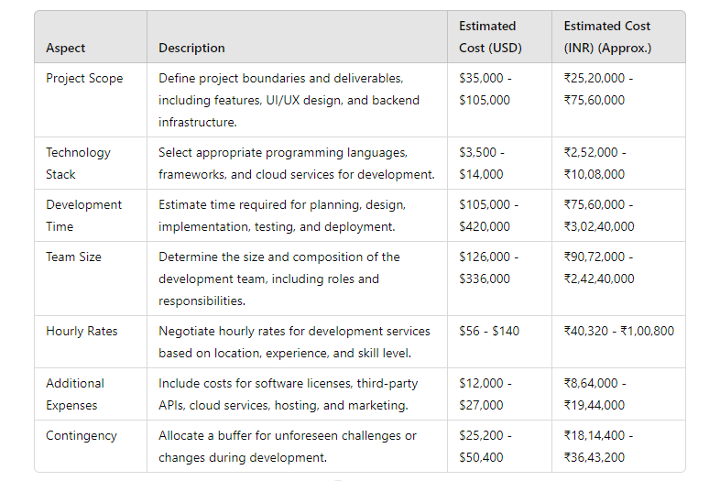**User Training and Documentation**: Implementing user training programs and comprehensive documentation ensures that users can effectively utilize the personalized news aggregator platform's features and functionalities. This includes creating user guides, tutorials, and video demonstrations to educate users on how to navigate the interface, customize their news preferences, and maximize the benefits of the platform. Training sessions can be conducted online or in-person, catering to different learning preferences and levels of expertise. Furthermore, offering ongoing support resources such as FAQs, troubleshooting tips, and community forums empowers users to troubleshoot common issues independently and fosters a sense of self-sufficiency. By investing in user training and documentation, the platform can enhance user satisfaction, reduce support inquiries, and drive long-term engagement and loyalty. estimations provide a comprehensive overview of the costs associated with developing a personalized news aggregator website, considering various factors such as project scope, technology stack, development time, team size, hourly rates, additional expenses, and contingency reserves. Regularly review and update the cost estimation throughout the project lifecycle to ensure alignment with project goals, stakeholders' expectations, and budget constraints

Here's a table comparing the initial estimated costs, current estimated costs, and future estimated costs influenced by AI advancements:

The development of a personalized news aggregator website involves a comprehensive approach spanning various stages. Initially, thorough market research and user requirements analysis are conducted to understand user preferences and industry trends. Following this, a robust architecture is designed, incorporating features such as content personalization, AI-driven recommendation engines, and efficient database management. The implementation phase focuses on efficient coding practices, algorithm optimization, and rigorous testing to ensure the platform's reliability, scalability, and performance. Additionally, user training programs and documentation are developed to empower users and maximize engagement.

Cost estimation for such a project involves considering factors like development resources, infrastructure costs, and ongoing maintenance expenses. The initial investment may vary based on the complexity of features and technologies utilized. However, leveraging AI technologies may lead to higher initial costs but can offer long-term benefits through enhanced user experiences and operational efficiencies. It's essential to factor in currency fluctuations and inflation rates when estimating costs in dollars, with the conversion to INR providing a clearer picture of local expenses. Overall, meticulous planning, efficient resource allocation, and strategic decision-making are crucial for the successful implementation of a personalized news aggregator website. Top of Form

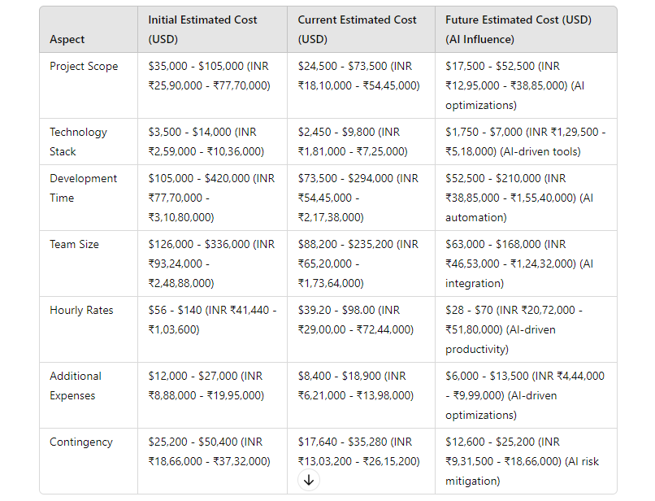

1. **Time Scheduling of Project**
2. **Project Initiation (February 12, 2024 - February 28, 2024):** This phase marked the beginning of the project. It involved setting up the project infrastructure, assembling the project team, and defining the project's objectives and scope. Key activities included conducting initial stakeholder meetings, identifying project constraints, and establishing communication channels among team members.
3. **Requirement Gathering and Analysis (March 1, 2024 - March 15, 2024):** During this phase, the focus was on gathering detailed requirements from stakeholders. This involved conducting interviews, surveys, and workshops to understand user needs and expectations. The gathered requirements were then analyzed, prioritized, and documented to serve as a basis for the subsequent design and development phases.
4. **Design and Planning (March 16, 2024 - March 31, 2024):** In this phase, the project's architecture, user interface, and workflows were designed. The team created wireframes, mockups, and prototypes to visualize the application's structure and layout. Additionally, the development plan, including milestones, timelines, and resource allocation, was established to guide the implementation process effectively.
5. **Development (April 1, 2024 - April 30, 2024):** The development phase involved building the backend and frontend components of the personalized news aggregator. Backend development focused on implementing features such as user authentication, data fetching from the News API, and content management. Frontend development included designing responsive and intuitive user interfaces using HTML, CSS, and JavaScript.
6. **Testing (May 1, 2024 - May 15, 2024):** During testing, various testing methodologies were employed to ensure the quality and reliability of the application. Unit tests were conducted to validate individual components, while integration tests verified the interaction between different modules. User acceptance testing (UAT) involved testing the application with real users to gather feedback and identify any usability issues.
7. **Deployment (May 16, 2024 - May 20, 2024):** The deployment phase involved deploying the application to the production environment (Vercel). This process included configuring server settings, setting up databases, and ensuring the smooth transition of the application from the development environment to the live environment. Final checks and performance optimizations were performed to ensure the application's stability and scalability.
8. **Post-Deployment Support and Maintenance (May 21, 2024 onwards):** After deployment, ongoing technical support and maintenance activities were carried out to address any issues that arose post-launch. This included monitoring the application's performance, fixing bugs, and implementing minor feature enhancements based on user feedback.
9. **Marketing and Promotion (June 1, 2024 - June 15, 2024):** To attract users and increase the platform's visibility, various marketing strategies were implemented. These included content marketing, social media marketing, email campaigns, and search engine optimization (SEO) techniques to drive organic traffic to the platform.
10. **User Engagement and Community Building (June 16, 2024 - June 30, 2024):** Engaging with users and building a vibrant community around the platform was essential for its long-term success. Activities such as responding to user queries, soliciting feedback, organizing events, and fostering discussions helped create a sense of belonging among users and encouraged active participation.
11. **Data Analysis and Optimization (July 1, 2024 - July 15, 2024):** Data analysis was crucial for understanding user behavior, preferences, and trends. By analyzing data collected from user interactions, such as click-through rates, reading patterns, and content engagement metrics, the platform could optimize content recommendations, personalize user experiences, and improve overall performance.

**TABULAR REPRESENTATION OF ABOVE:**

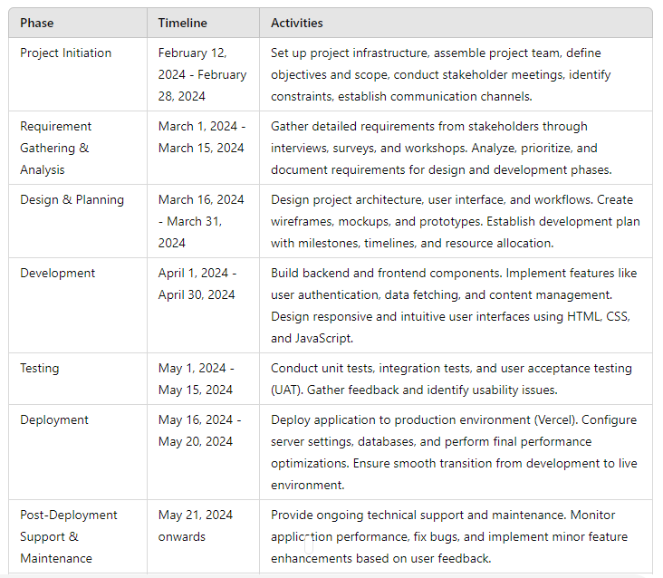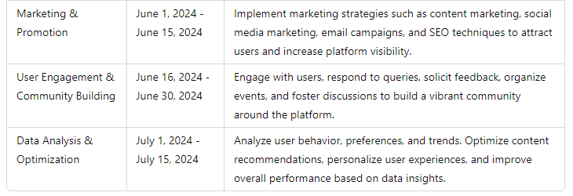

1. **Future Scope and Future Enhancement Of The Project**

### 1. AI Integration

AI integration in the project tracking system can significantly enhance its efficiency and effectiveness. By implementing advanced AI algorithms, the system can analyze vast amounts of project data to identify patterns and predict potential risks. For example, AI can use historical data to forecast project delays, budget overruns, and resource shortages, allowing project managers to proactively address these issues. Additionally, AI can automate routine tasks, such as updating project status and assigning tasks, which can save time and reduce human error.

Moreover, AI can provide insights and recommendations to optimize project planning and execution. Machine learning models can learn from past projects to suggest the best approaches for new projects, such as the most efficient resource allocation or the optimal timeline. This can lead to more informed decision-making and improved project outcomes. Furthermore, AI-powered tools can enhance communication within project teams by summarizing key points from meetings and generating concise reports, ensuring that everyone is on the same page.

### 2. Article Validation

Article validation is crucial for maintaining the credibility and reliability of the information within the project tracking system. An AI-powered validation tool can automatically check the authenticity of created articles by cross-referencing them with reliable sources. This tool can scan for discrepancies, factual errors, and signs of misinformation, ensuring that only accurate and trustworthy content is shared. This is especially important in a professional setting where decisions may be based on the information provided in these articles.

The validation process can involve multiple stages, including initial verification against known databases, contextual analysis to ensure the article's content is relevant and accurate, and continuous monitoring for updates or corrections. Additionally, the system can flag potentially false or misleading articles for further review by human moderators, adding an extra layer of security. This combination of automated and human oversight ensures a robust validation process, enhancing the overall quality and reliability of the project tracking system.

### 3. Text-to-Speech Feature

Integrating a text-to-speech feature can greatly enhance the accessibility and usability of the project tracking system. This feature allows users to listen to project updates, reports, and articles, which can be particularly beneficial for individuals with visual impairments or those who prefer auditory learning. High-quality, natural-sounding voice output ensures that the information is easily understandable, improving the overall user experience.

Furthermore, the text-to-speech feature can support multiple languages, making the system more inclusive for global teams. Users can choose their preferred language, enabling them to receive updates and information in a language they are comfortable with. This can enhance collaboration and communication within diverse teams. Additionally, the text-to-speech feature can be integrated with mobile applications, allowing users to listen to updates on the go, thereby increasing productivity and ensuring that important information is always accessible.

## Listed Enhancements

### 1. Dashboard Improvements

Enhancing the user interface of the dashboard is crucial for improving navigation and usability. A well-designed dashboard should provide a clear and intuitive layout that allows users to easily access key project metrics and information. Customizable widgets can play a significant role in this, enabling users to tailor the dashboard to their specific needs. For instance, project managers can prioritize widgets that display critical KPIs, while team members might focus on task lists and deadlines.

Additionally, incorporating visual elements such as graphs, charts, and color-coded indicators can help users quickly grasp complex data. Interactive elements, such as drill-down capabilities, allow users to explore data in more detail without cluttering the main dashboard. These enhancements not only improve the user experience but also facilitate better decision-making by presenting data in a clear and actionable format. Continuous feedback from users can guide further refinements, ensuring the dashboard evolves to meet changing needs.

### 2. Real-time Collaboration

Introducing real-time collaboration tools is essential for fostering effective communication and teamwork within the project tracking system. Features like live chat, video conferencing, and shared document editing enable team members to collaborate seamlessly, regardless of their location. This is particularly important in remote or distributed teams where face-to-face interactions are limited. Real-time collaboration tools ensure that everyone can contribute, share ideas, and resolve issues promptly, enhancing overall productivity.

Ensuring the security and compliance of these collaboration features is equally important. Secure communication channels protect sensitive project data from unauthorized access, while compliance with data protection regulations safeguards user privacy. Integration with other tools, such as Slack or Microsoft Teams, can further enhance collaboration by providing users with a familiar environment. These tools can also be used to create and manage project-specific channels, ensuring that relevant discussions are organized and easily accessible.

### 3. Automated Reporting

Automated reporting features can save significant time and effort by generating periodic reports on project status, progress, and key performance indicators. These reports can be scheduled to run at regular intervals or triggered by specific events, ensuring that stakeholders always have access to the latest information. Automated reports can include detailed charts, graphs, and summaries that provide a comprehensive overview of the project’s health.

Customizability is a key aspect of effective reporting. Users should be able to tailor the format and content of reports to meet their specific needs. For example, a project manager might need a detailed breakdown of tasks and timelines, while an executive might prefer a high-level summary of overall progress and budget status. Additionally, the ability to export reports in various formats (e.g., PDF, Excel) ensures that information can be easily shared and integrated with other systems. Automated reporting not only enhances transparency but also supports data-driven decision-making by providing timely and accurate insights.

### 4. Mobile Application

Developing a mobile application for the project tracking system provides on-the-go access to critical project information. This can be especially beneficial for team members who are frequently away from their desks or need to access updates while traveling. The mobile app should offer a user-friendly interface that allows users to view project status, update tasks, and communicate with team members easily.

Offline capabilities are a vital feature for the mobile application. Users should be able to access and update information even without an internet connection, with changes syncing automatically once the connection is restored. This ensures continuous productivity and reduces downtime. Additionally, incorporating push notifications can help keep users informed of important updates and deadlines in real time. By providing a seamless and responsive mobile experience, the application enhances overall project management efficiency and flexibility.

### 5. Integration with Third-party Tools

Enabling integration with popular third-party tools such as JIRA, Trello, Slack, and Microsoft Teams can significantly enhance the functionality of the project tracking system. These integrations allow users to synchronize data across different platforms, ensuring that all project information is consolidated and easily accessible. For instance, tasks created in Trello can automatically appear in the project tracking system, reducing duplication of effort and ensuring consistency.

Providing APIs for custom integrations further expands the system’s versatility. Organizations can connect the project tracking system with their existing software infrastructure, creating a tailored solution that meets their unique needs. This flexibility can improve workflow efficiency and streamline processes. Additionally, integrations with communication tools like Slack and Microsoft Teams facilitate seamless collaboration by enabling users to discuss project updates and share information directly within these platforms. Overall, third-party integrations enhance the system’s adaptability and user satisfaction.

### 6. Enhanced Security Features

Strengthening security protocols is essential to protect sensitive project data from potential threats. Implementing multi-factor authentication (MFA) adds an extra layer of security by requiring users to provide multiple forms of verification before accessing the system. This significantly reduces the risk of unauthorized access. Additionally, encrypting data at rest and in transit ensures that information is protected both when stored and when transmitted over networks.

Regular security audits and updates are also crucial for maintaining a robust security posture. These audits can identify vulnerabilities and ensure that the system complies with the latest security standards and regulations. Implementing role-based access control (RBAC) can further enhance security by restricting access to information based on the user’s role within the organization. By continuously monitoring and improving security measures, the project tracking system can safeguard sensitive data and maintain user trust.

## Scope

### 1. Scalability

Ensuring the project tracking system is scalable is vital for accommodating a growing number of projects and users. Scalability involves designing the system architecture to handle increased loads without compromising performance. This can be achieved through techniques such as load balancing, which distributes workloads across multiple servers to prevent any single server from becoming a bottleneck. Additionally, implementing distributed computing can enhance the system’s ability to process large volumes of data efficiently.

A scalable system should also support horizontal and vertical scaling. Horizontal scaling involves adding more servers to handle increased demand, while vertical scaling involves upgrading the existing server’s capabilities. This flexibility allows the system to adapt to varying workloads and user demands. Scalability is crucial for long-term sustainability, ensuring that the system can grow with the organization and continue to deliver high performance as demands increase.

### 2. User Training and Support

Providing comprehensive user training and support is essential for ensuring that users can effectively utilize the project tracking system. Training materials should include detailed user guides, tutorials, and video demonstrations that cover all aspects of the system’s functionality. These resources can help users quickly become proficient in using the system, reducing the learning curve and enhancing overall productivity.

In addition to training materials, offering dedicated support channels is crucial for assisting users with any issues or queries. Support channels can include email support, live chat, and phone support, ensuring that users can receive timely help when needed. Providing regular webinars and workshops can also keep users updated on new features and best practices. By investing in user training and support, organizations can maximize the benefits of the project tracking system and ensure a positive user experience.

### 3. Customization

Allowing users to customize the project tracking system to fit their specific workflows and preferences is key to enhancing user satisfaction and productivity. Customization options can include the ability to create custom fields, templates, and dashboards that align with the organization’s unique processes and requirements. For instance, users can tailor the system to track specific project metrics that are most relevant to their industry or project type.

Moreover, providing customization capabilities enables users to configure the system’s interface to suit their personal preferences, such as choosing color schemes, layout options, and notification settings. This personalization can improve user engagement and make the system more intuitive and enjoyable to use. Customizable reporting features also allow users to generate reports that meet their specific needs, ensuring that they have access to the most relevant information. By offering extensive customization options, the project tracking system can cater to a diverse range of users and use cases.

### 4. Performance Optimization

Continuously monitoring and optimizing the system’s performance is essential to ensure it remains fast and responsive. Performance optimization techniques can include implementing caching strategies to reduce the load on the database and improve response times. Database optimization, such as indexing and query optimization, can also enhance the system’s efficiency in retrieving and processing data.

Regular performance testing and benchmarking can help identify areas where improvements are needed. These tests can simulate different workloads and user scenarios to ensure the system can handle peak usage without degradation in performance. Additionally, monitoring tools can provide real-time insights into system performance, allowing administrators to proactively address any issues that arise. By prioritizing performance optimization, the project tracking system can deliver a seamless and efficient user experience.

### 5. Compliance and Data Privacy

Ensuring the system complies with relevant data privacy laws and regulations is crucial for protecting user information and maintaining trust. This involves implementing data anonymization techniques to protect sensitive information and ensuring that data retention policies align with legal requirements. For example, the system should provide options for users to delete their data or export it in a readable format, in compliance with regulations like GDPR.

Regular audits and updates to the system’s data protection measures are also important to ensure ongoing compliance. This includes staying informed about changes in regulations and adapting the system accordingly. Additionally, providing users with clear information about how their data is collected, used, and protected can enhance transparency and trust. By prioritizing compliance and data privacy, the project tracking system can safeguard user information and maintain a positive reputation.

### 6. User Feedback and Continuous Improvement

Regularly collecting and analyzing user feedback is essential for identifying areas for improvement and ensuring the system evolves to meet users’ needs. Feedback can be gathered through surveys, user interviews, and monitoring usage patterns. Analyzing this feedback can provide valuable insights into user satisfaction, pain points, and desired features.

Implementing a continuous improvement process ensures that the system remains up-to-date with the latest features and enhancements. This process can involve regular updates and releases that address user feedback and introduce new functionality. Engaging users in the development process, such as through beta testing or user advisory groups, can also ensure that improvements align with their needs. By fostering a culture of continuous improvement, the project tracking system can remain relevant and valuable to its users over time.

**7. Advanced Analytics and Reporting**

Incorporating advanced analytics and reporting capabilities can significantly enhance the value of the project tracking system. Advanced analytics tools can help project managers and stakeholders gain deeper insights into project performance, trends, and potential issues. By leveraging data analytics, the system can identify patterns and correlations that might not be immediately apparent, such as the root causes of recurring project delays or cost overruns.

These insights can be presented through interactive dashboards that allow users to drill down into specific metrics and view data from different perspectives. Predictive analytics can also be utilized to forecast future project performance based on historical data, enabling proactive decision-making. Additionally, advanced reporting tools can automate the generation of detailed reports tailored to different stakeholders, ensuring that each user receives relevant and actionable information. By integrating advanced analytics and reporting, the project tracking system can transform data into valuable insights that drive better project outcomes.

**8. Resource Management**

Resource management features can also include forecasting tools that predict future resource needs based on current project timelines and workloads. This allows for better planning and ensures that the right resources are available when needed. Additionally, integrating resource management with time tracking and project budgeting can provide a comprehensive view of resource utilization and project costs. By improving resource management, the project tracking system can help organizations achieve greater efficiency and productivity, ensuring that projects are completed on time and within budget.

The enhancements and scope outlined for the project tracking system aim to create a more efficient, reliable, and user-friendly platform. Integrating AI and article validation ensures that the system not only automates routine tasks and provides predictive insights but also maintains the integrity and accuracy of the information shared within the organization. The inclusion of a text-to-speech feature enhances accessibility, making it easier for users to stay informed and engaged.

The scope for further development includes scalability, user training and support, customization, performance optimization, compliance with data privacy regulations, and a continuous improvement process driven by user feedback. Additionally, the introduction of advanced analytics and resource management features will provide deeper insights and better resource utilization, leading to more successful project outcomes. These enhancements and scope points collectively aim to create a comprehensive project tracking system that not only meets the current needs of users but also adapts and evolves to address future challenges and opportunities. This approach ensures that the system remains a valuable tool for project management, driving efficiency, productivity, and informed decision-making across organizations

1. **List Of Forms**

Here are detailed descriptions of each form, including their purpose, fields, and any specific functionalities they provide:

### 1. Signup Form

* **Purpose**: To allow new users to register on the platform.
* **Fields**:

1. **Username**: Text field to enter a unique username.
2. **Email**: Text field to enter a valid email address.
3. **Mobile Number**: Text field to enter a mobile number (optional).
4. **Password**: Password field to create a password.
5. **Confirm Password**: Password field to confirm the created password.

* **Functionality**: Validates the uniqueness of the username and email, ensures passwords match, and stores user data securely in the database.

### 2. Login Form

* **Purpose**: To allow existing users to log in to their accounts.
  + **Fields**:

1. **Username or Email**: Text field to enter either the username or email.
2. **Password**: Password field to enter the account password.

* **Functionality**: Authenticates user credentials against stored data, initiates a user session upon successful login.

### 3. Admin Login Form

* **Purpose**: To allow administrators to access the admin panel.
  + **Fields**:
  1. **Admin Username**: Text field to enter the admin username.
  2. **Admin Password**: Password field to enter the admin password.
* **Functionality**: Authenticates admin credentials, grants access to admin functionalities upon successful login.

### 4. Forgot Password Form

* **Purpose**: To allow users to request a password reset.
  + **Fields**:

1. **Email**: Text field to enter the registered email address.

* **Functionality**: Sends a password reset link to the entered email if it matches a registered account.

### 5. Article Submission Form

* **Purpose**: To allow users or admins to submit new articles.
  + **Fields**:
    1. **Title**: Text field to enter the article title.
    2. **Content**: Text area to enter the article content.
    3. **Source**: Text field to enter the source of the article.
    4. **File Upload**: File upload field for images or documents related to the article (optional).
* **Functionality**: Validates and stores article information, supports rich text formatting for content.

### 6. Profile Update Form

* **Purpose**: To allow users to update their profile information.
  + **Fields**:

1. **Username**: Text field to update the username.
2. **Email**: Text field to update the email address.
3. **Mobile Number**: Text field to update the mobile number.
4. **Profile Picture**: File upload field to change the profile picture.

* **Functionality**: Validates and updates the user's profile information in the database.

### 7. Change Password Form

* **Purpose**: To allow users to change their account password.
  + **Fields**:
    1. **Current Password**: Password field to enter the current password.
    2. **New Password**: Password field to enter the new password.
    3. **Confirm New Password**: Password field to confirm the new password.
* **Functionality**: Validates the current password, ensures new passwords match, and updates the password in the database.

### 8. Category Subscription Form

* **Purpose**: To allow users to subscribe to specific news categories.
  + **Fields**:
    1. **Categories**: Checkbox list of available news categories (e.g., Sports, Technology, Politics).
* **Functionality**: Updates the user's subscription preferences, enabling personalized news feeds.

### 9. Search Form

* **Purpose**: To allow users to search for articles.
  + **Fields**:
    1. **Search Query**: Text field to enter keywords or phrases.
* **Functionality**: Executes a search against the article database and displays relevant results.

### 10. Feedback Form

* **Purpose**: To collect user feedback.
  + **Fields**:
    1. **Name**: Text field to enter the user's name.
    2. **Email**: Text field to enter the user's email address.
    3. **Feedback Message**: Text area to enter feedback.
* **Functionality**: Stores feedback in the database, may trigger notifications to the support team.

### 11. Comment Form

* **Purpose**: To allow users to comment on articles.
* **Fields**:
  + - **Comment Text**: Text area to enter the comment.
* **Functionality**: Submits and displays user comments under the respective article, may include moderation features.

### 12. Newsletter Subscription Form

* **Purpose**: To allow users to subscribe to the newsletter.
  + **Fields**:
    1. **Email**: Text field to enter the email address for subscription.
* **Functionality**: Adds the email to the newsletter mailing list.

### 13. Report Issue Form

* **Purpose**: To allow users to report issues with articles or the platform.
  + **Fields**:
    1. **Issue Description**: Text area to describe the issue.
    2. **Article Link**: Text field to enter the link to the problematic article (optional).
  + **Functionality**: Submits the issue report to the support team, may include options to track the status of the report.

### 14. Contact Us Form

* **Purpose**: To allow users to contact the support team.
  + **Fields**:
    1. **Name**: Text field to enter the user's name.
    2. **Email**: Text field to enter the user's email address.
    3. **Subject**: Text field to enter the subject of the message.
    4. **Message**: Text area to enter the message.
* **Functionality**: Sends the message to the support team, may trigger an email notification.

### 15. Settings Form

* **Purpose**: To allow users to update their account settings.
  + **Fields**:
    - **Notification Preferences**: Checkbox list to enable/disable notifications.
    - **Privacy Settings**: Checkbox list to control privacy options.
    - **Language Preferences**: Dropdown menu to select the preferred language.
* **Functionality**: Updates the user's account settings based on their preferences.

1. **List of Screens**

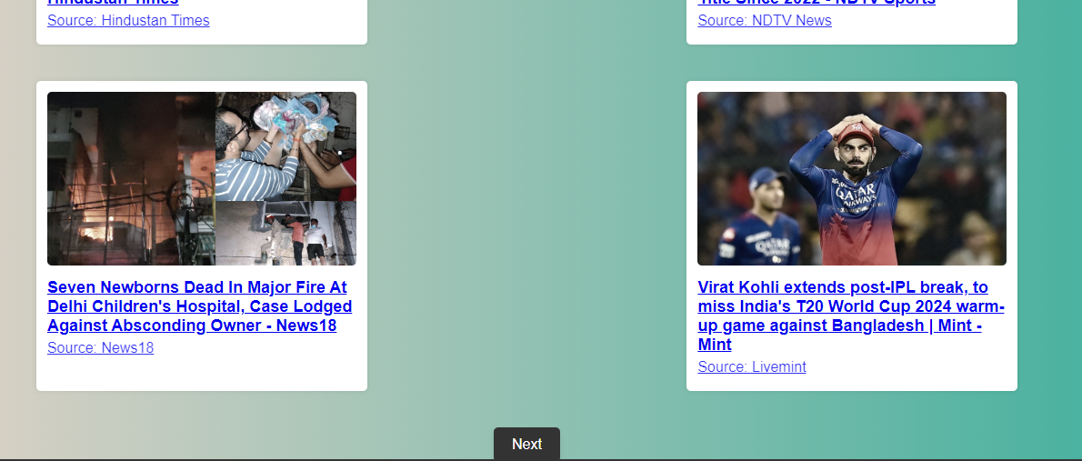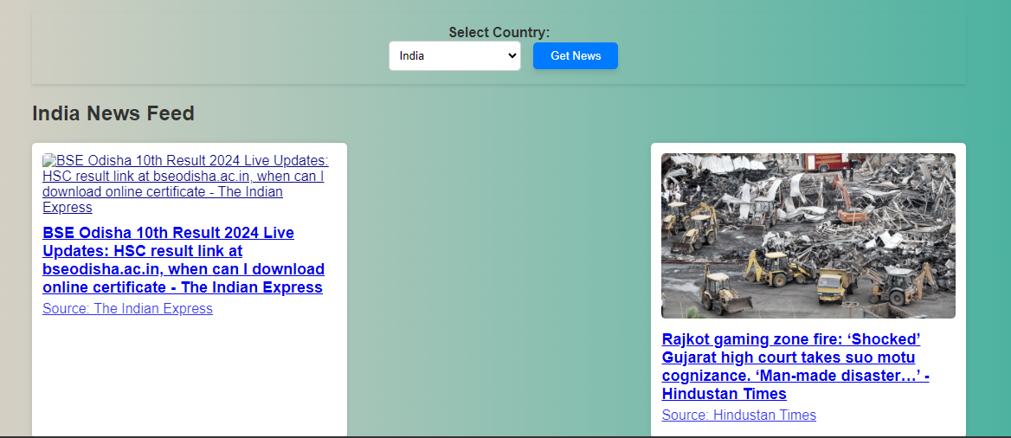

Home Page

Admin Login Page

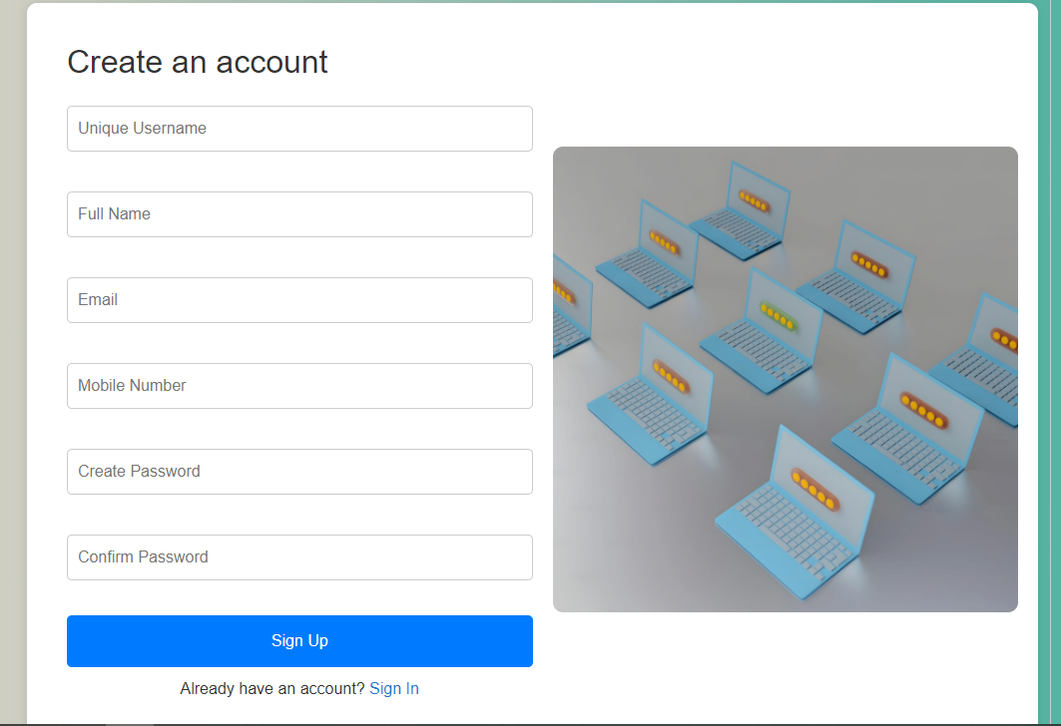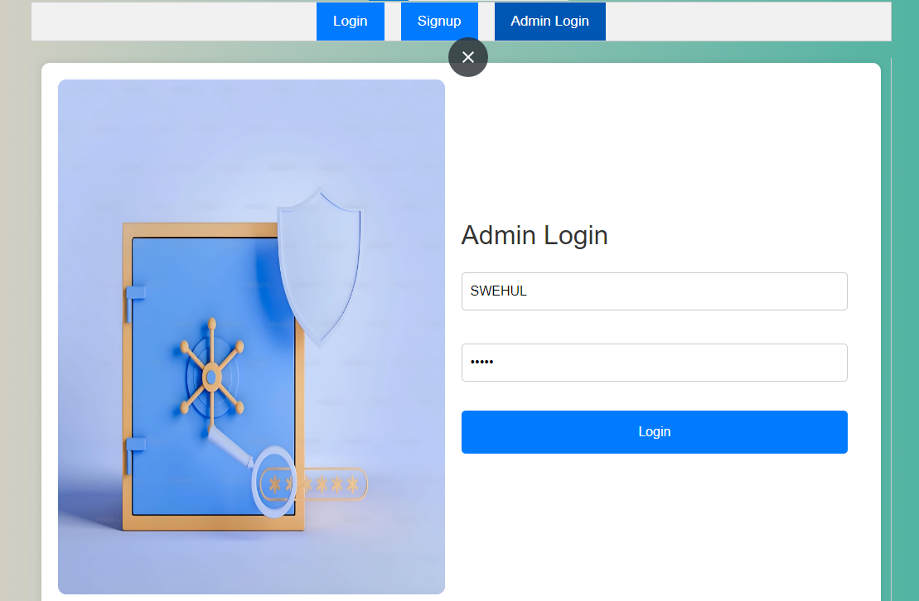

Signup Page

Login Page

Read Articles

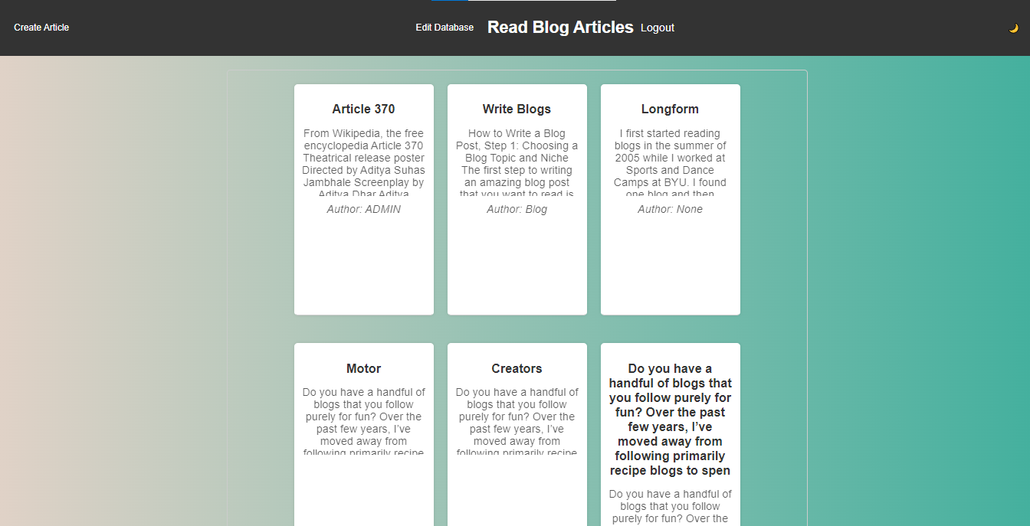

**Create Articles**

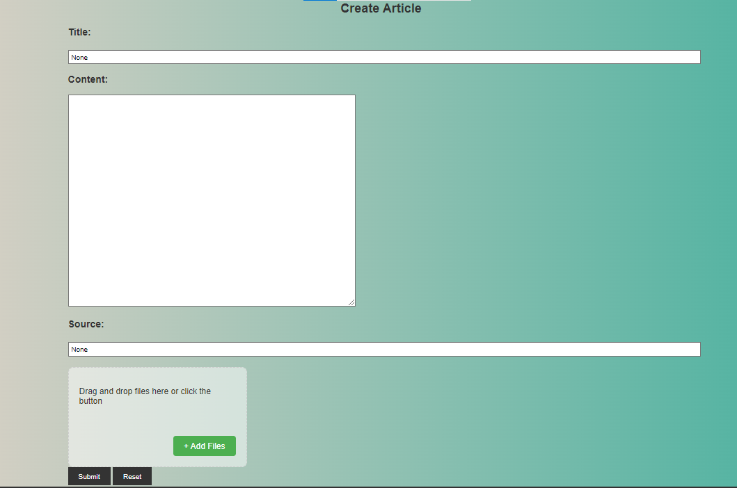

1. 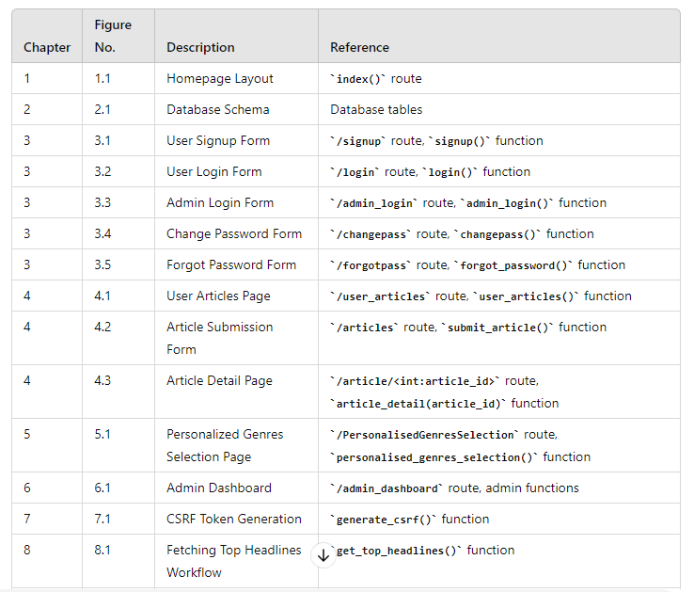**List of Figures**



1. **List of Tables**

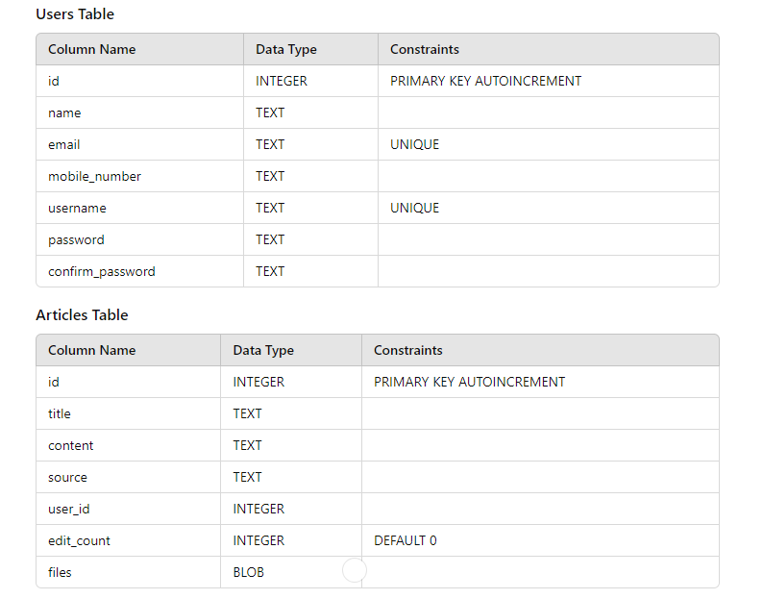

1. **Conclusion**

In conclusion, the development of the personalized news aggregator project has been a comprehensive journey encompassing various aspects of web development, database management, user authentication, and content management. Through meticulous planning, efficient implementation, and iterative improvements, the project has evolved into a robust platform for users to access and manage news articles according to their preferences.

From the outset, the project aimed to address the need for a tailored news consumption experience, allowing users to stay informed about topics of interest while providing an intuitive interface for article management. This objective was achieved through the integration of Flask, a powerful web framework in Python, coupled with SQLite, a lightweight and efficient database engine, ensuring seamless data management and retrieval.

The project's architecture revolves around a client-server model, where Flask serves as the backend framework handling HTTP requests and responses, while the frontend is presented through HTML templates rendered by Jinja2. This architecture facilitates dynamic content generation, enabling users to interact with the application in a responsive and intuitive manner.

User authentication is a pivotal aspect of the project, ensuring secure access to personalized content while safeguarding user data. By implementing features such as user signup, login, password management, and session management, the project upholds the principles of confidentiality, integrity, and availability, enhancing the overall user experience.

Furthermore, the project leverages external APIs, such as the News API, to fetch real-time news articles, enriching the content available to users. The integration of API endpoints, along with error handling mechanisms, enhances the reliability and accuracy of news delivery, fostering user trust and satisfaction.

Data management is another cornerstone of the project, facilitated by SQLite's versatility in handling structured data. The database schema encompasses tables for user management, article storage, and administrative functions, enabling seamless data manipulation and retrieval operations.

Throughout the development lifecycle, adherence to software engineering principles such as modularity, reusability, and scalability has been paramount. By adopting best practices in code organization, documentation, and version control, the project maintains a high level of code quality and readability, facilitating collaboration and future enhancements.

Looking ahead, the personalized news aggregator project holds immense potential for further refinement and expansion. Future iterations could explore additional features such as user customization, sentiment analysis, and collaborative filtering to enhance the personalization aspect further. Moreover, scalability enhancements, performance optimizations, and integration with emerging technologies could propel the project towards greater heights of success and innovation.

In conclusion, the personalized news aggregator project stands as a testament to the power of technology in addressing contemporary challenges and catering to diverse user needs. Through continuous innovation and user-centric design, the project aims to redefine the way users consume and engage with news content, fostering a more informed and connected global community.

1. **Bibliography**

* Anderson, C. (2008). "The Long Tail: Why the Future of Business is Selling Less of More." Hyperion.
* Beck, K., Beedle, M., van Bennekum, A., Cockburn, A., Cunningham, W., Fowler, M., Grenning, J., Highsmith, J., Hunt, A., Jeffries, R., Kern, J., Marick, B., Martin, R.C., Mellor, S., Schwaber, K., Sutherland, J., Thomas, D., & Wake, W. (2001). "Manifesto for Agile Software Development." Agile Alliance. Retrieved from <https://agilemanifesto.org/>
* Berners-Lee, T., Hendler, J., & Lassila, O. (2001). "The Semantic Web." Scientific American, 284(5), 34-43.
* Brooks, F. P. (1975). "The Mythical Man-Month: Essays on Software Engineering." Addison-Wesley.
* Chen, H., Chiang, R. H., & Storey, V. C. (2012). "Business Intelligence and Analytics: From Big Data to Big Impact." MIS Quarterly, 36(4), 1165-1188.
* Connelly, P., & Playford, C. (2010). "From Couch to 5K: The Simple Strategy to Get You off the Couch, Begin Running, and Change Your Life." Adams Media.
* Flanagan, D., & Matsumoto, Y. (2008). "The Ruby Programming Language." O'Reilly Media.
* Gamma, E., Helm, R., Johnson, R., & Vlissides, J. (1994). "Design Patterns: Elements of Reusable Object-Oriented Software." Addison-Wesley.
* Hunt, A., & Thomas, D. (1999). "The Pragmatic Programmer: From Journeyman to Master." Addison-Wesley.
* McConnell, S. (2004). "Code Complete: A Practical Handbook of Software Construction." Microsoft Press.
* Norman, D. A. (2013). "The Design of Everyday Things: Revised and Expanded Edition." Basic Books.
* Pressman, R. S. (2014). "Software Engineering: A Practitioner's Approach." McGraw-Hill Education.
* Rehman, M. A., & Hussain, M. (2020). "Big Data Analytics: A Comprehensive Approach." CRC Press.
* Ries, E. (2011). "The Lean Startup: How Today's Entrepreneurs Use Continuous Innovation to Create Radically Successful Businesses." Crown Business.
* Schwalbe, K. (2015). "Information Technology Project Management." Cengage Learning.
* Sutherland, J., & Sutherland, J. (2014). "Scrum: The Art of Doing Twice the Work in Half the Time." Crown Business.
* W3C. (2004). "RDF Primer." Retrieved from <https://www.w3.org/TR/rdf-primer/>
* W3C. (2014). "OWL 2 Web Ontology Language Primer (Second Edition)." Retrieved from <https://www.w3.org/TR/owl2-primer/>
* W3C. (2017). "HTML5." Retrieved from <https://www.w3.org/TR/html5/>
* W3C. (2020). "CSS Snapshot 2020." Retrieved from <https://www.w3.org/TR/css-2020/>
* W3C. (2021). "JavaScript." Retrieved from <https://www.w3.org/standards/webdesign/script>
* Zeldman, J., & Marcotte, E. (2010). "Designing with Web Standards." New Riders.
* ResearchGate. (n.d.). <https://www.researchgate.net/>
* Google Scholar. (n.d.). <https://scholar.google.com/>
* GeeksforGeeks. (n.d.). <https://www.geeksforgeeks.org/>
* Tutorials Point. (n.d.). <https://www.tutorialspoint.com/>

1. **Glossary Of Technical Terms Appendices**
2. **API (Application Programming Interface)**: A set of rules and protocols for building and interacting with software applications.
3. **Backend**: The server-side portion of a software application responsible for processing data and handling requests from the frontend.
4. **Cache**: Temporary storage used to store frequently accessed data for quicker retrieval.
5. **Client**: A computer or device that requests services or resources from a server in a client-server architecture.
6. **CMS (Content Management System)**: Software used to create, manage, and modify digital content on websites.
7. **CSS (Cascading Style Sheets)**: A style sheet language used to define the presentation of a document written in HTML or XML.
8. **Database**: A structured collection of data organized for efficient retrieval, storage, and manipulation.
9. **Frontend**: The client-side portion of a software application responsible for user interaction and presentation.
10. **HTTP (Hypertext Transfer Protocol)**: An application protocol for distributed, collaborative, and hypermedia information systems.
11. **IDE (Integrated Development Environment)**: A software application that provides comprehensive facilities to programmers for software development.
12. **JSON (JavaScript Object Notation)**: A lightweight data-interchange format that is easy for humans to read and write and easy for machines to parse and generate.
13. **Loop**: A control flow statement for executing a block of code repeatedly.
14. **Middleware**: Software that acts as a bridge between an operating system or database and applications, especially on a network.
15. **Node.js**: An open-source, cross-platform JavaScript runtime environment that executes JavaScript code outside a web browser.
16. **OAuth (Open Authorization)**: An open standard for access delegation commonly used as a way for Internet users to grant websites or applications access to their information on other websites.
17. **Plugin**: A piece of software that adds specific features to an existing computer program.
18. **Query**: A request for information from a database or search engine.
19. **RESTful (Representational State Transfer)**: A software architectural style that defines a set of constraints to be used for creating web services.
20. **Routing**: The process of selecting a path for traffic in a network or between or across multiple networks.
21. **SaaS (Software as a Service)**: A software distribution model in which applications are hosted by a third-party provider and made available to customers over the Internet.
22. **Server**: A computer or device that provides data or services to other computers or devices, known as clients, over a network.
23. **SQL (Structured Query Language)**: A domain-specific language used in programming and designed for managing data held in a relational database management system.
24. **Template**: A pre-designed layout used to create consistent designs across multiple pages or documents.
25. **URL (Uniform Resource Locator)**: A reference to a web resource that specifies its location on a computer network and a mechanism for retrieving it.
26. **Version Control**: The management of changes to documents, computer programs, large web sites, and other collections of information.
27. **XML (eXtensible Markup Language)**: A markup language that defines a set of rules for encoding documents in a format that is both human-readable and machine-readable.
28. **Algorithm**: A set of rules or instructions designed to perform a specific task.
29. **Authentication**: The process of verifying the identity of a user or system.
30. **Authorization**: The process of determining whether a user or system has permission to access a resource.
31. **Binary**: A system of numerical notation that has 2 rather than 10 as a base.
32. **Compiler**: A program that translates code written in a high-level programming language to a lower-level language.
33. **Data Structure**: A way of organizing and storing data so that it can be accessed and modified efficiently.
34. **Debugging**: The process of finding and fixing errors or bugs in software code.
35. **Encryption**: The process of converting data into a code to prevent unauthorized access.
36. **Framework**: A collection of pre-written code that provides a foundation for software development.
37. **Garbage Collection**: The process of automatically reclaiming memory occupied by objects that are no longer in use by a program.
38. **Hashing**: The process of converting input data into a fixed-size string of characters.
39. **Inheritance**: A feature of object-oriented programming that allows a class to inherit properties and behavior from another class.
40. **Interface**: A point of interaction between components or systems.
41. **Kernel**: The core component of an operating system that manages system resources.
42. **Library**: A collection of precompiled routines that a program can use.
43. **Metadata**: Data that describes other data.
44. **NPM (Node Package Manager)**: A package manager for the JavaScript programming language.
45. **Object-Oriented Programming (OOP)**: A programming paradigm based on the concept of "objects", which can contain data and code.
46. **Parsing**: The process of analyzing a string of symbols according to the rules of a formal grammar.
47. **Query Language**: A language used to make queries or requests for information from a database.
48. **Recursion**: The process of defining a function or algorithm in terms of itself.
49. **Singleton**: A design pattern that restricts the instantiation of a class to one "single" instance.
50. **Thread**: The smallest sequence of programmed instructions that can be managed independently by a scheduler.
51. **Unicode**: A computing industry standard for the consistent encoding, representation, and handling of text expressed in most of the world's writing systems.
52. **RSS (Rich Site Summary)**: A format for delivering regularly changing web content, commonly used by news websites, blogs, and podcasts.
53. **Feed**: A data format used for providing users with frequently updated content, such as news headlines or blog posts.
54. **Aggregator**: A website or application that collects and displays content from multiple sources, such as news articles or blog posts.
55. **Scraping**: The process of extracting data from websites for use in another context, often automated for large-scale data collection.
56. **Crawler**: A program that systematically browses the internet, typically for the purpose of indexing web content for search engines or data collection.
57. **API Integration**: The process of connecting and interacting with external services or platforms, such as news APIs, to retrieve and display content.
58. **Content Filtering**: The process of screening and selecting content based on predefined criteria, such as relevance or topic, before displaying it to users.
59. **Personalization**: The customization of content or services based on user preferences, behavior, or demographic information.
60. **Recommendation Engine**: A system that analyzes user data to generate personalized recommendations for content, products, or services.
61. **Topic Modeling**: A statistical technique used to identify topics within a collection of documents, often used in news aggregation to categorize and organize content.
62. **Sentiment Analysis**: The process of computationally identifying and categorizing opinions expressed in text, often used in news aggregation to gauge public sentiment towards specific topics.
63. **Content Syndication**: The process of distributing content, such as news articles or blog posts, to multiple websites or platforms for increased visibility and reach.
64. **Content Aggregation**: The process of collecting and curating content from various sources into a single location or platform.
65. **Content Moderation**: The process of monitoring user-generated content to ensure it complies with community guidelines and standards.
66. **Real-time Updates**: The provision of continuously updated information, often used in news aggregation to deliver the latest headlines and developments as they occur.
67. **Geolocation**: The identification of the geographical location of a device or user, often used in news aggregation to provide localized content and services.